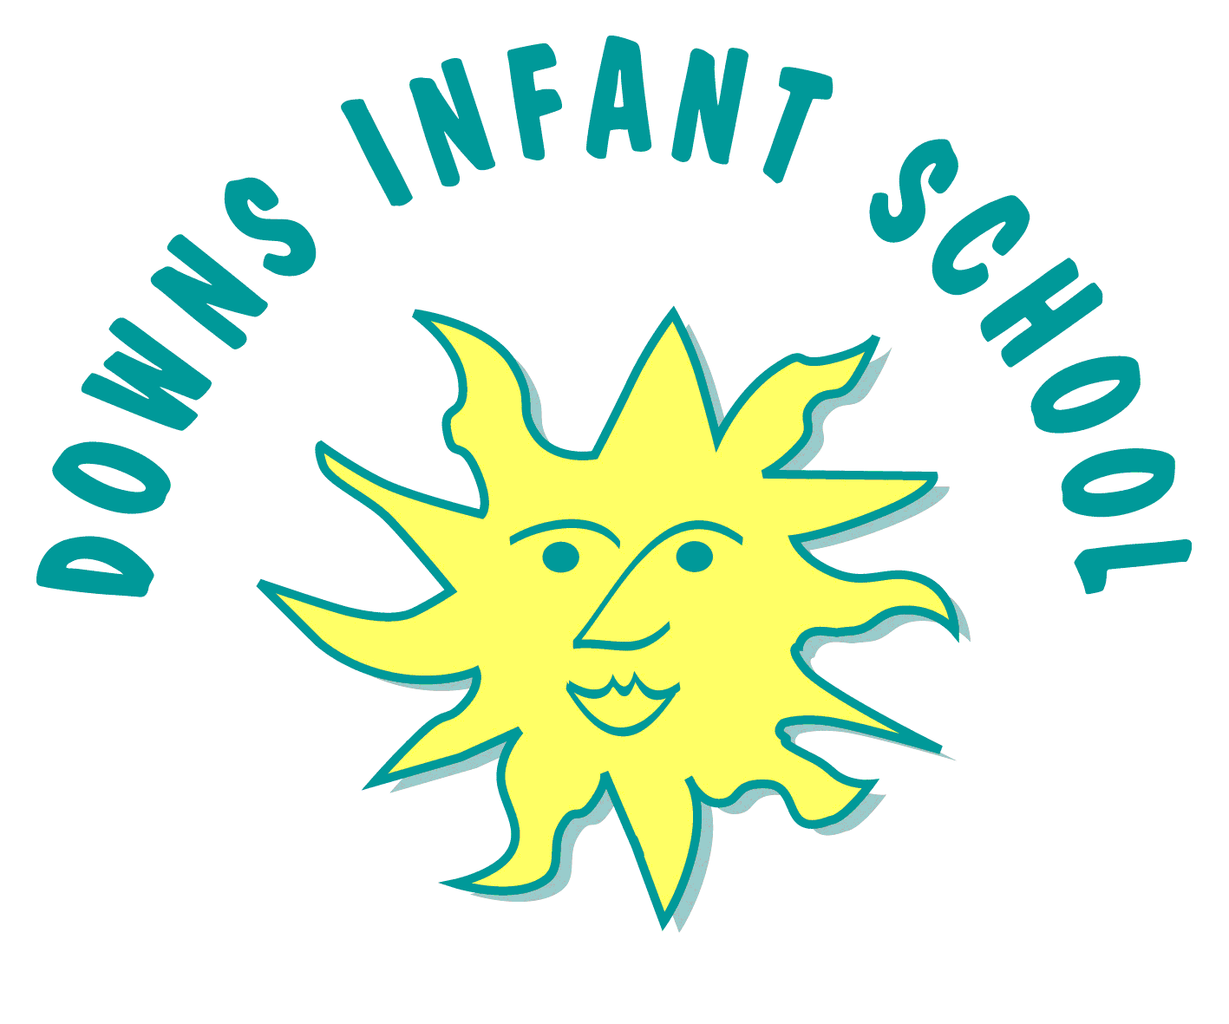
Downs Infants Curriculum Statement
PE

Giving every child the physical literacy, emotional and thinking skills to achieve in PE, Sport, physical activity and life
Intent | Implementation | Impact
What will take place before teaching in the classroom? | What will this look like in the classroom? | How will this be measured?
School values and aspirations for our learners  At Downs Infant School our PE curriculum aims to develop the whole child. We want our children to enjoy PE lessons and a range of physical activities and opportunities at school which we hope will inspire them to be physically active and to lead healthy and active lives now and into their futures. Our school values ‘Aspirstion, Belonging, Creativity, Diversity, Empathy and Flexibility’ are embedded into our PE lessons and whole-school approach.  Teaching aims  We aim to provide a broad and balanced PE curriculum which is inclusive to all children. This curriculum is carefully planned to fulfil the requirements of the National Curriculum and the EYFS framework. We plan for our children to develop their fundamental movement skills including running, jumping, throwing and catching, as well as developing balance, agility and co-ordination. We also want them to develop their dance skills and to participate in team games, developing their attacking and defending skills. We also plan for our children to develop their skills in gymnastics.  Our PE curriculum is progressive and enables children to work at their physical skill level at their ‘stage’ not ‘age’. We want our children to feel appropriately challenged in their P.E. lessons and aim to move each child on when they are ready.  Our PE curriculum is underpinned by 6 learning behaviours (cogs) that we want the children to develop.  These are:  - personal  - social  - cognitive  - creative  - physical  - health and fitness  Children should develop these learning behaviours through careful planning, questioning and support by the teacher.  We believe that when these 6 key skill areas work together in the whole child then the child can succeed. We plan to focus on one cog per half term to encourage progress in all of these areas.  We want our children to reach the End of Key Stage 1 having developed their physical skills to a strong level, and to feel proud of their progress. | Curriculum Design  We implement a curriculum that is progressive throughout the school.  In Reception it is based upon the EYFS framework and Development Matters and is explored through the strand of ‘Physical Development’ and ‘Expressive Arts and Design’.  We aim to provide a variety of diverse physical activities to engage our children and promote enjoyment of physical activity. In Reception children have one taught P.E. lesson each week. We use ‘Jasmine Core Real PE’ lessons, ‘Real dance’ and ‘Real gymnastics’. As well as this we have weekly ‘Physical Friday’ when we explore a wide range of outdoor gross motor opportunities including bikes and a range of wheeled vehicles, ball skills, and physical social games. We also have ‘Magic mover’ sessions to develop gross and fine motor skils in the classroom, physical movement breaks throughout the day and an annual sports day. During ‘COOL time’ (Choose our own learning time) children are able to access and are encouraged and supported to use a range of fine and gross motor equipment to promote physical development at their stage.  In Key Stage 1 our P.E. curriculum is based on the 2014 Primary National Curriculum in England. In KS1 children have two P.E. lessons each week. We use ‘Jasmine Core Real PE’ for one lesson and the other lesson which is delivered by our school Sport Coach includes ‘Real dance’ and ‘Real gymnastics’ as well as ‘multi-skills’ ‘games’ ‘invasion games’ and ‘athletics’. As well as this children have physical movement breaks throughout the day and an annual Sports Day. Children in Year 1 have access to physical activities outside as part of their COOL time.  We use ‘Jasmine Core Real P.E ‘Real Dance and Real Gymnastics.’ consistently to ensure a coherently planned and child friendly curriculum. This includes stories and songs to engage children with their P.E. lessons and a range of games.  Enrichment and Wider Community  In addition to our physical activity during the school day, Downs Infants also offers its children the opportunity to take part in extracurricular activities. These include ballet, tennis and karate clubs.  In Year 2 children are given the opportunity to perform at the Brighton Dome as part of the Let’s Dance festival. Year 2 children are also given the opportunity to take part in a ‘Scooter Workshop’.  At Down’s Infant School we also have whole-school events to raise the profile of PE and to inspire children to engage and develop their interests in physical activity. These include a scooter expert assembly and ‘healthy week’ which includes sports day for the whole school. | In Reception the areas of learning most relevant when measuring the impact of our teaching are Physical Development and Expressive Arts and Design. In Reception children have a baseline assessment and then they are assessed using Development Matters statements and through ongoing assessments against the ‘Real PE’ lesson objectives. In Reception children are also assessed as to whether or not they have achieved the Early Learning Goals in June. Observations and assessments are recorded on ‘Tapestry’.  In KS1 children are assessed against the National Curriculum. Children are assessed through ongoing assessments against the ‘Real PE’ lesson objectives and against the end of KS1 goals. Teacher judgements are made from observations in class and by talking to the children. This includes asking review questions at the end of lesson, asking open-ended questions.  Pupil voice is gained from children across all year groups to gain insight into their feelings about PE, their learning and achievements, and to plan for ways forward for PE for the school.

