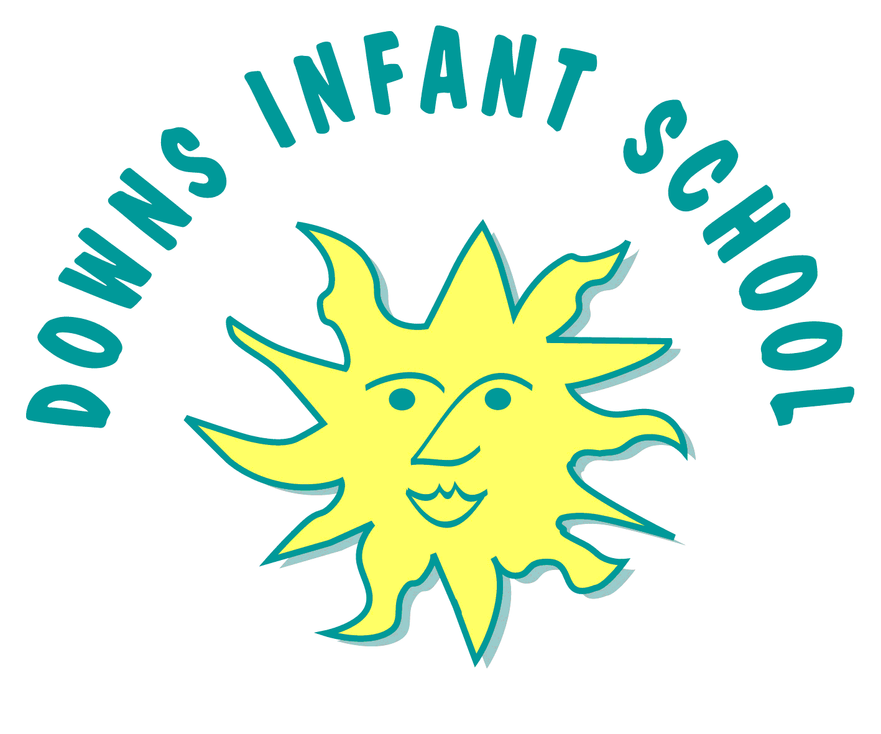
Downs Infants Curriculum Statement RE
“People of different religions and cultures live side-by-side in almost every part of the world, and most of us have overlapping identities which unite us in very different groups. We can love what we are, without hating what- and who we are not. We can thrive in our own tradition, even as we learn from others, and come to respect their teachings” — Kofi Annan
Intent | Implementation | Impact
What will take place before teaching in the classroom? | What will this look like in the classroom? | How will this be measured?
Here at Downs Infant School our teaching of Religious Education is based on the 2025-2030 Brighton and Hove SACRE Agreed Syllabus for Religious Education alongside the National Curriculum and EYFS requirements. It forms part of a broad and balanced curriculum that is inclusive to all children.  Religious Education in our infant school helps children explore big questions about themselves, others and the world around them. Through learning about a range of religious and non‑religious worldviews, children begin to notice similarities and differences, develop curiosity, and build early respect for diverse beliefs. They learn to talk about ideas, values and experiences with growing confidence, listen to others with kindness, and start forming their own thoughtful responses. RE nurtures children’s sense of identity, encourages positive dialogue, and lays the foundations for understanding, interpreting and reflecting on the world as they grow.  Principle aim (based on B&H syllabus and adapted for our school):  “In our infant school, Religious Education helps children explore big questions about life and discover what people believe and how this shapes the way they live. Through stories, celebrations, and thoughtful discussions, children begin to make sense of different religions and worldviews, and start to reflect on their own ideas, experiences, and ways of living.”  . We also use RE to encourage our children to develop an appreciation of the world in which they live and to reflect upon their responsibility towards it. This is part of our wider Our City Our World project, in association with Brighton and Hove Council and other schools across the city.  Religious Education is taught throughout the school in such a way as to reflect the overall aims, values, and philosophy of the school. At Downs Infant School Religious Education plays an important role, along with all other curriculum areas, particularly PSHE in promoting the spiritual, moral, social, and cultural development of our children. | RE is a core subject of the curriculum for all pupils. We teach 36 hours of RE across the year in each year group, including Reception. This allows us to meet all of the aims and expected standards from both the National Curriculum and the Brighton and Hove Agreed Syllabus.  RE teaching is focused on Christianity, Judaism and Islam, as specified in the Agreed Syllabus, but we have made sure to give children opportunities to learn about other religious and non religious worldviews (organised, individual and personal) where relevant, as we believe that this reflects the diverse nature of our school more appropriately.  RE is structured so that it:  - Makes sense to pupils  - Focuses on core concepts  - allows pupils to encounter diverse examples of religion and worldviews  - enables pupils to embed learning in their long-term memory  - makes space for pupils’ own beliefs/worldviews  - encourages pupils’ personal development, applying their learning to living  In line with the agreed syllabus, learning across all year groups broadly breaks down into three strands:  - Believing (Religious beliefs, teachings, sources; questions about meaning, purpose and truth)  - Expressing (Religious and spiritual forms of expression; questions about identity and diversity  - Living (Religious practices and ways of living; questions about values and commitments)  These strands are woven into the learning across the year, and allow us the flexibility to teach topics at relevant times, in line with annual celebrations and significant religious events (alongside stand alone learning about important dates and celebrations across a range of religions each year).  Consolidation of RE learning during COOL time and creative approaches to learning are an integral element of implementation at Downs Infant School.  At Downs Infant School we also involve families in learning about and celebrating different faiths and beliefs, making home/school links.  School assemblies throughout the year further equip children to explore and understand faiths and beliefs and to reflect on learning, asking thoughtful questions and making connections. | We measure impact across the EYFS and KS1 by looking at how children show that they can remember, use and talk about the key ideas and skills taught. Teachers check children’s understanding in line with our Programme of Study, noticing how well each child is developing their knowledge, curiosity and ability to express their own ideas with respect.  RE planning focuses on key questions and learning outcomes. Teachers then assess whether pupils are emerging, meeting, or exceeding expectations against these learning outcomes. We expect that most pupils will meet the expected outcomes, but emerging and exceeding options allow for learning across different age groups and spectrums of ability.  Teachers are able to assess children’s understanding of various topics in a formative way, through the discussions that are central to all teaching of RE at Downs Infant School. Children’s ability to talk about what they are learning is a key part of the teaching of RE.  Summative assessment at the end of each unit is reviewed to ensure it effectively informs teachers of the knowledge or skills that still need to be embedded and to ensure progression.  RE learning and consolidation is monitored by the subject leader throughout all year groups using a variety of strategies such as learning walks, teacher surveys and pupil interviews.

