Parent’s Guide: Maths at Downs Infant School
 | EYFS
Addition | Subtraction | Multiplication | Division
Counting  Children are introduced to the concept of counting, number order and number recognition through practical activities and games. We use Numberblocks to introduce each number.  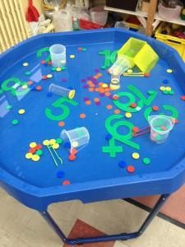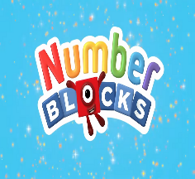  This Photo by Unknown Author is licensed under CC BY-SA  When counting, 1:1 correspondence (pointing to each object as they count) is a key skill, along with the knowledge that anything can be counted, for example, claps, steps and jumps.  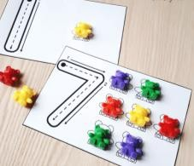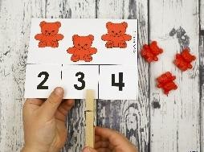  Children practise selecting the correct numeral to represent amounts to 10 before moving on.  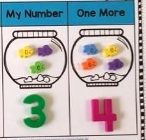  Finding 1 more  Once secure with counting, children count forwards to find 1 more. | Counting backwards  Children are introduced to the concept of counting backwards through child-initiated games such as singing counting songs and playing running races (“5,4,3,2,1,0 - GO!”).  Finding 1 less  Once this skill is secure, children learn to count backwards to find 1 less.  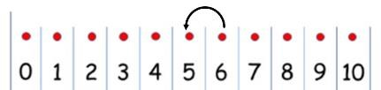  Children are introduced to the concept of ‘less’ by learning that subtracting means taking away a certain number of objects from a group (leaving them with less objects).  Taking away ones  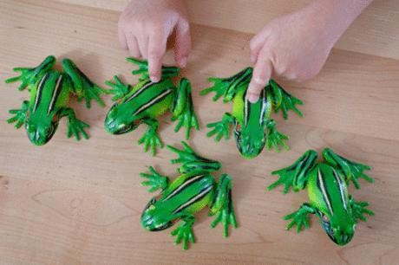  Children count a set of objects then take away  1 at a time. They then recount the set using  1:1 correspondence to find out how many are left. | Doubling  The concept of doubling is taught as adding two equal groups together.  Before doubling can be introduced, children need to have a secure knowledge of counting, number facts and addition.  Children use practical resources to add together 2 equal groups of objects.  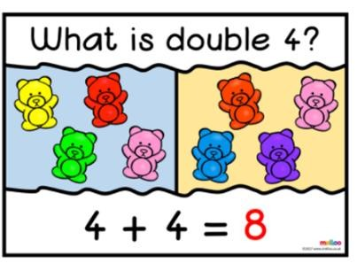  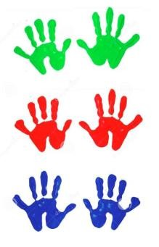  Children practise this skill using a range of practical resources and through games and activities. | Halving and sharing  Before halving and sharing can be introduced, children need to have a secure knowledge of counting backwards, number facts and subtraction.  Children should then be introduced to the concept of halving and sharing through practical games and activities.  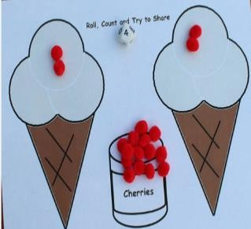  Children practise physically ‘halving and sharing’ through activities such as sharing food for their Teddy Bear’s Picnic, sharing resources equally to play a game.  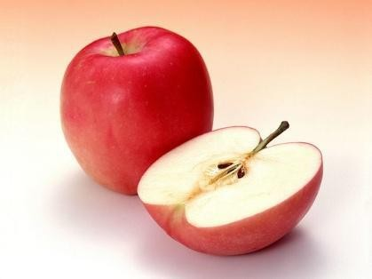
Find the total number of items in 2 groups by counting  Once counting is secure, children are introduced to the concept of ‘more’ by learning that adding two groups of objects together gives them a larger number (more objects).  Children use concrete apparatus to combine 2 groups by counting each object.  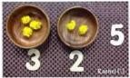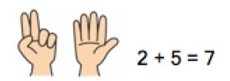  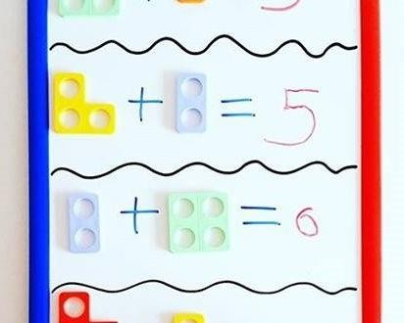  Children make a record in pictures, words or symbols of addition activities.    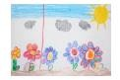 | Children use physical objects to demonstrate how something can be taken away.  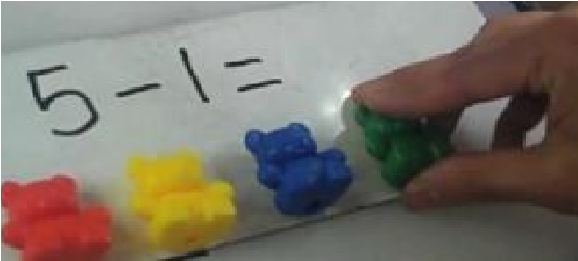  Once, understanding is secure, children move on to crossing out drawn representations.  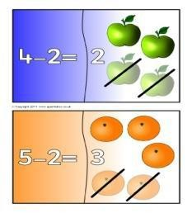  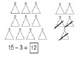 | 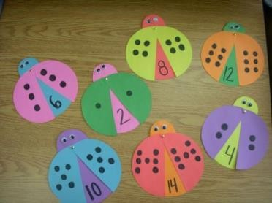  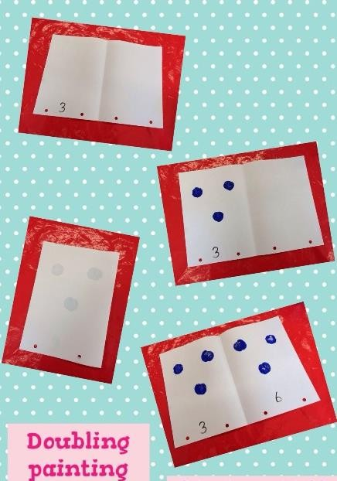  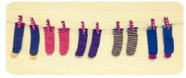  By the end of Reception, children are expected to understand the concept of doubling and to be able to double a number up to 10. | 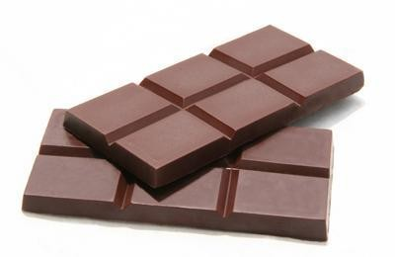  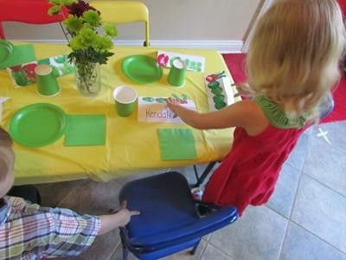  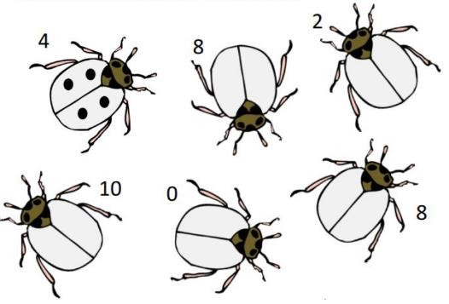  By the end of Reception, children are expected to understand the concept of halving and sharing.

Year 1
Addition | Subtraction | Multiplication | Division
Children use a variety of methods to combine 2 groups to find the total.  Part-part-whole  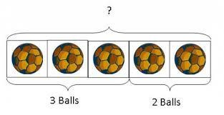  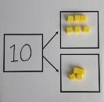  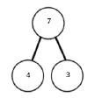  Children count one part and then the other part to find the whole.  Numberlines  Starting at the bigger number and count on in ones, some children may start drawing their own number line.    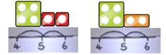  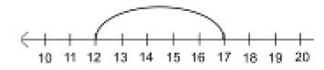  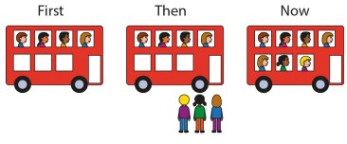  First there was 4, then we added 3 more, now there is 7.  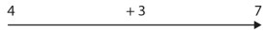 | Taking away ones  Children use physical objects, counters, cubes etc. to show how objects can be taken away.  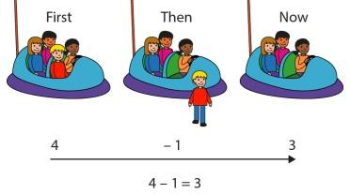  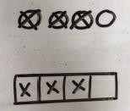  They can cross out drawn objects to show what has been taken away.  Counting back  Children start at the larger number and then count back in ones.  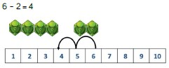  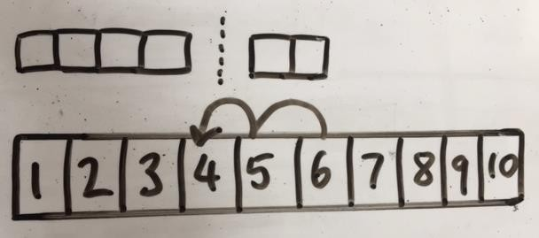 | Doubling  Children use a variety of resources to find double of a number.  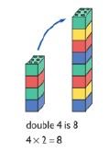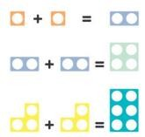  Children use their knowledge of double being an amount added twice.  Counting in multiples  Children count in multiples, supported by concrete objects in equal groups.  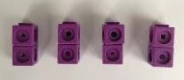  Count in multiples of a number aloud.  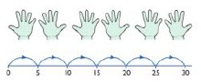  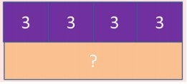 | Sharing using a range of objects  Children use a variety of practical resources to share ‘equally’ between a number of groups.  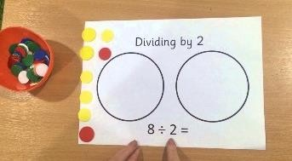  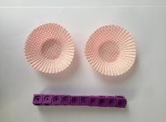  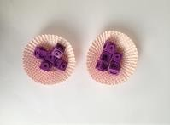  10 shared equally between 2 is 5.  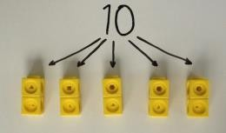  Children will start to use pictures and shapes to share quantities equally.  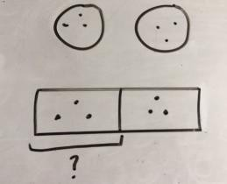  6 ÷ 2 = 3  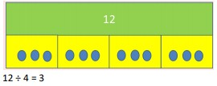
    8 |   1
Regrouping to make 10  Children start with the bigger number and use the smaller number to make 10. They then count how many are left over.  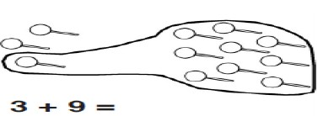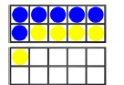  6  + 5 =  11  Children start to use partitioning to help them to make 10  5 has been partitioned into 1 and 4. The 1 is used to make 10 and then 4 is added to make 14.  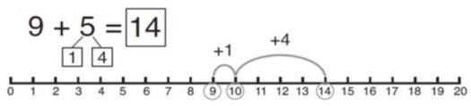  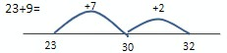  Using tens and ones  Children continue to develop understanding of partitioning and place value.  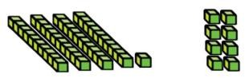  41 + 8 =  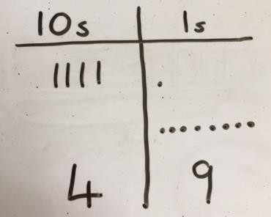  Children use lines to represent tens and dots to represent ones. | Making 10  14 – 5 =  Children can use number frames to help them.  They make 14 on the ten-frame. Then they take away the four first to make 10 and then takeaway one more so they have taken away 5. They are left with the answer 9.  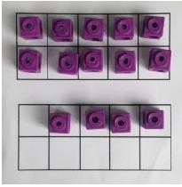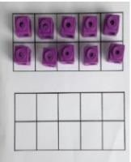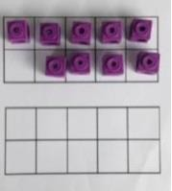  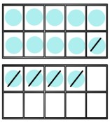  14 – 5 =  Children can draw the ten frames and cross out the circles as they take them away.  Count on to find the difference  Children start to use basic bar models with items to find the difference. Starting on the smaller number and counting on.  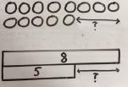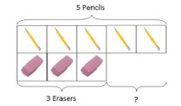  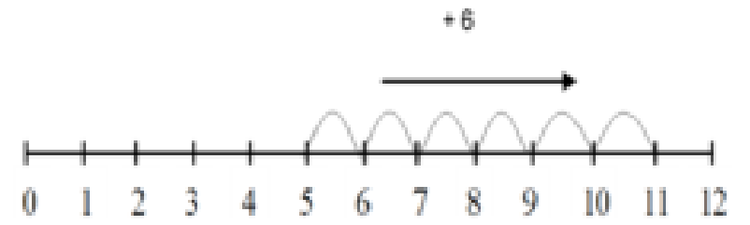  Children can draw bars to find the difference between 2.  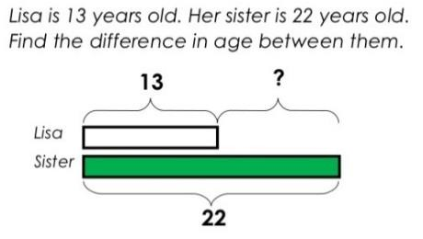 | Repeated addition  Children use practical resources to count in  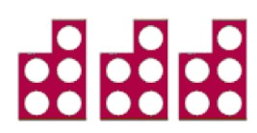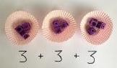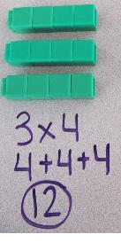  equal groups.  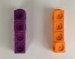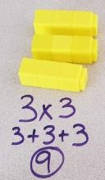  Children start to represent the practical resources in a picture and use a bar model.  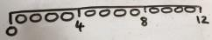  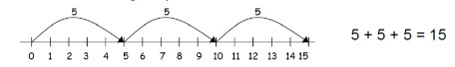  Once knowledge is secure, children start to write addition sentences to describe objects and pictures.  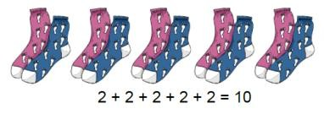  2 x 5 = 10 | Repeated subtraction and grouping  Children build on their subtraction skills to count in groups.  They use practical resources and ask ‘how many groups of 2 are in 6?’  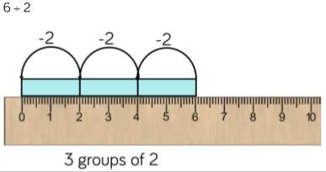  Children continue to develop this skill by using pictorial representations to help them to solve the calculation.  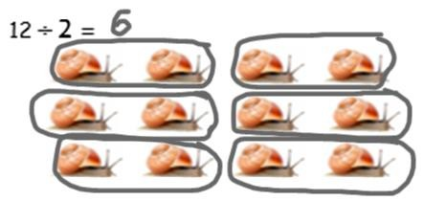  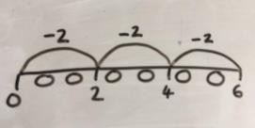  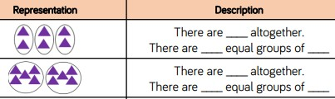

Year 2
Addition | Subtraction | Multiplication | Division
Adding 3 single digits  Children use their knowledge of number bonds to 10 and 20.  4 + 7 + 6 = 17  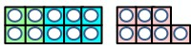  Children make 10 with 2 of the digits (if possible) then add on the third digit, e.g. put  4 and 6 together to make 10. Add on 7  Children then move from practical to  pictorial, and then to written representations.  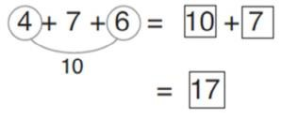  Adding a two digit number and ones Children continue to use their knowledge of number bonds to 10.  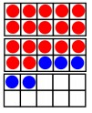  17 + 5 = 22  Use ten frames to make ‘magic’ ten.  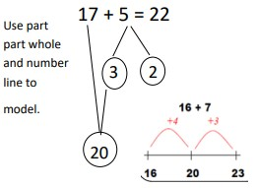 | Column method  Children use Base 10 to make the bigger number then take the smaller number away.  48 – 7 =  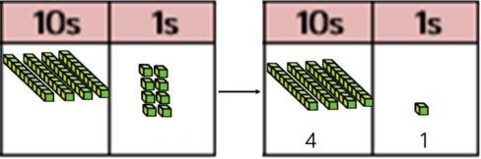  41 – 26 =  In this example, we cannot easily take 6 away from 1 so we exchange 1 ten for 10 ones.  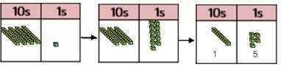  This partitions 41 into 30 and 11. Now we can take 6 away from the ones leaving us with 5.  We can now take 2 tens away from our 3 tens leaving us with 1 ten.  1 ten and 5 ones make 15 in total.  Once knowledge is secured using the practical resources, children move to a drawing pictorial representations of the Base 10 using sticks and dots. They cross out the number that they are taking away.  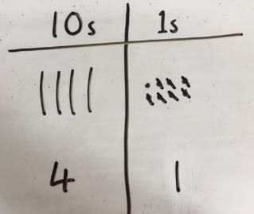  48 - 7 = 41 | Arrays- showing commutative multiplication  Children create arrays using practical resources to show multiplication sentences.  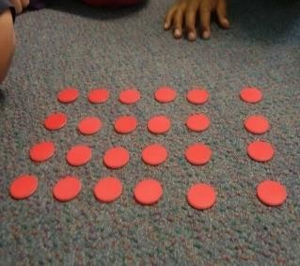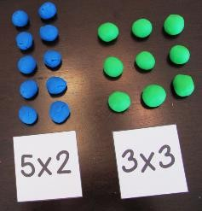  Children should understand that an array can represent different equations and that, as multiplication is commutative, the order of the multiplication does not affect the answer.  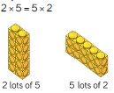  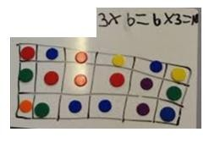 | Division as grouping  Children use practical resources to divide quantities into equal groups.  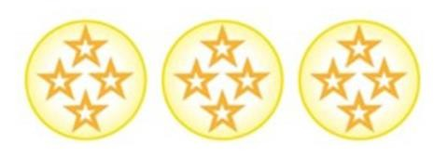  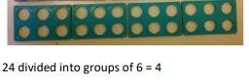  Number lines can be used. The number of jumps equals the number of groups  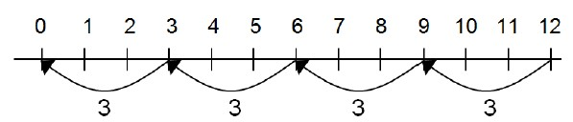  Bar models are another useful representation. Split the bar into the number of groups you are dividing by, then work out how many would be within each group.  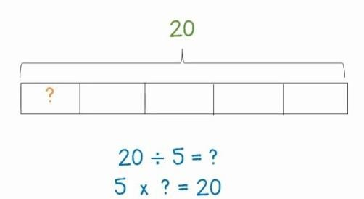

Using tens and ones (as in Year 1) Children continue to develop understanding of partitioning and place value.  41 + 8 =  Children to use lines to represent tens and dots to represent ones.  Using a column method  Children use base 10 blocks to represent the numbers. Adding the ones together and then adding the tens.  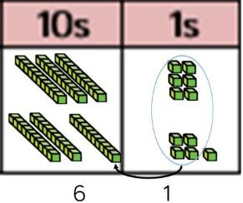  36 + 25 = 61  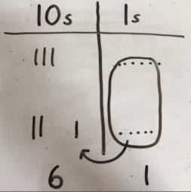  Pictorial representations using sticks for 10s and dots for 1s.  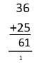  Once knowledge is secure, children move on to a formal written method. | 41 – 26 =  Children exchange 1 ten for 10 ones so that they can take 6 away more easily.  Then they take away the 2 tens to leave them with 15.  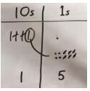  Once knowledge is secure, a formal written method is used.  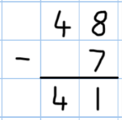  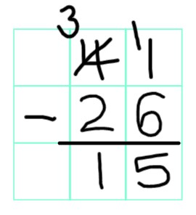 | Once knowledge is secure, children begin to draw pictorial representations of arrays to solve multiplication sentences.  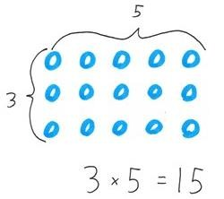  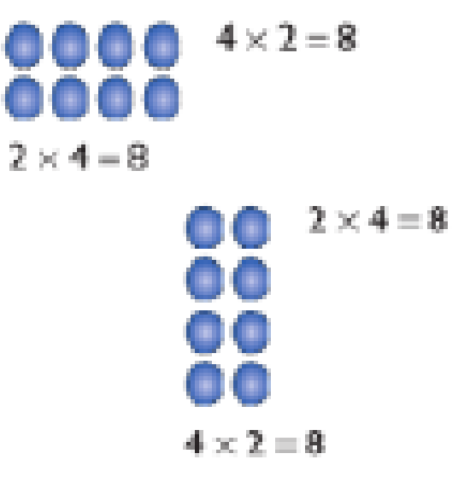  Children use an array to write multiplication sentences and reinforce repeated addition.  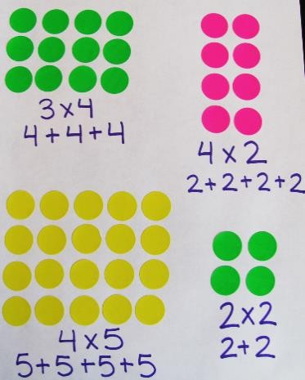 | Division within arrays  Link division to multiplication by creating an array and thinking about the number sentences that can be created.  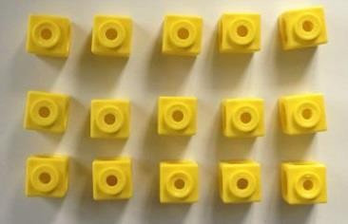  Eg 15 ÷ 3 = 5 5 x 3 = 15  15 ÷ 5 = 3 3 x 5 = 15

