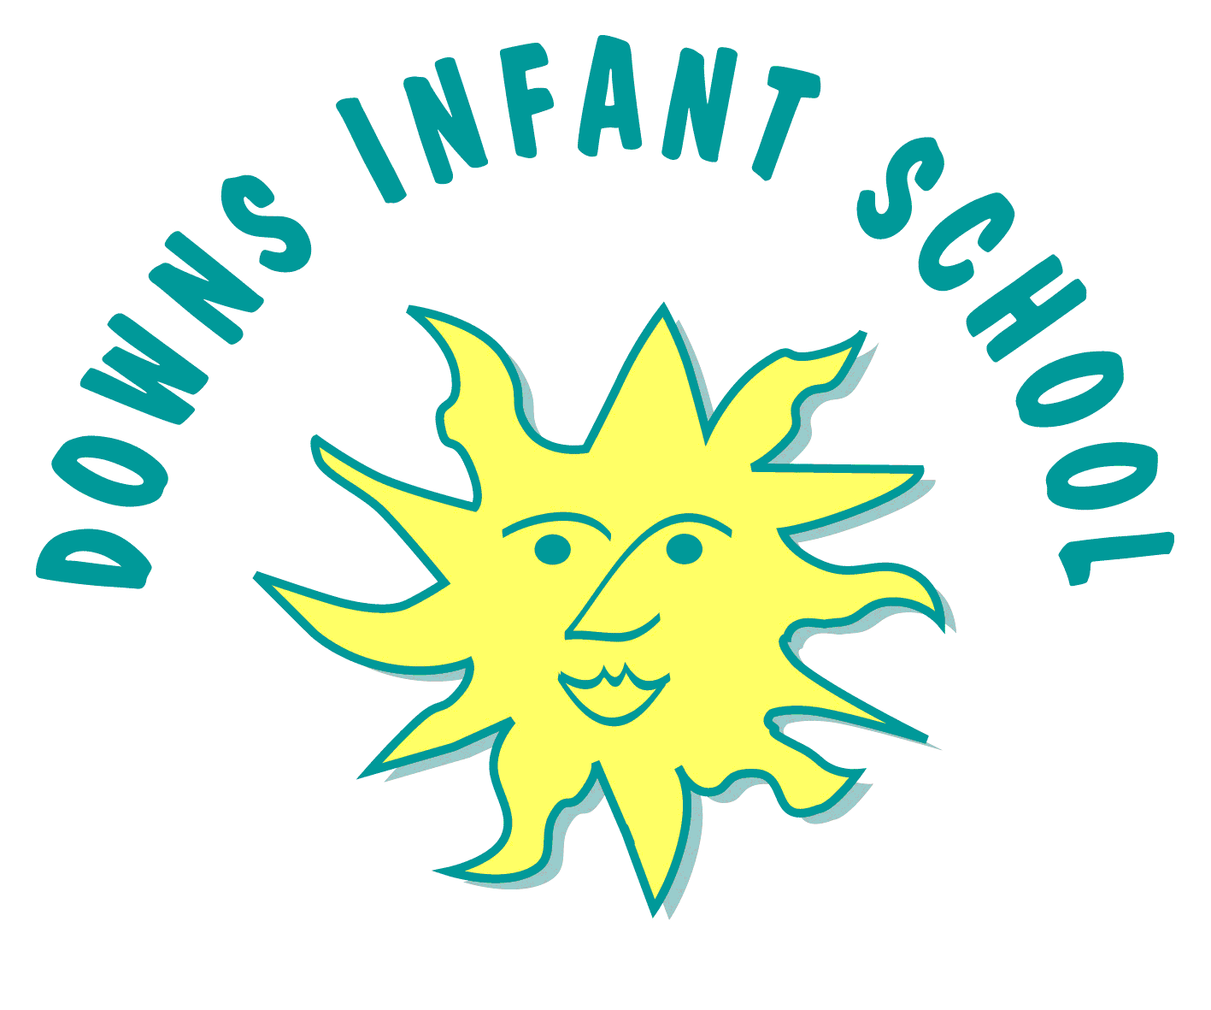
Downs Infants PSHE Curriculum Statement
‘A little consideration, a little thought for others, makes all the difference’ – Eeyore, Winnie-The-Pooh
Intent | Implementation | Impact
What will take place before teaching in the classroom? | What will this look like in the classroom? | How will this be measured and what will be the outcomes?
Downs Infant School is warm, open and nurturing. From the greeting our children receive on arrival to school each day, to the way adults model making mistakes, we strive to make every child feel special. We have a strong sense of community which is inclusive of all and we teach our children to be kind and the value of love. This is in line with our school values of ambition, belonging, creativity, diversity, empathy and flexibility. We are creative and innovative in our approach to education and we champion an inquisitive and curious approach to our learning. We deeply value play as an integral part of our children’s ongoing learning with both achievements and effort, celebrated and rewarded.  At Downs Infant School, we believe that PSHE education is fundamental and encompasses many areas. It impacts every aspect of our children’s learning and development and is a vital part of their preparation for life. To reflect this, it has been given a higher status of ‘core subject’.  We believe that it is integral to our children to provide PSHE learning that is age appropriate and rich in problem-solving knowledge, skills and strategies to help our children learn well and have a healthy, happy and fulfilling life.  In PSHE, we learn how taking care of ourselves and each other is part of looking after the world and nature, which helps us feel good and connected to the environment around us. PSHE has a huge part to play in with our environmental school project ‘Our City, Our World’. PSHE helps our children understand the importance of their wellbeing, social responsibility and how their actions impact the world around them.  We provide many opportunities for children to have significant amounts of time for continuous provision and as a result we are able to apply and develop their skills in real and meaningful situations. Learning to tidy away large blocks with a group of children can present some wonderful opportunities for PSHE skills to develop.  Our PSHE curriculum supports our infant school behaviour ethos, encouraging mutual respect, inclusivity, responsibility and an enhanced self-esteem in a happy and caring environment. It also makes a significant contribution to safeguarding, helping us fulfil our statutory duty to teach our children to keep themselves healthy and safe. The PSHE curriculum develops our children’s learning and confidence in school and also helps them to feel confident and safe in the wider community, allowing them to develop their independence.  Unlike, a number of other subjects, the specific knowledge taught in PSHE education changes regularly due to legal changes, medical or technological updates. At Downs Infant School, we continue to ensure that any aspect of PSHE education is accurate, up to date, unbiased and balanced. Our PSHE lead meets each term with the Brighton and Hove PSHE network of teachers and PSHE leads. We have parent / carer consultations, focus groups and workshops as well regular discussions with our delegated school council members regarding ongoing or developing PSHE education to help us prioritise the quality of our PSHE learning and ensure that it is reflecting the needs of all of our children in our school, including children with SEND. We believe that this approach helps us to ensure that our PSHE curriculum is adapted and responsive to the school community as a whole. | At Downs Infant School, our PSHE curriculum challenges our children’s thinking, assumptions and stereotypes within a safe environment. It follows three core themes developed from the PSHE Association’s ‘Programme of Study’ as promoted by Department of Education and Brighton and Hove’s PSHE leads. (The Department of Education provided grant funding to the PSHE Association to advise schools in developing their PSHE curriculums and improve the quality of teaching.)  - Health and wellbeing.  - Relationships.  - Living in the wider world.  Learning from one area may be related and applicable to others so there is often an overlap between the three themes. To complement our Green Curriculum, PSHE is considered through a ‘green lens’. When planning and teaching PSHE, we consider the wider impact PSHE learning and skills developed have on the world. We also incorporate aspects of SEAL (Social and Emotional Aspects of Learning) within our PSHE curriculum. Our PSHE curriculum follows the Early Years Statutory Framework for the Early years Foundation Stage and focuses on the Prime Area of Personal, Social and Emotional Development.  Brighton and Hove schools’ PSHE leads provide excellent teaching and learning resources adapted from the PSHE Association’s Programme of Study. Our teachers make good use of the resources to present information clearly and in an engaging way.  Our areas of learning within the themes include: New Beginnings - Citizenship, Getting on and falling out, Good to be me and Growing an anti-racist school, Equality, Inclusion and Diversity, Gender stereotypes, Feeling Good Feeling Safe, Relationship and Health Education (RHE), part of RSHE, Mental Health and Wellbeing, Keeping Healthy and Safe, Changes.  Our PSHE curriculum also includes opportunities to link British Values, RE or our school’s values together. For example, we promote the practice of democracy in our school environment through the development of our school council.  We ensure that we cover all statutory aspects of PSHE and follow the statutory guidance for ‘Relationships Education, Relationships and Sex Education and Health Education’ through the PSHE Association Programme of Study (used by Brighton and Hove PSHE leads).  At Downs Infant School, the children’s knowledge, skills and attributes are developed and previous years learning is revisited, reinforced and enhanced each year. We also encourage the development of speaking and listening skills in our children through our curriculum. We believe that quality over quantity is essential with PSHE learning and ensure that our learning is creative and extended through continuous provision rather than simply a number of sessions within the classroom. This allows our children to apply their skills in a real and meaningful context. Teachers have flexibility to adapt teacher directed sessions as necessary as they are best placed to understand the needs of their children and consider sensitive safeguarding issues, for example, adoption.  At Downs Infant School, we believe that our learning environment is essential to our pupils’ social and emotional development. At the beginning of a new school year, each class develops a ‘Learning Zones’ area with a visual display to help the children visually recognise their emotions and those of others. The display is created through discussion with the children and is designed to help them manage and respond to those feelings and situations so that they can engage in behaviour which promotes safety and learning.  Age-appropriate knowledge is learned with cross curriculum links (for example, age-appropriate knowledge that is learned about the body, builds on previous learning and links to the Science curriculum. Economic Wellbeing is discussed within areas of money management in Maths and also Gender and Careers.)  Our PSHE curriculum overview has been mapped out to take into account the age of children at each point. For example, RHE and FGFS is taught later in the school year to allow for growth in emotional maturity over the year and as such, readiness to learn. | Our PSHE curriculum is reflected in having happy and confident children transitioning into their next year. Our children will be able to show the development of their PSHE skills. For example, being healthy - our children will be aware of their bodies and how to keep them healthy; positive relationships - how to regulate their own behaviour, get along with others and make new friends within school and the wider community. Our children will develop an understanding of other cultures and become citizens of the world.  By teaching about empathy, and respect for nature, PSHE encourages children to develop eco – conscious behaviours, make thoughtful choices, and take an active role in protecting the planet, which aligns with the goals of our Green Curriculum.  As a result of direct teaching and extended continuous provision, our children will be very quickly able to demonstrate building relationships and positive behaviours and attitudes. Our play based approach will allow children to develop skills such as turn taking, sharing and self-regulating independently and practise their skills. Teachers and TAs work and play alongside children to see what is important to them and how they apply what they have learned.  We show the impact of the children’s learning in their play and observations which we record on ‘Tapestry’, our learning journal.  As they move through the school and with the very best PSHE teaching, we will see children taking ownership of their own learning.  There is a consistency of resources and displays as well as language quality texts that promote PSHE and literacy across the classes.  By the time they reach year 2, children will be able to reflect on the development of their skills, for example with self-regulation - calming themselves down by using breathing techniques that they have learnt previously.  Teachers are able to adapt their learning to meet the needs of their own class. Year group teams work collaboratively to support each other and the needs of the cohort.  As a whole school, we have a rolling programme of subject evaluation and development.  As a result of participating in LA training, teachers have solid subject knowledge of PSHE and are therefore able to modify the curriculum.  Where practice is particularly good, we see support staff modelling, teaching and adapting PSHE according to the needs of the children.  RHE (RSHE) is be assessed in the summer terms using teacher judgements from observations in class and continuous provision and by talking to the children (pupil voice). The children will understand the physical aspects involved in RHE at an age appropriate level.  RHE (RSHE) workshop is included on the school website. Because of the strong impact that our PSHE curriculum has, our children are well prepared for the transition to Junior school.

