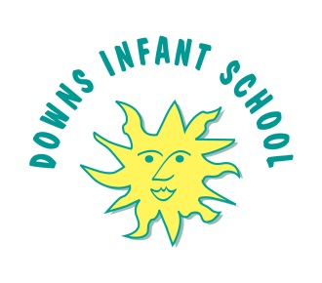
D Downs Infant School Parental Agreement
for School to Administer Medicine

Our school has a policy that staff can only administer medicine with parental consent.

Downs Infant School will only accept prescribed medicines, with written permission from parent/carer that are in-date, labelled, provided in the original container as dispensed by a pharmacist and include instructions for administration, dosage and storage.

Date for Review/End of Course of medicine
Name of Child
Date of Birth
Class
Medical Condition or Illness

Medicine
Name/Type of Medicine
(as described on the container)

Medicine Expiry Date
Dosage/Method/Timing
Time Medicine last administered by parent
Special Precautions / Other Instructions
Any relevant side effects that the school needs to know about?
Procedures to take in an emergency

The above information is, to the best of my knowledge, accurate at the time of writing and I give my consent to school staff administering medicine in accordance with the school policy. I will inform the school immediately, in writing, if there is any change in dosage or frequency of the medication or if the medication is stopped.

Signature:________________________________ Date:__________________

