Geography roundup- Autumn 2 2025
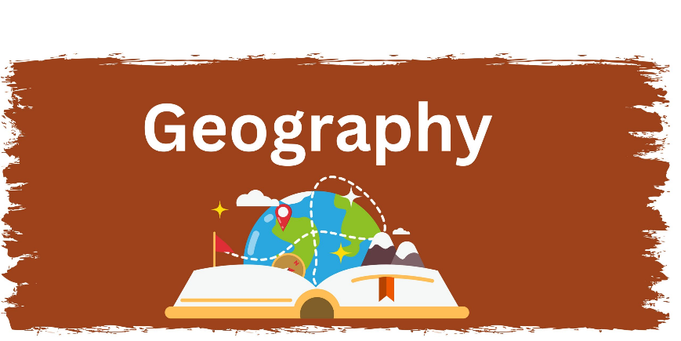
In Year 2, children have been learning about the United Kingdom and its four countries. During C.O.O.L time (Choose Our Own Learning), children explored each country through themed suitcases, which helped to bring their learning to life.
Children used Google Earth, globes, and maps to locate the four countries within the United Kingdom. Through play projects, they drew, made, built, and wrote about what they had learned, including the human and physical features of each country and their flags.
Pupil voice
‘England is bigger than other countries, London is the capital city’
‘A compass has North, South, Earth and West on it. It tells you what direction to go in’

In Year 1, children have been learning about Africa. They have learned that Africa is a continent made up of 54 countries. The children have compared Africa with the United Kingdom, looking at similarities and differences.
As part of their geography learning, the children have compared the climate in Africa with the climate in the United Kingdom. They have also used globes and maps to help them locate Africa and the UK and to develop their understanding of the world.
Pupil voice
Kenya is dry, they don’t get much rain’
‘England, we get more cloudy’
‘Kenya doesn’t have roads and tall buildings’
‘That looks like London, I can see the River Thames’
‘That looks like London, I can see a clock tower’
‘I think it is Scotland, I can see Loch Ness’.

In Reception, children have wonderful opportunities to explore geography in their C.O.O.L time (choose our own learning). Maps are displayed around the classroom to spark curiosity, and teachers engage children in daily discussions about the weather and changing seasons. They also enjoy talking about where they live, learning the names of different countries, and discovering which animals can be found in different parts of the world.

Pupil voice
‘Australia is hot and sunny’
‘London is far away, I live in England, I live here at the bottom’
‘Me and my mum went to the North Pole’
‘I’ve seen snow, two times in North America’.

