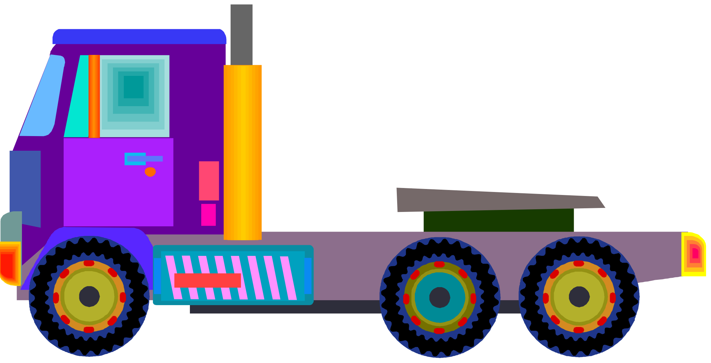
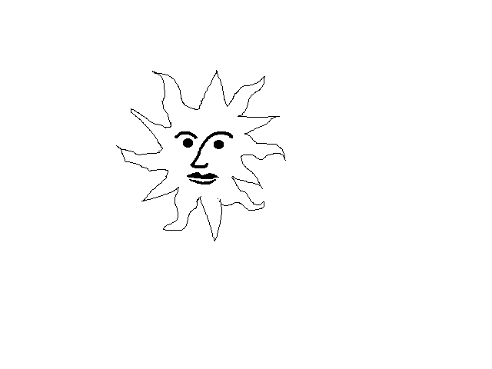
Understanding the world Helen
-Explore the natural world around them and describe what they see hear and feel
-Understand the effect of changing seasons (Winter)
-To learn about maps and draw information from them
-To learn about different types of beliefs including how Chinese New Year is celebrated. (Wednesday Jan 29th)
- Talk about images from the past
Physical development:
- Revise and refine the fundamental movement skills they have already acquired in Real Gym, Cool times and Physical Friday: • rolling • crawling • walking • jumping • running • hopping • skipping • climbing
- In Real gym learn how to develop and apply shapes on the floor and on apparatus
- Develop their small motor skills so that they can use a range of tools competently, safely and confidently, eg scissors, brushes
- To use a pencil and hold it effectively
- To begin to form recognisable letters

DOWNS INFANT SCHOOL
Expressive arts and design
-To learn to sing a range of songs and to play along with different instruments.
-To explore mark making using a variety of tools and techniques.
-To learn to create observational drawings using a range of media.
-To use imagination in role- play areas and with ‘small world’ and construction.
-To express feelings and ideas through creative activities and share their creations

Key Learning for the topic:
We are going on a journey!
Reception 2026

Spring Term (first half)

Our Value this half term is:
Creativity

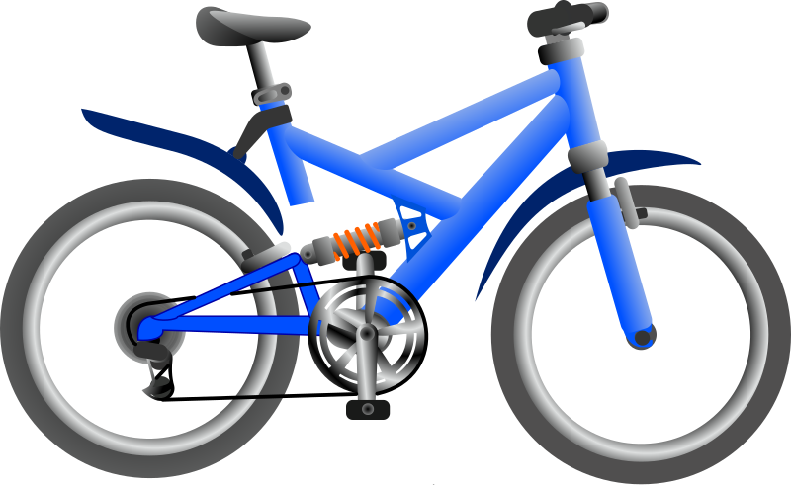
Mathematics
- To understand the purpose of counting and that the last number in the count tells us how many things there are all together (cardinality)
- To order numbers and learn about ordinality
- To compare numbers
- To explore the composition of numbers and learn that a 'whole' is made up of smaller parts
- To explore ways to represent numbers using the Hungarian number pattern
- To explore numbers that are composed of '5 and a bit'
- To compare quantities and use the language of 'more than', 'fewer than' and 'an equal number'
- To practice counting beyond 20

Communication, language and literacy:
- Say the sounds that all single letters represent.
- To learn some digraphs – these are 2 letters that make 1 sound e.g. sh, ch, ai
-Hear and say sounds at the beginning, middle and end of words.
-To know what a question is, ask questions and find out the answers.
To understand that listening is as important as talking.
-Write for a variety of purposes; posters for the transport role-play, messages, labels, booking forms, tickets etc.
-To write letters applying taught formation.
- To read a range of familiar and common words and simple sentences independently.
- To show an understanding of story structures e.g. Opening, build up, problem, resolution and ending. To tell stories with expression considering setting and characters,
To represent a story in a variety of ways including reading and transcribing story maps and through drama.
- To find out information from non-fiction books.

Key Texts
We’re Going on a Bear Hunt, Michael Rosen
Bear’s Dream - Janet-Slingsby
The Naughty Bus Jan-Oke
Various non-fiction books about vehicles

This outlines the curriculum coverage intended for the half term. Due to the way the curriculum is mapped out over the year there may be specific subjects that are not focused upon in a particular topic. This topic guide may be amended at times to reflect changing needs and circumstances, to enable flexibility in capitalising upon the educational potential of unforeseen special events, children’s’ interests and ‘one offs’.
Personal, social and emotional:

- To build relationships
- To express feelings and consider the feelings of others.
- To have a developing respect for the cultures and beliefs of others.
- To understand that people have different needs, views and feelings that need to be treated with respect.
- To work as part of a group, taking turns and understanding agreed codes of behaviour.
- To learn about healthy bodies and minds.

