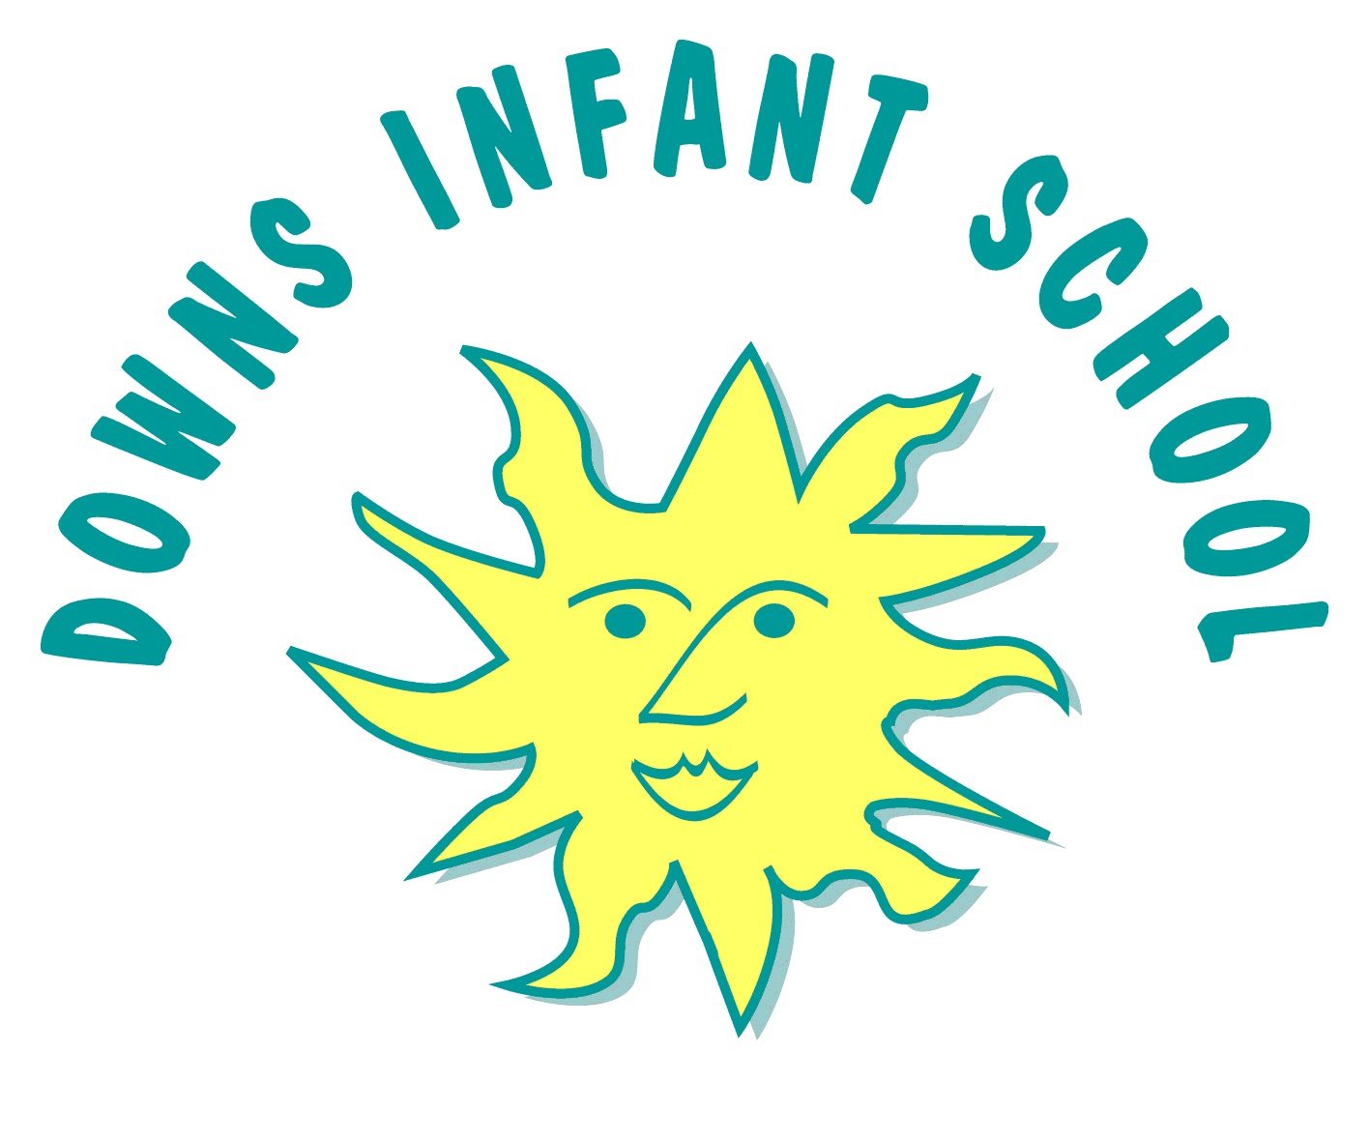
Downs Infants Curriculum Statement RE
“People of different religions and cultures live side-by-side in almost every part of the world, and most of us have overlapping identities which unite us in very different groups. We can love what we are, without hating what- and who we are not. We can thrive in our own tradition, even as we learn from others, and come to respect their teachings” — Kofi Annan
Intent | Implementation | Impact
What will take place before teaching in the classroom? | What will this look like in the classroom? | How will this be measured?
Here at Downs Infant School our teaching of Religious Education is based on the 2018 Brighton and Hove Agreed Syllabus for Religious Education alongside the National Curriculum and EYFS requirements. It forms part of a broad and balanced curriculum that is inclusive to all children. It is our intent that the RE curriculum will equip children with understanding of our increasingly diverse world, giving them the knowledge to make sense of what is happening, why people choose to live their lives in different ways and what different groups of people believe. It should enable the children to have the knowledge, understanding and skills necessary to hold balanced and informed conversations about religions and world views.  We use RE to encourage our children to develop an appreciation of the world in which they live and to reflect upon their responsibility towards it. This is part of our wider Our City Our World project, in association with Brighton and Hove Council and other schools across the city.  We aim to enable our children to have a greater understanding of the beliefs of other people. We believe that this will help make them better world citizens with an appreciation of differences. In teaching RE we help our children to understand how following a religion or set of beliefs can help some people to lead better lives and to become better people.  Religious Education is taught throughout the school in such a way as to reflect the overall aims, values, and philosophy of the school. At Downs Infant School Religious Education plays an important role, along with all other curriculum areas, particularly PSHE in promoting the spiritual, moral, social, and cultural development of our children. | RE is a core subject of the curriculum for all pupils. We teach 36 hours of RE across the year in each year group, including Reception. This allows us to meet all of the aims and expected standards from both the National Curriculum and the Brighton and Hove Agreed Syllabus.  RE teaching is focused on Christianity and Judaism, as required by the Agreed Syllabus, but we have made sure to give children opportunities to learn about other world religions where relevant, as we believe that this reflects the diverse nature of our school more appropriately. RE is taught on a thematic basis at Downs Infant School, with a different ‘theme’ being focused on each half term. These are:  1. Religions and Rituals  2. Gifts and Giving  3. Beginnings and Endings  4. Caring for Others  5. Friendship  6. Belonging  These themes are woven into the learning across the year, and allow us the flexibility to teach topics at relevant times, in line with annual celebrations and significant religious events. Children will be given in-depth understanding of what religious people do, why they do it and how the moral principles from different religions may be used to guide their own decisions. Each module of RE is also accompanied by a ‘Philosophy Question’, which will allow them to deepen their understanding of what has been taught each term, and apply this to their own lives.  At Downs Infant School we also involve families in learning about and celebrating different faiths and beliefs, making home/school links.  School assemblies throughout the year further equip children to explore and understand faiths and beliefs and to reflect on learning, asking thoughtful questions and making connections. | RE assessment is ongoing to inform teachers with their planning, lesson activities and differentiation.  In all year groups assessment is recorded through observations via Tapestry.  Teachers are able to assess children’s understanding of various topics through the discussions that are central to all teaching of RE at Downs Infant School. Children’s ability to talk about what they are learning is a key part of the teaching of RE.  Summative assessment at the end of each unit is reviewed to ensure it effectively informs teachers of the knowledge or skills that still need to be embedded and to ensure progression.  RE is monitored by the subject leader throughout all year groups using a variety of strategies such as learning walks and pupil interviews.

