Downs Infants Curriculum Statement
Science
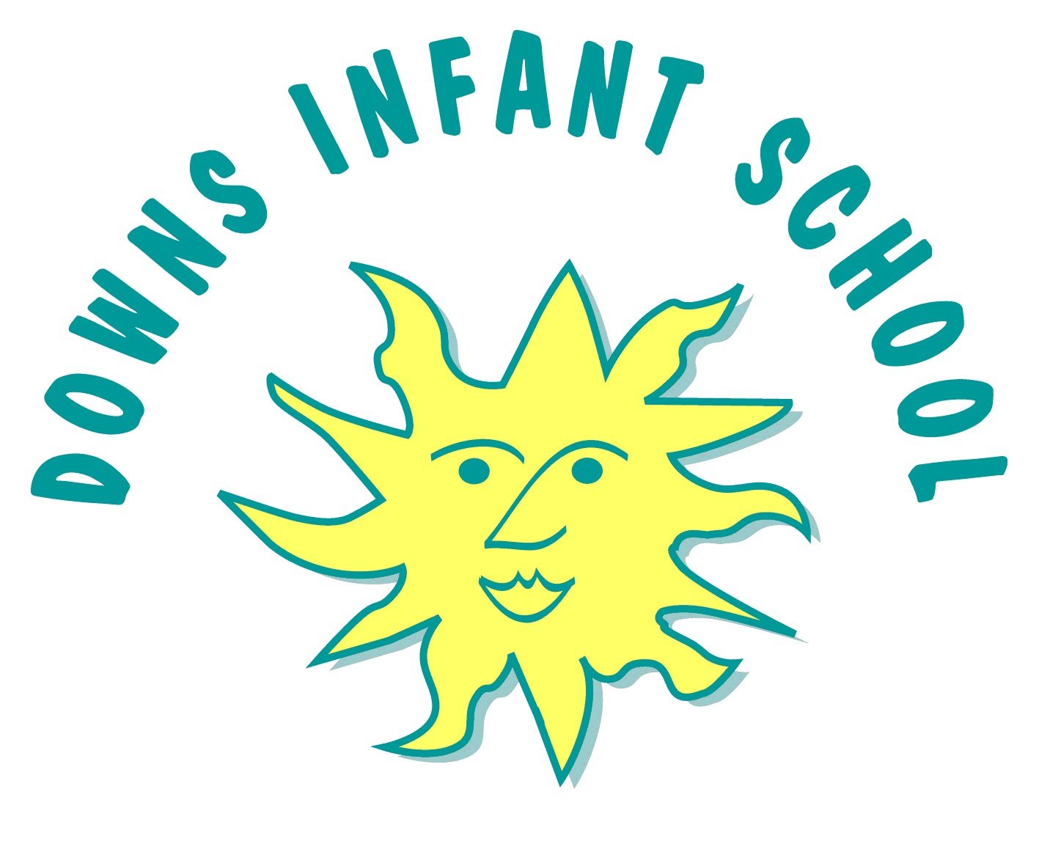
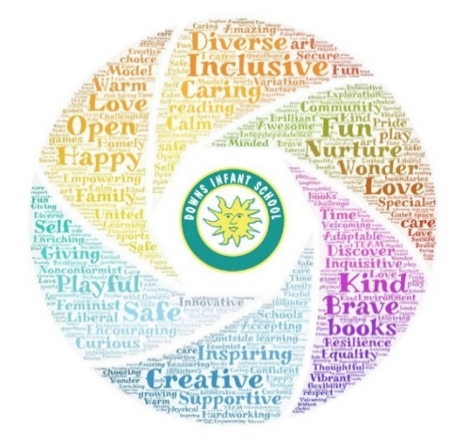

“The important thing is to never stop questioning” Albert Einstein
Intent | Implementation | Impact
What will take place before teaching in the classroom? | What will this look like in the classroom? | How will this be measured?
At Downs Infant School, we aim to provide a broad and balanced curriculum and to fulfil the requirements of the National Curriculum and the EYFS, which is inclusive to all children. This is in line with our school values of ambition, belonging, creativity, diversity, empathy and flexibility.  We aim to provide an education that is rich in knowledge that allows pupils the opportunity to apply skills, revisiting prior learning in continuous provision with an enquiry based approach.  We link science to pupils topic work, as much as is possible so that the learning has meaning and is relevant. Our aim is to develop how children work scientifically and confidently alongside the content we teach, giving them opportunities for enquiry when they arise and encouraging pupils to use scientific language appropriately.  Pupils learning will be through coherent planning and will be both cross-curricular and direct when specific content needs to be taught. Thus giving their learning a purpose and context. Creativity is widely encouraged to give learning purpose and inspiration. Learning is child centred. We aim to give the children a desire to learn and an experience of ownership over their learning and challenges.  Downs Infants is part of the Our City Our World project, which enables us to address scientific areas of interest throughout the teaching of many subjects, as we inspire pupils to see the natural world with awe and wonder, to recognise the impact we can have as a society and the possible changes we can make to support the health of our planet and all life on earth. With the greening of our curriculum we teach pupils key vocabulary to support climate literacy and the transition to Downs Juniors, who are also a part of the project.  We want to ensure an education that develops the whole child. We encourage a hands on approach to learning supported by research on the internet and a range of children’s books and literature to enhance our science teaching. In our daily school life, we look for opportunities to discuss scientific developments in many aspects of life.  We believe the curriculum should include experiences of our cultural, artistic and social heritage, and encourage pupils to contribute to this. In science, this includes being introduced to key scientific figures who challenge stereotypes of scientists. | Curriculum Design  We implement a curriculum that is progressive throughout the school. In Reception it is based upon the Foundation Stage Curriculum and Development Matters. Science in Reception is explored through the strand of ‘Understanding the World’– The World’ and ‘Physical Development – Health and Self-care’. In Key Stage 1 our Science curriculum is based on the 2014 Primary National Curriculum in England.  We aim to provide a variety of diverse hands-on experiences and activities to enrich pupils learning. Progression documents and medium term plans inform teachers of the overview of the subject and where there are cross-curricular links. In Year 1, ‘seasonal changes’ is often an on-going interactive display in the classroom.  The teaching of Science follows a cross curricular approach and evidence of this can be seen in areas such as English (e.g. Year 1- class animal and classification and Year 2 History – materials)  Enrichment and Wider Community  We encourage exploring local areas, and pupils in Year 1 have a trip linked to science each term. E.g. Autumn – local area walk, season focus, Spring – Trip to the Earth ship, materials and plants focus, Summer – Beach trip and Rampion Wind farm, materials and animals focus.  We use trips where appropriate to enhance and support learning within the school. E.g. We visit Pulborough Brooks in year 2 as part of our bee topic. Other trips include Preston Park and Blaker’s Park, the farm and the use of our own Apple Alley.  We have outdoor areas (the garden, the woodland and the tree tops) which are used daily to give opportunities for scientific investigations of the natural world.  This year we are developing the learning lodge on the woodland to create a science hub, this will support the OCOW project throughout the school and provide a place to explore and investigate plants, materials, micro habitats and living things further. Giving the opportunity to develop outdoor learning and scientific exploration.  We encourage inviting people in to school (from the local community and parents) to share real-life experiences with the children. e.g. in Reception, we have invited parents in to share their knowledge about links with transport to extend children’s experiences of the world.  These opportunities further help to make science meaningful and ‘real’.  Learning walks provide an opportunity to look at science within classrooms and the outdoor environments. These provide an opportunity to review and prioritise different areas. This can raise where support is needed and actioned, either in PDM, year group focus sessions. | In Reception the areas of learning most relevant when measuring the impact of our teaching is ‘Understanding the World’. In Reception children have a baseline assessment and then they are assessed using Development Matters statements before being assessed as to whether or not they have achieved the Early Learning Goals in June. In the EYFS assessment is recorded through observations in children’s online learning journals via tapestry.  In KS1 children are assessed against the National Curriculum. Teacher judgements are made from observations in class and by talking to the children (pupil voice). This includes asking review questions at the end of lesson and asking open-ended questions. In the treetops, a child in year 2 stated that they had built a habitat, which protected their animal from a predator. Another child then pretended to be circling the burrow and was a predator. When topics are re-visited, it is an opportunity to embed and reuse their knowledge and skills from previous learning. Progress made by individuals is made by assessing work against the learning objectives and children are also encouraged to self-assess.  Due to the nature of our curriculum, children have the opportunity to continue scientific enquiry and investigation and to deepen their interests and understanding during Cool time.  As a whole school, we are organised into subject teams with representation from each year group. This allows us to consider and review our sequence of learning. We work on a rolling programme where we have a half termly focus for evaluation and development. This is when we have opportunities to observe teaching, speak with children about their learning, immerse ourselves in our subject area and support wherever necessary across the whole school giving us a complete and honest picture.  The science learning hub will develop into a space for rich exploration into scientific learning, where inquiring minds can take time to follow their interests and the subject further.  The development of the OCOW project at our school will enable the school community to come together with a shared approach to caring for our world. The impact will reach beyond the classroom and our outdoor learning spaces, into homes. Creating a ripple effect of change makers and positive choices for living and working together that not only support, but improve our natural world.

