Our Designated Safeguarding Lead is Mr Phil Jones. In his absence, please speak to Mrs Walker.

Mr Phil Jones 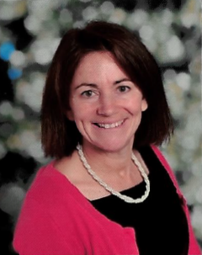 Mrs Lisa Walker
PhilipJones@downsinf.brighton-hove.sch.uk LisaWalker@downsinf.brighton-hove.sch.uk

