Downs Infant School – SEND in a Nutshell 23-24
Number on roll: 347  Number of SEN: 46 –13.26%  Number of EHCPs: 19 – 5.48%  Area of Need Number % of all % of SEN  Cognition and Learning 5 1.44% 10.87%  Communication and Interaction 19 5.48% 41.3%  Social, Emotional and Mental Health 18 5.19% 39.13%  Sensory and/or Physical 4 1.15% 8.7%  Key Strengths of SEND - Improvements and training  - Introduction and development of the ‘Hive’ provision  - Implementation of Continuous Provision approach  - Regular classroom drop ins and observations with a focus upon SEND children  - SEN review meetings – termly with SENCo/INCo and class teachers  - SEND feedback to Governors – Tony Fallowfeild – Quality of Education Group  - Curriculum design clear in its intention on support for all children – support gained from Special School Outreach services in order to differentiate planning appropriately (Next Steps Framework introduced Aut 23)  - Introduction and development of Talk4Writing  - Multi-disciplinary meetings used as a format for professional discussion and possible interventions/provision  - BHISS training utilised for key staff and whole staff PDMs  - Bespoke training given to SEND TAs, including Speech & Lang. and BHISS Autism and Language troubleshooting sessions  - National College training material shared with staff – utilised on strike days for groups and throughout year for specific staff/needs  - Parent workshops held on behaviour, anxiety and Just Right  - IEP training and refinement with teaching staff  - All leaders are collaborative in their approach to leading SEND  - Timely and thorough responses to parental enquiries – strong relationships built between families and school – parental workshops and coffee mornings  - MAYBO de-escalation and safer holding training for support staff  - Real PE with differentiated video demonstrations for physical disabilities  - Key teachers attending TouchBase Attachment awareness training | High Quality Teaching for All  Cognition and Learning Communication and Interaction  - Streamed phonics groups - Multi-sensory phonics - 1:1 ‘see and learn’ - Every Child Counts training - Reading Army - Better Reading Partnership - Seaside View referrals - BHISS referrals - Literacy Support Service - WESFORD screenings - Raven’s progressive matrices - PhAB assessment - Talk Boost - School start - 1:1 NHS SALT interventions - The Hive - Nurture group - Talking partners - Seaside View referrals - Speech Link assessments and interventions - Private Speech and Lang. input - Play-based learning - Lunch time clubs  Social, Emotional and Mental Health Sensory and/or Physical  - The Hive - Just Right - Emotion Coaching - Nurture groups - Play therapist - Trainee Play therapists x2 - BHISS referrals - CAMHS referrals - Playground Buddies - Music volunteers - Play-based learning - SMHS links and referrals - Boxall Profiles - Strengths and Difficulties Questionnaires - Sensory circuits - Movement breaks - The Hive - Write Dance - Sensory room - Zen Dens - Physical Friday - Sensory questionnaires - Seaside View referrals - Physio interventions - Private OT input - NHS OT referrals - Sensory tools for individuals

Absence  Attendance  7 July 2023 SCHOOL 28 April 2023 SCHOOL (last report) 9 June 2023 LA (latest) May 2023 National (latest data available) 8 July 2022 SCHOOL  Over all 93.8% 93.3% 90.2% (Primary 95%) 91.1% 94.2%  PP 88.2% 87% 91%  EAL 89% 88% 91%  PA 82.7% (54) 81.7% (62) 84.8% (49)  SEN 92.5% 92.1% 93.3%  Fixed Term Exclusions (up to 5 days): 4  Permanent Exclusions: 0  % of SEN exclusions: 100% (all SEMH as primary area of need)  BAP: 3  % of SEN BAP: 100%  Reduced Timetables: 2 x 4y/o & 3 x Stat. School Aged  % of SEN Reduced Timetables: 100%  Outcomes (22-23)  YR SEN Sup. YR EHCP Y1 SEN Sup. Y1 EHCP Y2 SEN Sup. Y2 EHCP  EYFS 25% GLD 0% GLD - - - -  Phonics SC - - 38% pass 0% pass 83% pass 33% pass  Reading - - 33% ARE 33% ARE  Writing - - 17% ARE 0% ARE  Maths - - 56% ARE 33% ARE | Strengths and Areas for Development  Our key strengths in SEND:  - Knowledgeable, warm, compassionate, patient staff.  - Communication with all stakeholders. Regular phone call and email updates to parents to inform them of changes to behaviour, attainment, groupings, staffing, referrals, assessments, provision and strategies.  - Support for parents/pupils – parent/carer workshops, signposted to relevant training materials and books, links made with mental health practitioners and family support workers.  - Supporting parents whilst on the SEND assessment pathways and signposting to support services including AMAZE, mASCot, PaCC etc.  - Coffee mornings for parents and encouragement of parental support groups.  - Supporting parents through EHCNA process including evidencing and navigating appeals and tribunals.  - Identification of needs, via Graduated Approach. Internal process for referrals discussed in weekly meetings with SLT to discuss children and emerging needs. Liaison meetings held with outside agencies and swift appointments booked. As an impact of the above, many EHCP’s have been agreed and implemented or are underway.  - Progress in SEND provisions – The Hive, interventions, carefully matched staff to support in 1:1 TA roles etc. which have a positive impact on learning – feedback from parents and parents/ carers during Annual Reviews and more frequent informal conversations.  To improve SEND our key areas for development are:  - Differentiation documented in lesson planning; Improvement on all children’s inclusivity in adult directed, core curriculum lessons.  - Continue to ensure that we raise standards in all areas for our SEN children, including reading and learning key vocabulary.  - Ensuring that all teachers continue to offer a consistent approach to the teaching of SEND children and including them in lessons.  - To ensure that IEPs are useful documents that are used by all. To continue to support teachers with the planning of targets for SEND children.  - Assessment – to ensure that Next Steps Framework targets are incorporated into the daily/ weekly planning and assessment of those SEND pupils with high needs.  - Whole school to have further training on trauma and attachment.

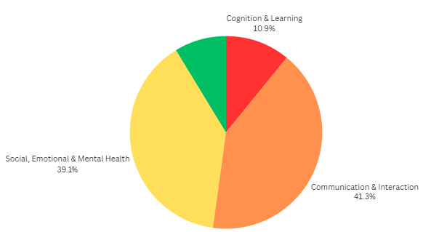
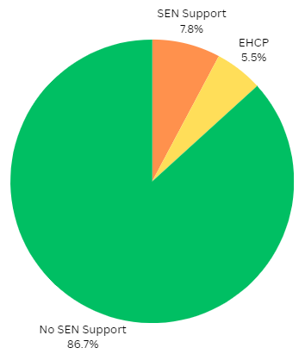
SEN Support Status - DIS
Broad Area of Need - DIS
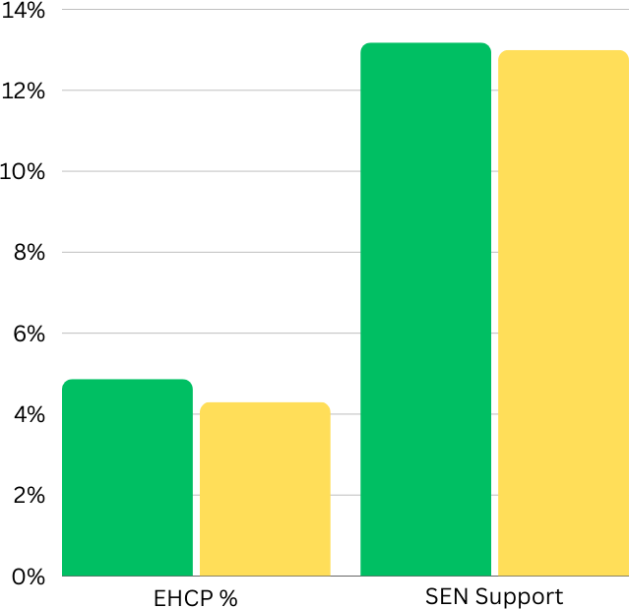
- Downs Infants
- National (primary)

SEN Support Compared to National
*National figures are through primary (years 1-6) not infants

