Downs Infants Curriculum Statement: Our Infant Curriculum

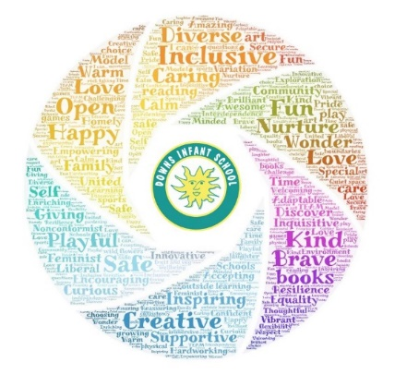
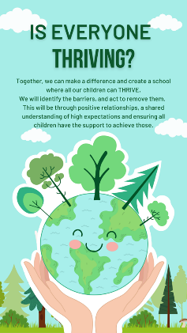
Ambition, Belonging, Creativity, Diversity, Empathy, Flexibility

Intent | Implementation | Impact
What will take place before teaching in the classroom? | What will this look like in the classroom? | How will this be measured?
Downs Infants is a warm, open and nurturing school, which has a deep commitment to a child-centred and unique infant education. We have a strong sense of community, which is inclusive of all, and teach our children to be kind and the value of love.  We take a creative and innovative approach to education here, fostering an inquisitive and curious approach to the curriculum where we value play as the important work of child-hood.  Our values state what we want our children to leave with after their time at Downs Infant School:  - Ambition  - Belonging  - Creativity  - Diversity  - Empathy  - Flexibility  With these values driving our intent, we want to ensure an education that develops the whole child. It should enable children to be able to make the very best of their lives; having choice and opportunity in their social and economic situation, contributing to society, and developing a sense of self-worth.  We want to provide an education that is rich in knowledge and opportunities to apply that knowledge, revisiting it in ‘continuous provision’ and using it to problem-solve and to engage in their own projects.  We believe the curriculum should include experiences of our cultural, artistic and social heritage, and that children should be enabled and inspired to be life-long learners. | Throughout the school we seek to provide opportunities for child-initiated learning. We encourage children to wonder, and to question, ‘what if…?’. We provide rich learning environments with ‘continuous provision’ at their heart. Direct instruction of important skills and knowledge gives children rich resources with which to engage these environments.  Within all learning environments we:  - Start from where the children are: building on their knowledge and interests to challenge them and take them somewhere new.  - Adopt a theme-based approach so that children see links between areas of study, and have opportunities to apply what they learn in a variety of contexts.  - Ensure progression through the EYFS and Key Stage 1, working in subject teams so all teachers understand progression in all subjects.  - Plan opportunities for children to become fluent in the skills and knowledge that will enable them to make good progress by making use of environments outside the classroom.  - Consider the kinds of experiences that children need to have, both to develop their knowledge and to provide developmentally appropriate challenges.  - Are flexible with the organisation of learning so that passions can be nurtured and depth of learning provided for.  - Extended periods of ‘free-flow’ throughout the 4 classrooms, any shared areas and the outside areas.  - A continuous morning without an adult imposed school-wide breaktime.  - Teaching assistants and understanding next steps for all children so they can ‘sprinkle’ instruction appropriately to extend children’s development.  - Providing easily accessible and open-ended resources so that children are able to create the contexts for their own play.  - Gradually increasing periods of direct instruction that are tailored to the developmental stage of the children.  Whole school assemblies as well as lunchtime allow further development of the skills and attributes we value. | An important source of evidence is from the pupils themselves.  - Through observations of the behaviour and attitudes of children in all areas of the school.  - Active and regular pupil voice work with the school council.  - Subject specific pupil voice work on regular evaluation days.  - Working and playing alongside children to see what is important to them and how they apply what they have learned.  - From their parents at parent consultations (specific children) and through parent representatives (trends).  We see the impact of our work in children’s activities which we record on Tapestry, our learning journal.  - Pupils take pride in their work and are able to talk about their learning.  - Children apply that they have learned to new contexts in ‘continuous provision’.  - Pupils’ work is moderated and assessed in line with national expectations. Our school has consistently performed in line with, or above, national comparators on a range of measures for reading, writing, phonics and maths. Professional dialogue between teachers informs teachers and subject leaders about the attainment and progress of children throughout the school.  Staff professional development and involvement in school improvement priorities gives us feedback on all aspects of the school including the curriculum. In addition there is a rolling programme of subject teams’ evaluation and development as well as Governor Evaluation Days termly.

