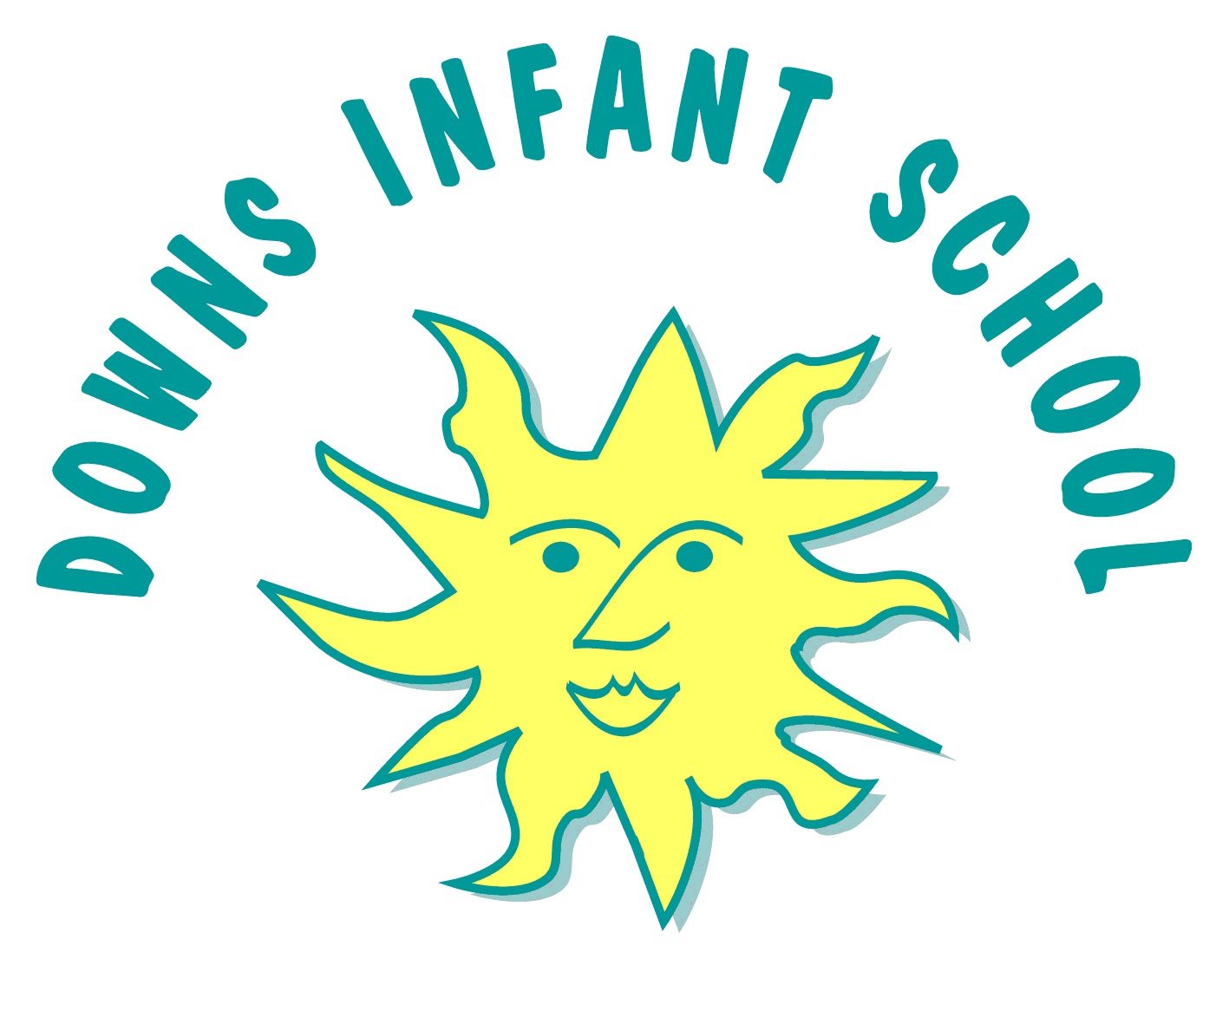
Downs Infants Curriculum Statement
PE

Giving every child the physical literacy, emotional and thinking skills to achieve in P.E., Sport and life.

Intent | Implementation | Impact
What will take place before teaching in the classroom? | What will this look like in the classroom? | How will this be measured?
School values  At Downs Infant School we aim to develop the whole child. We aim that children are enabled to make the very best of their lives; having choice and opportunity in their social and economic situation, contributing to society, and developing a sense of self-worth. We aim to provide a broad and balanced curriculum and to fulfil the requirements of the National Curriculum and the EYFS, which is inclusive to all children. We use our curriculum drivers to feed into and inspire our children in physical education.  Teaching aims  We want our children to develop their fundamental movement skills including running, jumping, throwing and catching, as well as developing balance, agility and co-ordination. We also want them to develop their dance skills and to participate in team games, developing their attacking and defending skills. We want our children to enjoy and feel appropriately challenged in their P.E. lessons. We promote learning behaviours in the children that are linked to our key teaching skills. Children should develop the 6 key learning behaviour skills through careful questioning and support by the teacher.  These are:  - personal  - social  - cognitive  - creative  - physical  - health and fitness  We believe that when these 6 key skill areas work together in the whole child then the child can succeed. It is important to focus on and teach each of these skills over a period of time within our P.E. lesson.  Aspirations for learners  We want our children to reach the End of Key Stage 1 having developed their physical skills to a strong level. We want to children to be inspired by their PE lessons and all physical activity opportunities in school. We hope all of this combined will lead to our children leading healthy and active lives in to their future. | Curriculum Design  We implement a curriculum that is progressive throughout the school. In Reception it is based upon the Foundation Stage Curriculum and Development Matters. P.E. in Reception is explored through the strand of ‘Physical Development’ and ‘Expressive Arts and Design’.  We aim to provide a variety of diverse physical activities to engage our children and promote enjoyment of physical activity. In Reception children have one taught P.E. lesson each week. We use ‘Jasmine Core Real PE’ lessons, ‘Real dance’ and ‘Real gymnastics’. As well as this we have ‘Physical Friday’, ‘Magic mover’ sessions, physical movement breaks throughout the day and an annual sports day. During ‘COOL time’ (Choose our own learning time) children are able to access and are encouraged and supported to use a range of fine and gross motor equipment to promote physical development.  In Key Stage 1 our P.E. curriculum is based on the 2014 Primary National Curriculum in England. In KS1 children have two P.E. lessons each week. We use ‘Jasmine Core Real PE’ for one lesson and the other lesson includues ‘Real dance’ and ‘Real gymnastics’ as well as ‘multi-skills’ ‘games’ and ‘athletics’. As well as this children have physical movement breaks throughout the day and an annual Sports Day.  We use ‘Jasmine Core Real P.E, Dance and Gymnastics.’consistently to ensure a coherently planned and child friendly curriculum. This includes stories and songs to engage children with their P.E. lessons as well as videos of children their age demonstrating physical skills at a variety of levels to ensure children are thinking about challenge. During each unit there is a focus ‘learning behaviour’ skill (personal, social, cognitive, creative, physical, health and fitness).  Enrichment and Wider Community  In addition to our physical activity during the school day, Downs Infants also offers its children the opportunity to take part in extracurricular activities. These include ballet, tennis and karate clubs.  In Year 2 children are given the opportunity to perform at the Brighton Dome as part of the Let’s Dance festival. They are also encouraged to take part in ‘DownsFest’; a celebration of music and movement at our school. All children are also given the opportunity to take part in a ‘Scooter Workshop’.  At Down’s Infant School we also promote engagement in whole ‘Physical Activity’ events such as ‘GB athlete event day’. | In Reception the areas of learning most relevant when measuring the impact of our teaching are Physical Development and Expressive Arts and Design. In Reception children have a baseline assessment and then they are assessed using Development Matters statements. Children are assessed through ongoing assessments against the ‘Real PE’ lesson objectives. In Reception children are also assessed as to whether or not they have achieved the Early Learning Goals in June. Observations and assessments are recorded on ‘Tapestry’.  In KS1 children are assessed against the National Curriculum. Children are assessed through ongoing assessments against the ‘Real PE’ lesson objectives Teacher judgements are made from observations in class and by talking to the children. This includes asking review questions at the end of lesson, asking open-ended questions.

