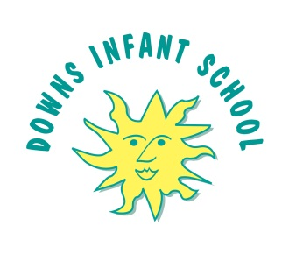D Downs Infant School Parental Agreement

for School to Administer Medicine

**Our school has a policy that staff can only administer medicine with parental consent.**

**Downs Infant School will only accept prescribed medicines, with written permission from parent/carer that are in-date, labelled, provided in the original container as dispensed by a pharmacist and include instructions for administration, dosage and storage.**

|  |  |
| --- | --- |
| **Date for Review/End of Course of medicine** |  |
| **Name of Child** |  |
| **Date of Birth** |  |
| **Class** |  |
| **Medical Condition or Illness** |  |

**Medicine**

|  |  |
| --- | --- |
| **Name/Type of Medicine**  **(as described on the container)** |  |
| **Medicine Expiry Date** |  |
| **Dosage/Method/Timing** |  |
| **Time Medicine last administered by parent** |  |
| **Special Precautions / Other Instructions** |  |
| **Any relevant side effects that the school needs to know about?** |  |
| **Procedures to take in an emergency** |  |

**The above information is, to the best of my knowledge, accurate at the time of writing and I give my consent to school staff administering medicine in accordance with the school policy. I will inform the school immediately, in writing, if there is any change in dosage or frequency of the medication or if the medication is stopped.**

**Signature:________________________________ Date:__________________**