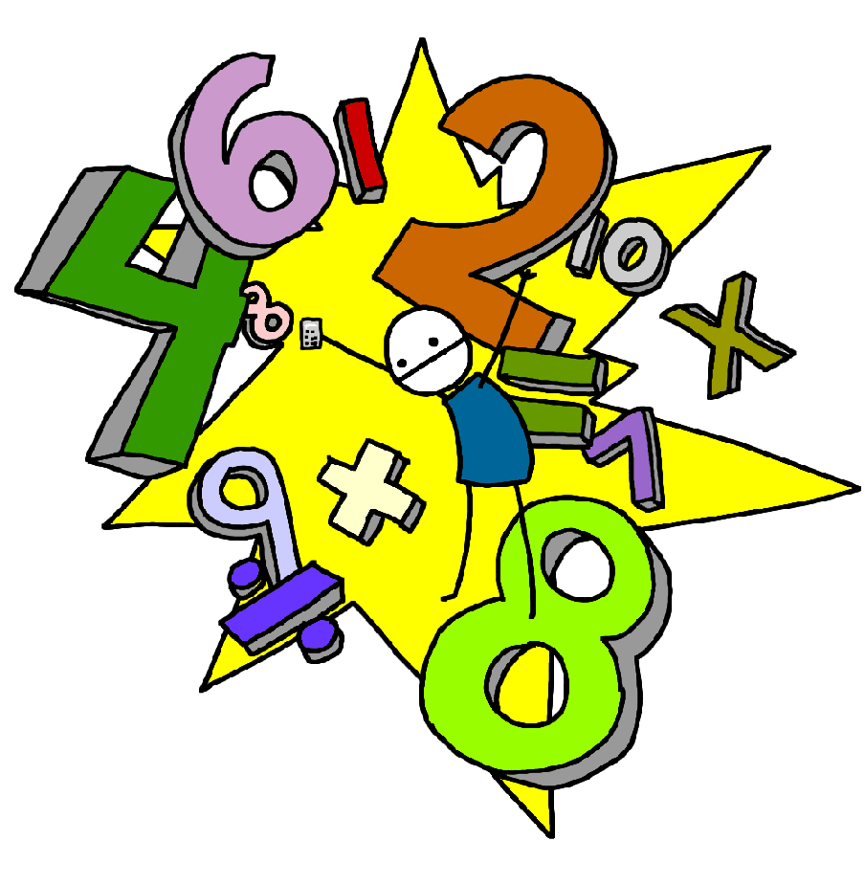Challenge 18
Recall the halves of all even numbers to 10
E.g. half of 8

Challenge 17
Recall the doubles of all numbers to 10
E.g. double 6, 2 lots of 7, 2 x 9…

Challenge 20
Recall division facts for the 2 times tables up to 2 x 12
E.g. 10 ÷ 2 =
14 ÷ 2 =

Challenge 19
Recall all the multiplication facts for the 2 times tables up to 2 x 12
E.g. 4 x 2 , 8 x 2

Challenge 22
Recall division facts for the 10 times tables up to 10 x 12
E.g. 30 ÷ 10 =
60 ÷ 10 =

Challenge 21
Recall all the multiplication facts for the 10 times tables up to 10 x 12

Challenge 24
Recall division facts for the 5 times tables up to 5 x 12
E.g. 30 ÷ 5 =
45 ÷ 5 =

Challenge 23
Recall multiplication facts for the 5 times tables up to 5 x 12

