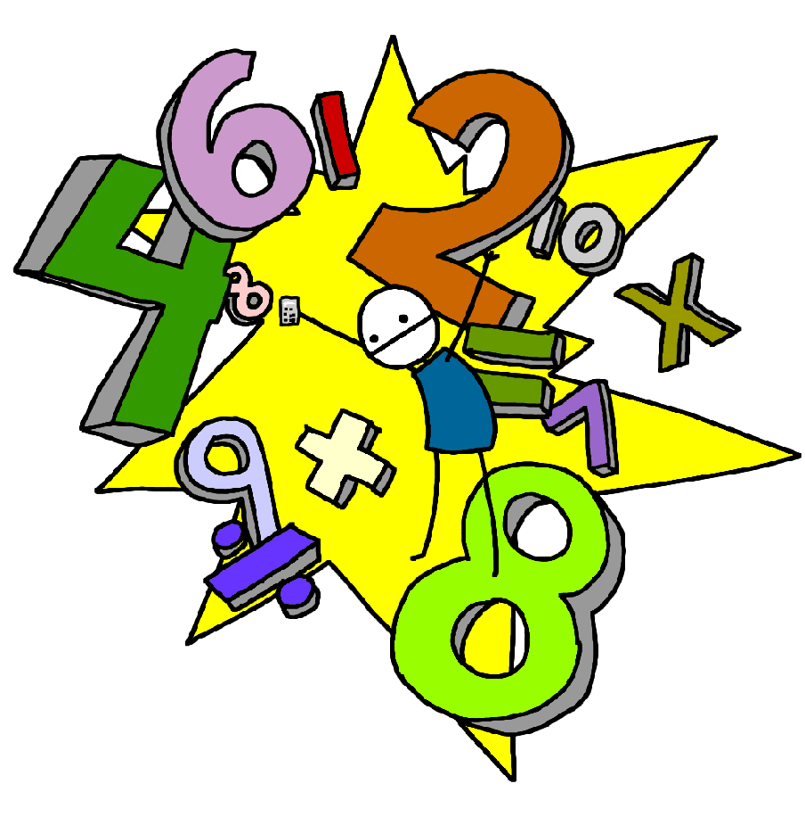Challenge 2
Count back in ones from any number up to 20.
E.g. 8,7,6,5… 15,14,13,12,11…

Challenge 1
Count on in ones up to 20 from any number.
E.g. 6,7,8,9… 8,9,10,11,12…

Challenge 4
Find one less than any number from 1-10
E.g. one less than 8, 6 – 1, the number before 4…

Challenge 3
Find one more than any number from 1-10
E.g. 4 + 1, the number after 7, one more than 5…

Challenge 6
Know what numbers add together to make 5
E.g. 1 + 4, 2 + 3, 5 + 0
(Link to subtraction facts e.g. 5 – 2 – 3 )

Challenge 5
Know what numbers add together to make 10
E.g. 1 + 9, 2 + 8, 3 + 7,
4 + 6, 5 + 5, 0 + 10
(Link to subtraction facts e.g. 10 – 2 – 8 )

Challenge 8
Know what numbers add together to make 7
E.g. 1 + 6, 2 + 5, 3 + 4
7 + 0
(Link to subtraction facts e.g. 7 – 2 – 5 )

Challenge 7
Know what numbers add together to make 6
E.g. 1 + 5, 2 + 4, 3 + 3
6 + 0
(Link to subtraction facts e.g. 6 – 2 – 4)

