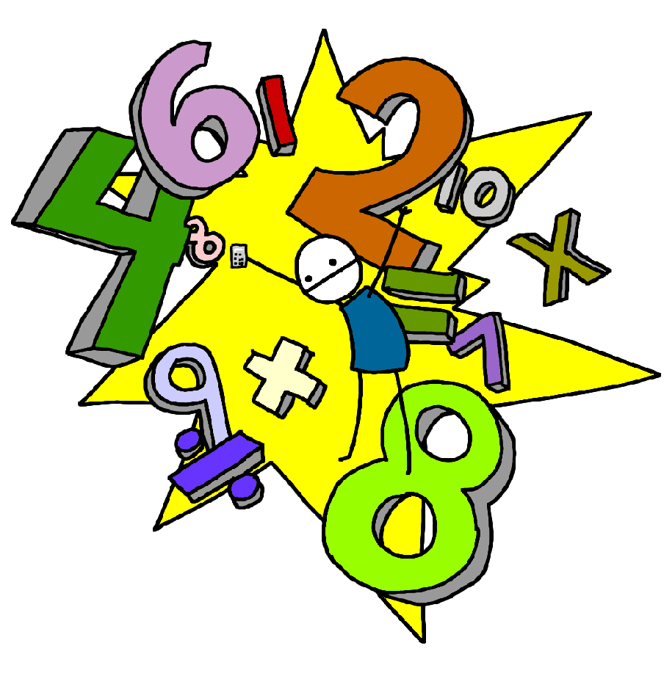Challenge 26
Recall division facts for all of the 3 times table up to 3 x 12

Challenge 25
Recall multiplication facts for all of the 3 times table up to 3 x 12

Challenge 28
Recall division facts for all of the 4 times table up to 4 x 12

Challenge 27
Recall multiplication facts for all of the 4 times table up to 4 x 12

Challenge 30
Recall division facts for all of the 8 times table up to 8 x 12
E.g. 48 ÷ 8 =

Challenge 29
Recall multiplication facts for all of the 8 times table up to 8 x 12

Challenge 32
Recall division facts for the 6 times table up to 6 x 12

Challenge 31
Recall multiplication facts for all of the 6 times table up to 6 x 12

