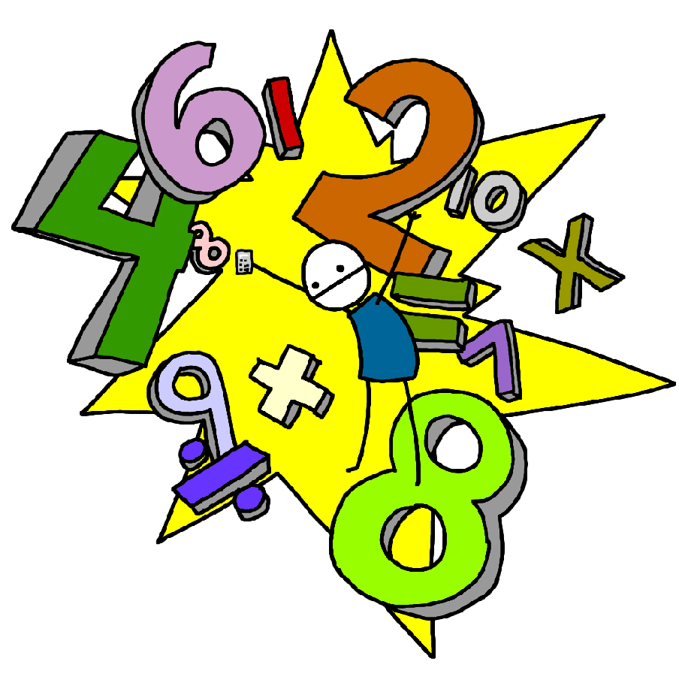 Challenge 34
Recall division facts for the 9 times table up to 9 x 12

Challenge 33
Recall multiplication facts for all of the 9 times table up to 9 x 12

Challenge 36
Recall division facts for the 7 times table up to 7 x 12

Challenge 35
Recall multiplication facts for all of the 7 times table up to 7 x 12

Challenge 38
Recall division facts for the 11 times table up to 11 x 12

Challenge 37
Recall multiplication facts for all of the 11 times table up to 11 x 12

Challenge 40
Recall division facts for the 12 times table up to 12 x 12

Challenge 39
Recall multiplication facts for all of the 12 times table up to 12 x 12

