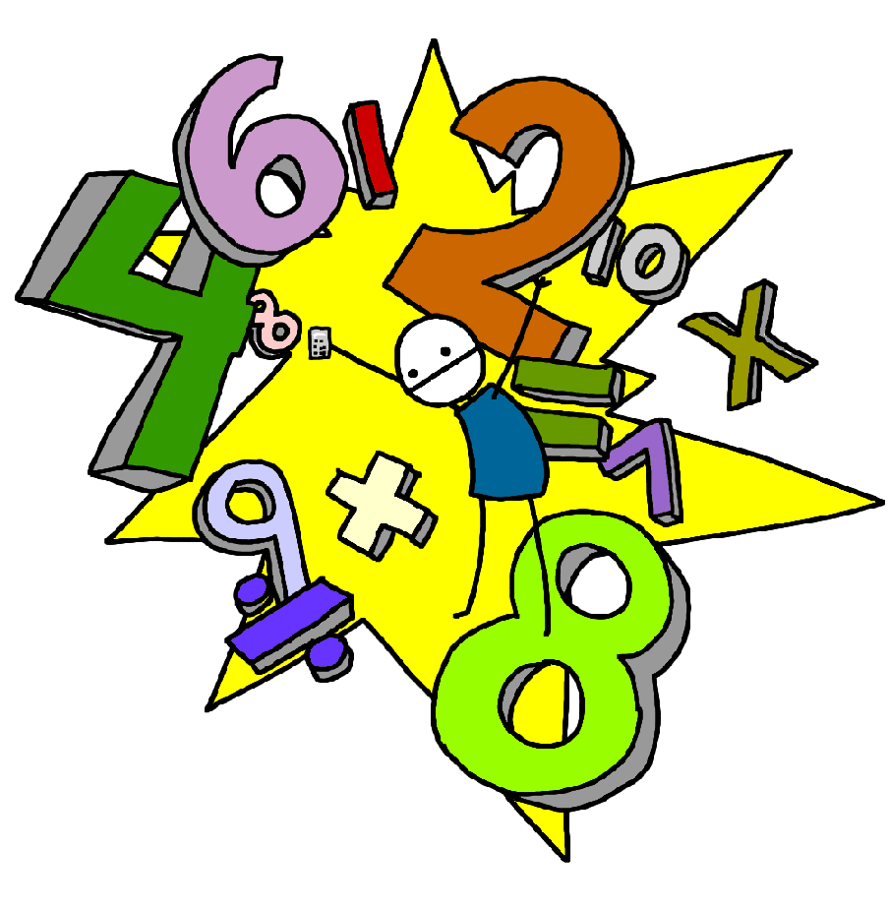Challenge 10
Know what numbers add together to make 9
E.g. 1 + 8, 2 + 7, 3 + 6
4 + 5, 0,9
(Link to subtraction facts e.g. 9 – 2 – 7 )

Challenge 9
Know what numbers add together to make 8
E.g. 1 + 7, 2 + 6, 3 + 5
4 + 4, 0 + 8
(Link to subtraction facts e.g. 8 – 2 – 6 )

Challenge 12
Count back in twos starting with any number up to 20.
E.g. 20,18,16,14……4,2,0

Challenge 11
Count on in twos up to 20 from any number.
E.g. 2,4,6,8….…18,20

Challenge 14
Count back in tens starting with any tens number up to 100.
E.g. 100,90,80,70…20,10,0

Challenge 13
Count on in tens to 100 from any other tens number.
E.g. 10,20,30,40……90,100

Challenge 16
Count back in fives starting with any multiple of five up to 100.
E.g. 50,45,40,35…10,5,0

Challenge 15
Count on in fives up to 100 starting at any multiple of 5.
E.g. 5,10,15,20…….45,50

