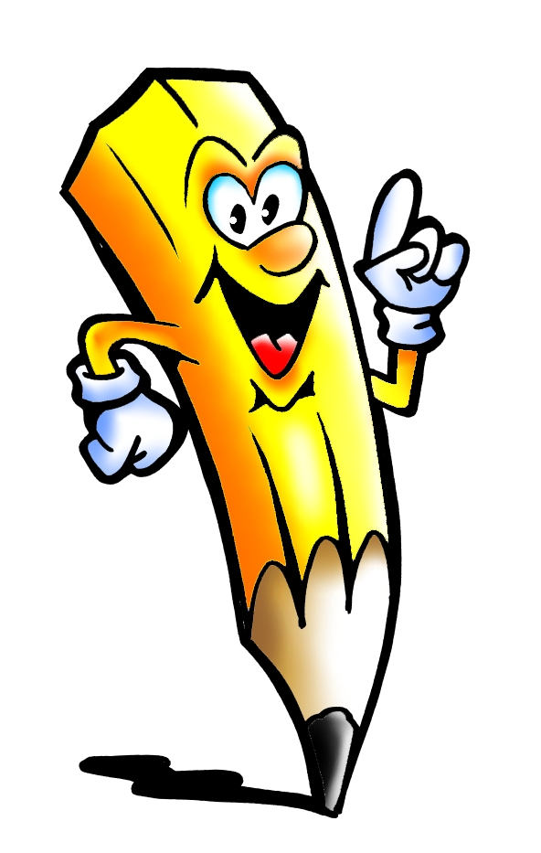Challenge 14
back
from
children
him
Mr
Challenge 13
look
don’t
come
will
into

Challenge 16
about
got
their
people
your
Challenge 15
get
just
now
came
oh

