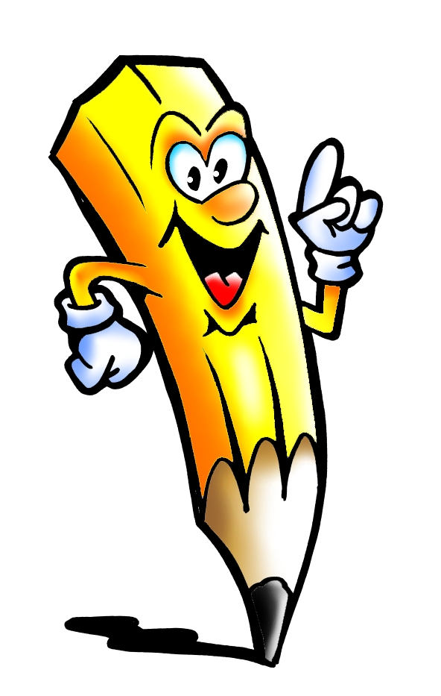Challenge 34

- each
- book
- it’s
- green
- different
- let
- girl
- which
- inside
- run

Challenge 33
- fun
- place
- mother
- sat
- boat
- window
- sleep
- feet
- morning
- queen

Challenge 36
- fell
- friends
- box
- dark
- grandad
- there’s
- looking
- end
- than
- best
Challenge 35
- any
- under
- hat
- snow
- air
- trees
- bad
- tea
- top
- eyes

