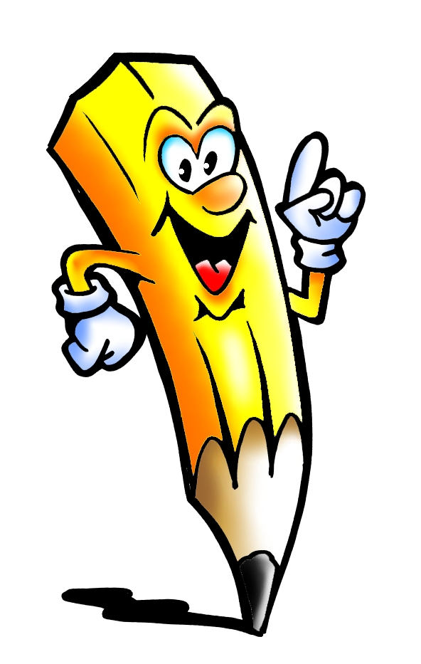Challenge 10
as
no
mum
one
them
Challenge 9
not
then
were
go
little

Challenge 12
when
it’s
see
looked
very
Challenge 11
do
me
down
dad
big

