 | Reception- Diwali Lamp  Big Ideas  - Designing  - Technical Skills  - Making  - Evaluating  Whole School DT Map  An introduction to designing and making a product. Children will explore simple tools to join and attach in different ways. They will use oracy skills to talk about the size and parts of their product. In food technology, children will learn basic hygiene and how to use simple utensils and equipment - including measuring.  They taste, describe and evaluate a range of food and will be able to talk about some foods are good for you and why. | Year 1- Toys  Using the stimulus of their topic on toys, children will begin to learn how designers evaluate existing products and innovate designs with an intended user in mind. The outcome of their project will be to design and make a prototype of a toy with a moving part, including levers, sliders or wheels. They will be introduced to a simple design brief through identifying must have criteria and they will build on their understanding of joining and stiffening a range of materials in order to make their product stronger. On completion of their project, they will be introduced to evaluation as they will compare their prototype to their design brief.  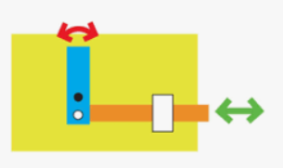  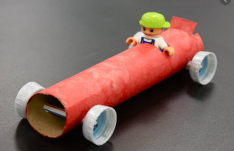  In food technology, pupils will build on their knowledge of basic hygiene, their knowledge of a healthy balanced diet and they will begin to understand where food comes from. They build on basic measuring skills to include dry and liquid ingredients in a range of different containers. |  | Year 2- Garment  Using the stimulus of their Science topic and English book about the importance of Bees, children will identify the features of existing products then select and justify which elements they will include on their own design. The outcome of their project will be to design a panel to attach to a t-shirt which includes a message to provoke a response or suggest something. They will be introduced to a simple design brief through identifying must have criteria, needs/challenges of the user and they will build on their understanding of joining and stiffening by putting the stitches closer together. On completion of their project, they will be introduced to evaluation as they will compare their garment to their design brief and suggest an aspect they would change and why.  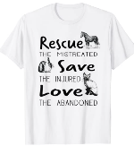  In food technology, pupils will build on their knowledge of basic hygiene, their knowledge of a healthy balanced diet and they will begin to understand the different food groups. They will measure time and weigh, dry ingredients and liquids accurately on digital and simple scales. They will build on basic use of utensils and equipment to mix, grate, slice, and chop safely.  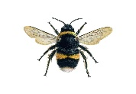
Year 3 – Slave aid  Using the stimulus of their topic on the Egyptians, children will identify the needs/challenges of the user/s to identify success criteria to include on the design specification. This will include sorting the criteria into essential and desirable features. The outcome of their task is to design and make a prototype of a device that could have helped the slaves move their heavy slabs of rock from one location to another. They will be shown a small box (with something inside in for weight) that they will have to move from location A to location B without being able to lift it by hand alone. They will discuss the strengths and weakness of existing products and link these with ideas for their own design. On completion of their project, they will be introduced to evaluation questions on different aspects of their product and they will also suggest an aspect they would change and why.  In food technology, pupils will build on their knowledge of basic hygiene, including consequences of poor hygiene. | Year 4 – Carrying tool  Using the stimulus of their History Invaders and Settlers topic and English book ‘Arthur and the Golden Rope’, children will identify the features of existing products then select and justify which elements they will include on their own design. The outcome of their project will be to design a bag for Arthur. They will develop initial design ideas through the investigation and analysis of a range of materials/components and their properties that could be selected. They will also build on their understanding of strengthening, stiffening and reinforcing fabrics joining and stiffening using the back stitch. On completion of their project, they will evaluate by comparing their garment to their design brief, how well it meets the intended purpose and suggest an aspect they would change and why.  In food technology, pupils will build on their understanding and use basic principles of a healthy and varied diet to prepare food and talk about their diets. |  | Year 5 – Bridges  Using the stimulus of their Geography topic ‘The Amazon River’, children will identify the features of existing products then select and justify which elements they will include on their own design. The outcome of their project will be to design and make a small model version of a bridge that could carry a car across. They will briefly look at the invention and creation of bridges to understand how key events and individuals in design and technology have helped shape the world. During construction children will choose the most appropriate way to strengthen, stiffen and reinforce structures.  On completion of their project, they will evaluate designs and products based on innovation, quality, functionality and how appealing they are with specific reference to the design specification. Alongside this, they will suggest areas for improvement with reference to the design specification.  In food technology, pupils will build on their understanding and apply and discuss rules for basic food hygiene and other safe practices e.g. hazards related to ovens, knives or raw food. |  | Year 6 – Explorer shoe cover  Using the stimulus of their Geography topic ‘The Hidden World’ Antarctica, children will, based on their knowledge, generate some ideas for a design specification and refine these in order of importance. The outcome of their project will be to design and make a prototype version of a boot cover. During construction children will sew the hemming stitch accurately and produce a well finished product. On completion of their project, children will evaluate designs and products based on innovation, quality, functionality and how appealing they are with specific reference to the design specification. Alongside this, they will suggest areas for improvement with reference to the design specification.  In food technology, pupils will weigh and measure time, dry ingredients and liquids accurately on more complex scales.

