 |  | Reception- My World  Whole School Geography Map  An introduction to where they live, their town of Hyde and the country of England. Children will explore their school grounds and their local area throughout the year.  Big Ideas  -Work and communicate geographically  -Where in the world?  -Human and physical features  -Human and physical processes  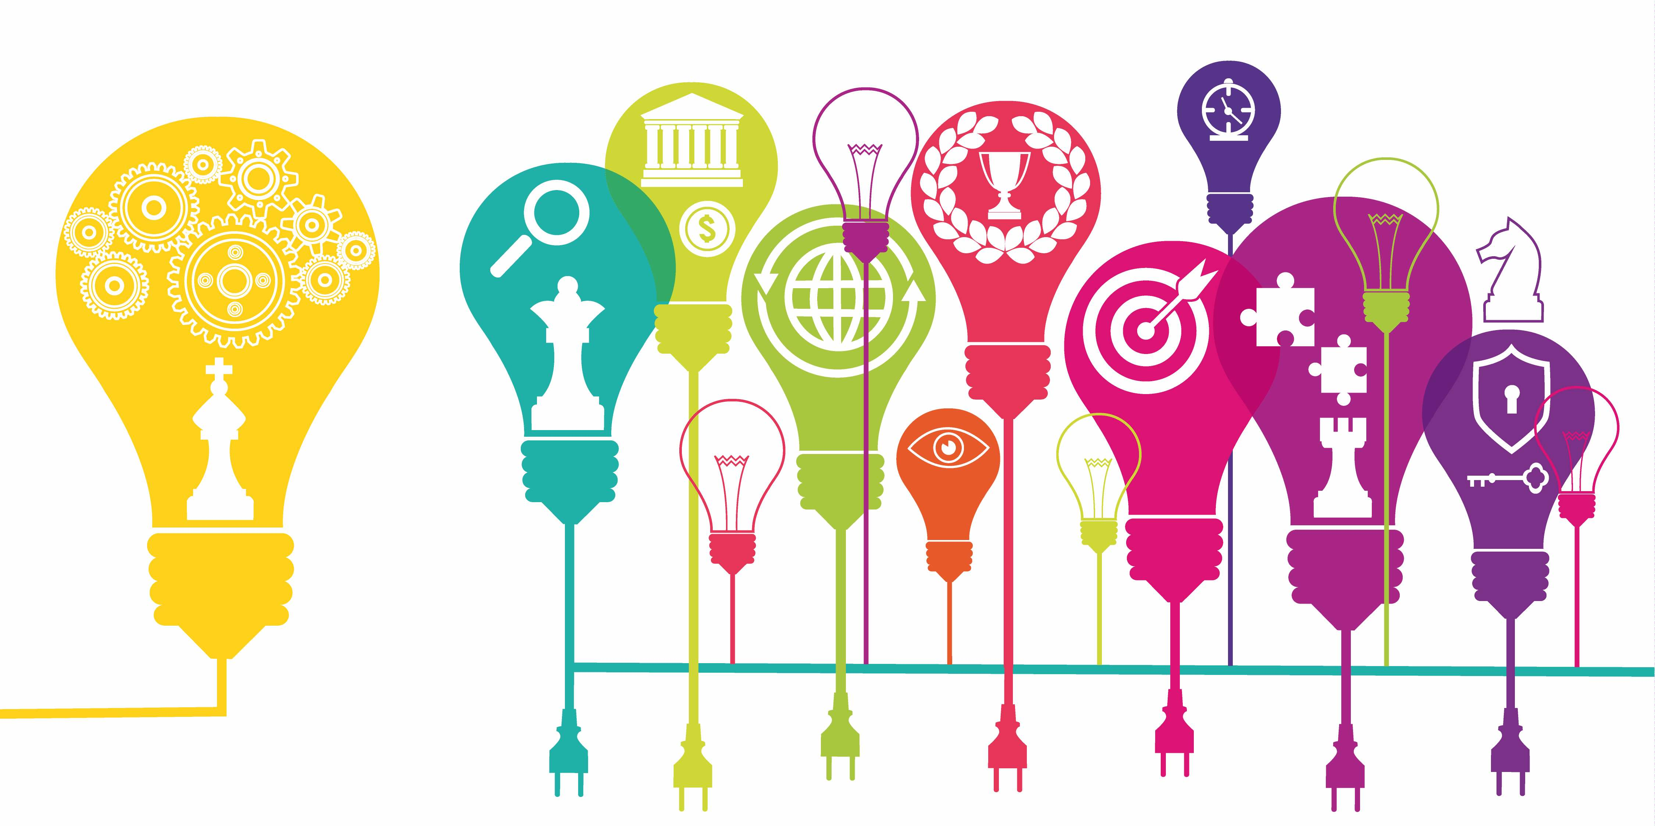  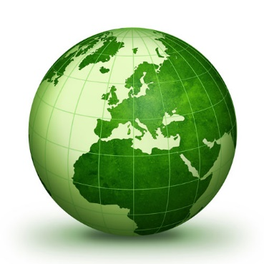 |  | Year 1- The UK  Children learn to recite their address and they start to understand the location of Hyde in relation to Manchester, England and the UK on a map. They learn the names and locations of the 4 UK countries and are able to identify London as the capital city of England. Children learn what it means to study Geography and the difference between human and physical features in the UK, including the weather.  Year 1- City, Country, Coast Comparison  Children use geographical skills to compare the human and physical features of Manchester (city), Eyam (countryside) and Cleveleys (seaside).  Skills- Use aerial photographs; read atlas pages; read and create simple maps with pictorial representations; read a World and UK map; positional language and N,E,S,W | Year 2- The World  Children build on their knowledge of the UK by identifying capital cities and the seas and oceans surrounding the UK. They start to develop their global knowledge by identifying the 7 continents and 5 oceans of the world and their location in relation to the equator and poles. Children start to understand how physical geography shapes the world.  Year 2 – Manchester and Nairobi comparison  Children use geographical skills to compare the human and physical features and processes of Manchester and Nairobi, including seasonal and locational variations in weather and the contrasting lives of Nairobi’s citizens.  Skills- Use aerial photographs, a globe, a world map, atlases and simple keys; create maps from plan perspective; N,E,S,W
Year 3 – Climate Zones and Biomes  Children will develop their understanding of the significance of the equator in determining the climate of a location. They will also explore how the climate affects the physical and human geography of an area, including a focus on different biomes.  Year 3 – North and South America  Children develop their global knowledge by learning the location of some major countries and states in North America and South America. They will identify the physical and human features of three localities with contrasting climate zones and biomes. They will also begin to understand about indigenous people and how they have been affected over time.  Skills- Read and Identify the features of different types of maps, globes, atlases (independently); read simple ordinance survey keys; read grid references in an atlas; 8 points of a compass; create a map with a key | Year 4 - Europe  Children develop their global knowledge by learning the location of, and some of the human and physical features of, Norway, Spain and Russia. They will learn about the diverse biomes and climate zones within these countries.  Year 4- Australia  Children will learn about the location of Australia and about some of its major cities, physical features and human features. They will explore how the geography of Australia has changed over time, including changes for the indigenous people.  Skills- Use more complex world maps, ordinance survey maps, keys, contour lines, atlases inc. grid ref and globes; 8 points of a compass and 4 figure grid references |  | Year 5 – Waters of the World  Children will start to gain knowledge about the hydrosphere by looking at its impact on physical and human features and processes in the world. They will also explore how human actions are influencing the hydrosphere and at changes over time. Children will be able to name, locate and describe the features of significant bodies of water and how they shape the landscape, including the Mersey, Nile, Amazon, Mississippi, Ganges and Thames – this will build on their global knowledge as these rivers are in locations studied in other year groups. They will learn about the Tropics of Cancer and Capricorn and their significance to the hydrosphere.  Year 5 – Brazil  Children will begin by learning about longitude and latitude so that they can build on their knowledge about the significance of global positioning to a location. They will then explore the physical geography of Brazil with a specific focus on the Amazon Rainforest. Finally, they will look at Brazil’s human geography and focus on the contrasting lives of different Brazilian citizens.  Skills- Use atlases and maps that show longitude and latitude; use a range of sources (including digital technology); 8 compass points; 6 figure grid references |  | Year 6 – The Hidden World  Children will develop their knowledge by studying the physical and human features and processes, as well as their interactions, in places of the world that are sparsely inhabited- Antarctica and The Great Barrier Reef.  Year 6 – Disasters  Children will learn about the lithosphere and how plate tectonics shape the land over time. They will learn about the formation of volcanoes and why earthquakes happen, including finding out about some famous eruptions and earthquakes. They will identify reasons why people choose to live in disaster prone areas. Children will learn the location of the Alps, Himalayas, Rockies, Andes and Atlas mountains.  Skills- Use atlases and maps that show longitude and latitude; use relief maps to identify physical features; use a range of sources (including digital technologies); 8 compass points; 6 figure grid references

