 | Reception- The Past  Big Ideas  - Work and communicate historically  - When in the world?  - Looking at people and society, rule and law, beliefs, conflict, significant people and lessons learnt.  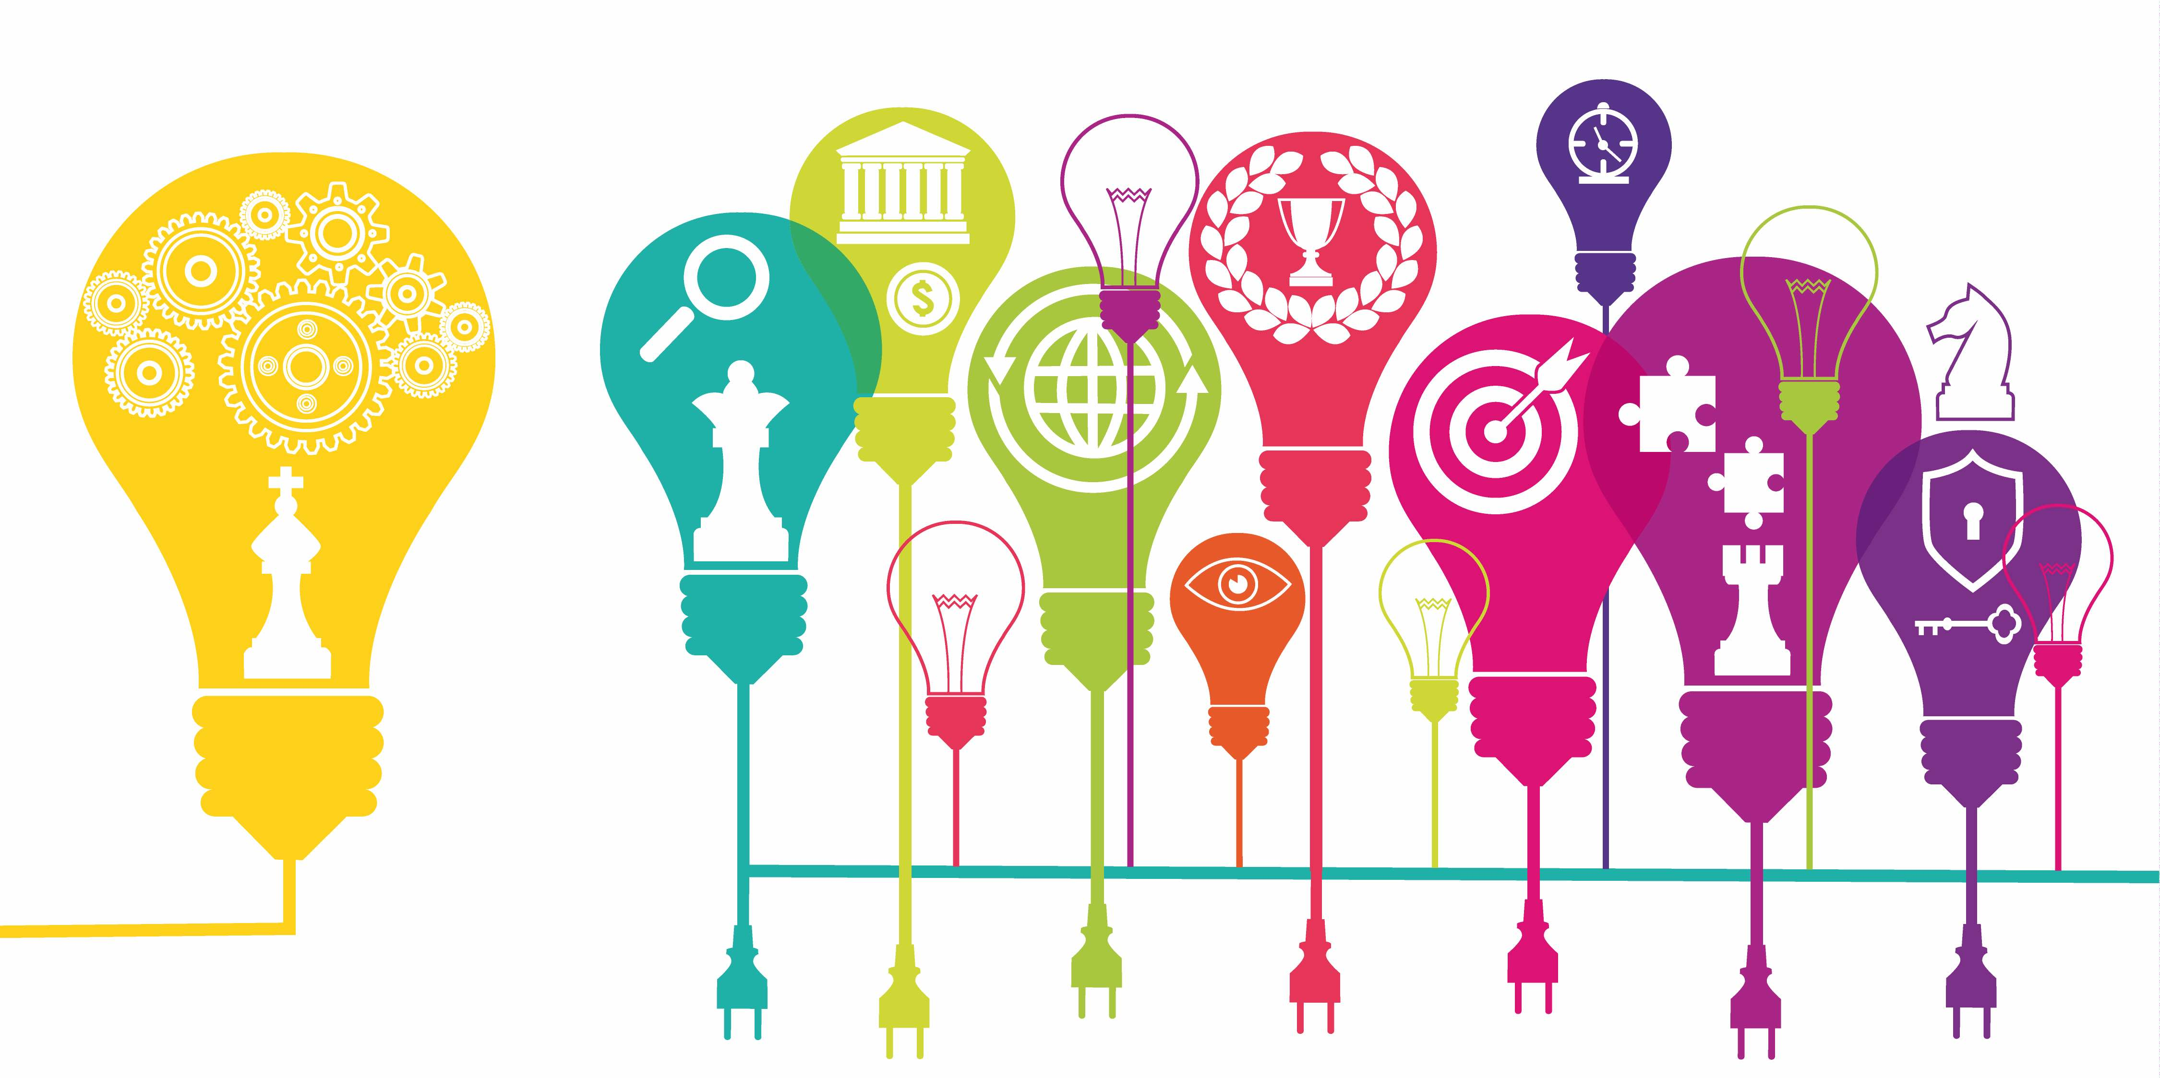  Whole School History Map  Children use ‘The Train Ride’ book to look at changes to trains and holidays over time. Children will learn about Florence Nightingale and about the queen.  Skills: Using language relating to the passing of time.  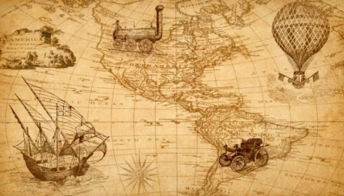 | Year 1- Toys and Pastimes  As an introduction to chronology, children use the familiar concept of toys and pastimes to explore how changes happen over time. They look at which toys have stood the test of time (including looking at Ole Kirk Christianson who invented Lego) and how technology has changed the world of toys. When studying history in other year groups, children will explore the toys and pastimes during that period.  Year 1- Transport  Children apply their understanding of change over time to look at innovations in transport over the last 100 years. They will begin to look at the positive and negative impacts of change. They will learn about the history of trains, cars and flight, whilst considering what they think transport will look like in the future. They will learn about significant individuals such as, Amelia Earhart and George Stephenson.  Skills- Use simple sources, identify different thoughts and feelings, order events on a simple timeline, and use chronological language. |  | Year 2- The Great Fire of London  Children start to build their knowledge about British history by looking at the chronology of a significant event and how it influenced the world today. Children learn about Samuel Pepys and Christopher Wren.  Year 2 – Explorers  Children begin to understand that British history has influenced world history and vice versa. They start to understand that different historical events were happening at the same time through studying explorers and the places they discovered. They will build on their knowledge of transport innovations. Children learn about Christopher Columbus, Roald Amundsen and Neil Armstrong.  Skills- Use a range of primary and secondary sources, give personal interpretations from sources, identify different thoughts and feelings of people from history, and use a timeline and dates to discuss chronology.
Year 3 – Stone Age to Iron Age  Children develop their historical knowledge of the British Isles by studying events beyond living memory and BC/E. They begin to understand chronology and placing their learning on a timeline. Children learn about archaeological remains, such as Cheddar Man and how they have supported historical study.  Year 3 – Egyptians  Children develop their understanding of world history and of events that happened BC/E through studying the Ancient Egyptian civilisation. They will learn about similarities and differences between the history of different places at the same time by applying their learning about the stone age. They will learn about the main beliefs during this civilization and the discovery of Tutankhamun.  Skills- Interrogate primary and secondary sources by discussing their similar and contrasting ideas and their origins, understand BC and AD, and read and use a timeline in years, decades and centuries. | Year 4 – Romans  Adding to their knowledge on the British Isles and world history, children learn about the sophistication of the Roman Empire and the characteristics of this time, with a particular focus on their exploration and conquests. They will learn about their eventual occupation of Britain and the impact they had here and throughout the world. Children will learn about Julius Caesar, Emperor Hadrian, Emperor Claudius and Boudicca  Year 4 – Invaders and Settlers  Children will learn that when the Romans left areas that they had previously occupied in Britain, the Anglo-Saxons, Scots and Vikings invaded and settled here. They will learn about the characteristics of this time and about their differing cultures. Children will learn about Leif Erikson and relate this to their knowledge on explorers and transport innovations.  Skills- Apply prior historical knowledge to new contexts, interrogate primary and secondary resources in relation to facts and opinions, and begin to discuss reliability of sources. |  | Year 5 – The Industrial Revolution and Victorians  Children learn about the Industrial Revolution as a significant point in British history and add to their chronology of these isles. They will explore innovations and focus on change from different perspectives, including the impact of these changes today. They will identify some of the characteristics of the Victorian era as part of their study. Children will learn about significant people from this time, including Richard Arkwright, James Watt, James Brindley, Doctor Barnardo, Lord Shaftsbury, Henry Hunt, Queen Victoria and George Stephenson.  Year 5 – Ancient Greeks  Adding to their knowledge of world history and of ancient civilisations, children will learn about the beliefs, society and conflicts in the Ancient Greek civilisation – including their eventual conquest by the Romans. They will compare Athens to Sparta and draw conclusions about their successes and limitations. Children will identify the lessons learnt from this civilisation both in Britain and throughout the world and make comparisons to their learning on Ancient Egyptians. They will learn about Hypocrites, Archimedes and Alexander the Great.  Skills- Interrogate primary and secondary resources in relation to facts and inferences, discuss reliability of sources, synthesise information from a range of sources, and understand the role of opinion and propaganda. |  | Year 6 – The Mayans  Building on their knowledge of ancient civilisations, children will learn about the Mayans and compare their findings to their understanding of the Egyptians and Greeks. They will learn how successful the Mayans were for a long period of time and what events led to a change in their civilisation. They will identify British historical events that they have learnt about which were happening at the same time.  Year 6 – World War 2  Children will learn about another, more recent, significant event in British history as they study World War 2 and the importance of the Battle of Britain. They will identify causes of conflict and reflect on their learning in other year groups to identify patterns and trends in relation to war and conflict. They will identify social changes occurring in Britain and the world due to the war. Children will learn about Winston Churchill, Adolf Hitler and Alan Turing.  Skills- Interrogate primary and secondary resources in relation to their reliability, usefulness and which is most tangible, describe differing political, cultural, religious and social arguments, and identify bias and propaganda.

