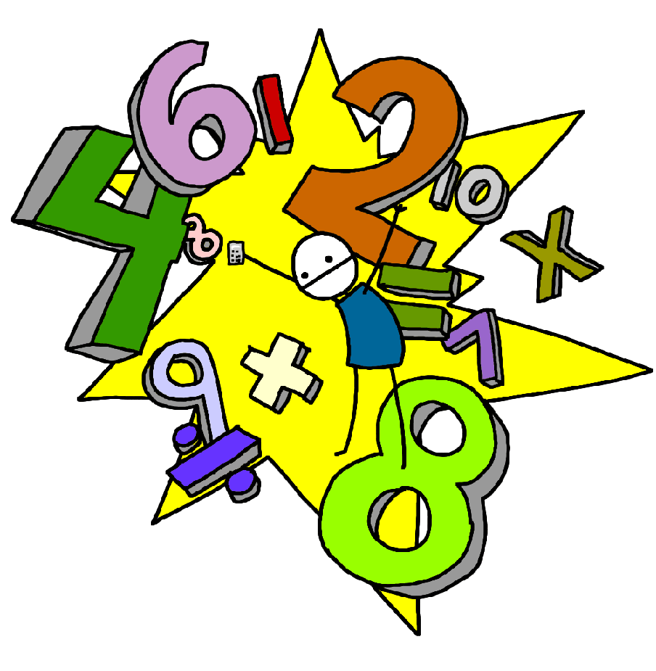**Challenge 18**

Recall the halves of all even numbers to 10

E.g. half of 8

**Challenge 17**

Recall the doubles of all numbers to 10

E.g. double 6, 2 lots of 7, 2 x 9…

**Challenge 20**

Recall division facts for the 2 times tables up to 2 x 12

E.g. 10 ÷ 2 =

14 ÷ 2 =

**Challenge 19**

Recall all the multiplication facts for the 2 times tables up to 2 x 12

E.g. 4 x 2 , 8 x 2

**Challenge 22**

Recall division facts for the 10 times tables up to 10 x 12

E.g. 30 ÷ 10 =

60 ÷ 10 =

**Challenge 21**

Recall all the multiplication facts for the 10 times tables up to 10 x 12

**Challenge 24**

Recall division facts for the 5 times tables up to 5 x 12

E.g. 30 ÷ 5 =

45 ÷ 5 =

**Challenge 23**

Recall multiplication facts for the 5 times tables up to 5 x 12