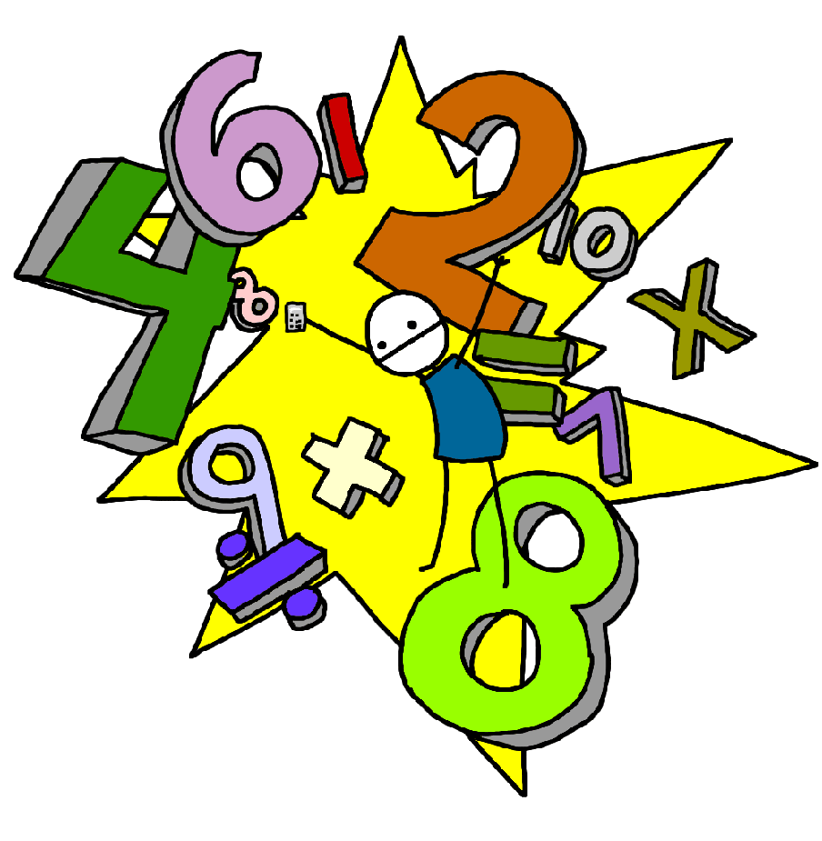**Challenge 2**

Count back in ones from any number up to 20.

E.g. 8,7,6,5… 15,14,13,12,11…

**Challenge 1**

Count on in ones up to 20 from any number.

E.g. 6,7,8,9… 8,9,10,11,12…

**Challenge 4**

Find one less than any number from 1-10

E.g. one less than 8, 6 – 1, the number before 4…

**Challenge 3**

Find one more than any number from 1-10

E.g. 4 + 1, the number after 7, one more than 5…

**Challenge 6**

Know what numbers add together to make 5

E.g. 1 + 4, 2 + 3, 5 + 0

(Link to subtraction facts e.g. 5 – 2 – 3 )

**Challenge 5**

Know what numbers add together to make 10

E.g. 1 + 9, 2 + 8, 3 + 7,

4 + 6, 5 + 5, 0 + 10

(Link to subtraction facts e.g. 10 – 2 – 8 )

**Challenge 8**

Know what numbers add together to make 7

E.g. 1 + 6, 2 + 5, 3 + 4

7 + 0

(Link to subtraction facts e.g. 7 – 2 – 5 )

**Challenge 7**

Know what numbers add together to make 6

E.g. 1 + 5, 2 + 4, 3 + 3

6 + 0

(Link to subtraction facts e.g. 6 – 2 – 4)