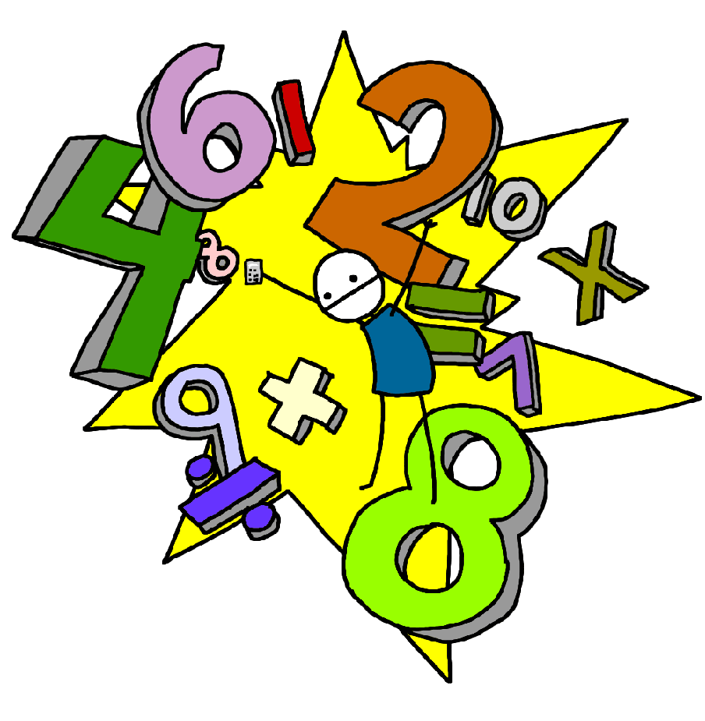**Challenge 26**

Recall division facts for all of the 3 times table up to 3 x 12

**Challenge 25**

Recall multiplication facts for all of the 3 times table up to 3 x 12

**Challenge 28**

Recall division facts for all of the 4 times table up to 4 x 12

**Challenge 27**

Recall multiplication facts for all of the 4 times table up to 4 x 12

**Challenge 30**

Recall division facts for all of the 8 times table up to 8 x 12

E.g. 48 ÷ 8 =

**Challenge 29**

Recall multiplication facts for all of the 8 times table up to 8 x 12

**Challenge 32**

Recall division facts for the 6 times table up to 6 x 12

**Challenge 31**

Recall multiplication facts for all of the 6 times table up to 6 x 12