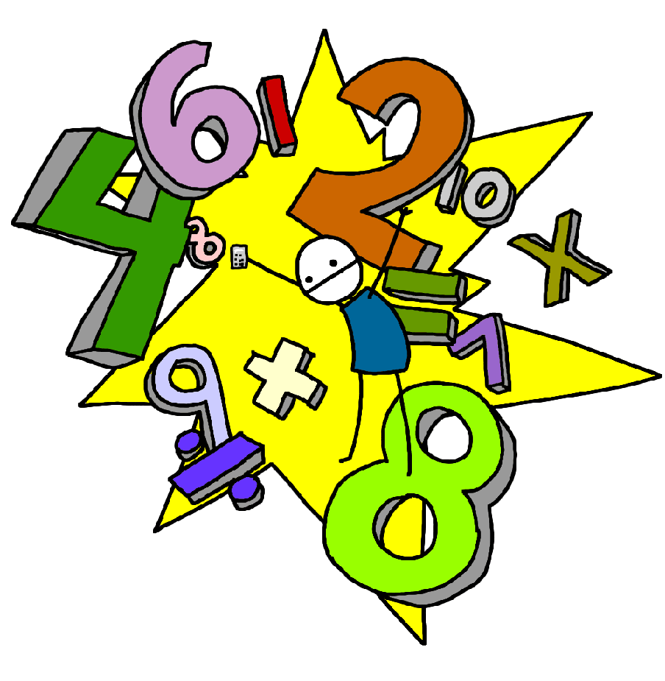 **Challenge 34**

Recall division facts for the 9 times table up to 9 x 12

 **Challenge 33**

Recall multiplication facts for all of the 9 times table up to 9 x 12

 **Challenge 36**

Recall division facts for the 7 times table up to 7 x 12

 **Challenge 35**

Recall multiplication facts for all of the 7 times table up to 7 x 12

 **Challenge 38**

Recall division facts for the 11 times table up to 11 x 12

 **Challenge 37**

Recall multiplication facts for all of the 11 times table up to 11 x 12

 **Challenge 40**

Recall division facts for the 12 times table up to 12 x 12

 **Challenge 39**

Recall multiplication facts for all of the 12 times table up to 12 x 12