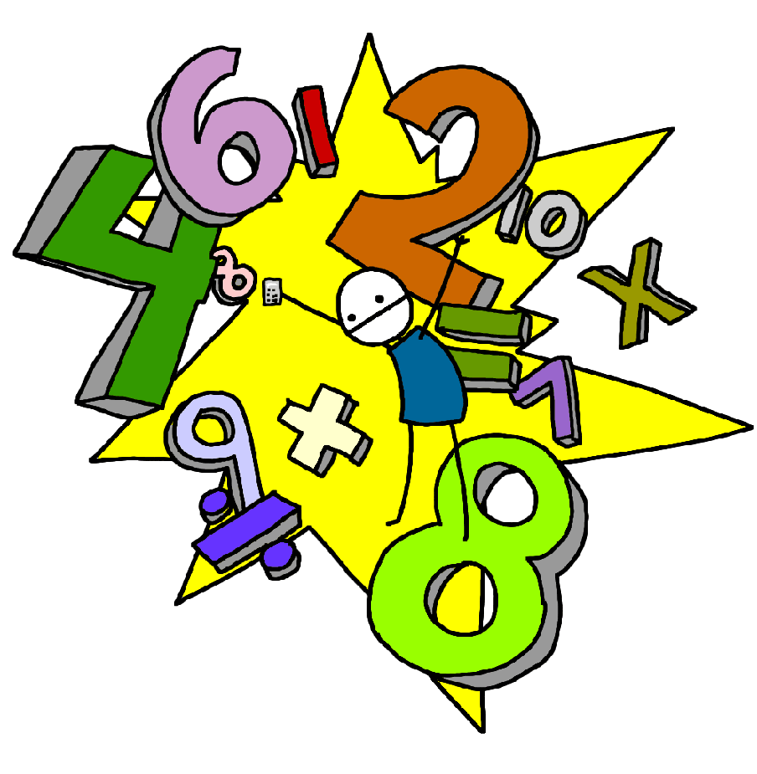**Challenge 10**

Know what numbers add together to make 9

E.g. 1 + 8, 2 + 7, 3 + 6

4 + 5, 0,9

(Link to subtraction facts e.g. 9 – 2 – 7 )

**Challenge 9**

Know what numbers add together to make 8

E.g. 1 + 7, 2 + 6, 3 + 5

4 + 4, 0 + 8

(Link to subtraction facts e.g. 8 – 2 – 6 )

**Challenge 12**

Count back in twos starting with any number up to 20.

E.g. 20,18,16,14……4,2,0

**Challenge 11**

Count on in twos up to 20 from any number.

E.g. 2,4,6,8….…18,20

**Challenge 14**

Count back in tens starting with any tens number up to 100.

E.g. 100,90,80,70…20,10,0

**Challenge 13**

Count on in tens to 100 from any other tens number.

E.g. 10,20,30,40……90,100

**Challenge 16**

Count back in fives starting with any multiple of five up to 100.

E.g. 50,45,40,35…10,5,0

**Challenge 15**

Count on in fives up to 100 starting at any multiple of 5.

E.g. 5,10,15,20…….45,50