Netflix parents’ guide: what is it and is it safe for kids?

Netflix is the undisputed champion of on-demand video: it’s now a globe-spanning, era-defining behemoth whose very name is synonymous with 21st century telly-watching.
Like its many rivals, it has enjoyed a further surge in popularity during the COVID-19 lockdown, and with good reason: it offers a vast array of content, ranging from classic films to the latest TV box-sets and from gritty grown-up thrillers to child-friendly cartoons.
Conscious that people may be using it as a kind of virtual babysitter at the moment, Netflix has rolled out several new features to help families have safer, more enjoyable streaming experiences.
So, do they work? Here’s what parents and carers need to know about the video-streaming pioneer.

What is Netflix?
Netflix is the most popular streaming service worldwide, with more than 167m subscribers, although newer arrivals such as Amazon Prime Video, Disney+ and Hulu have started to challenge its monopoly.
Subscriber can stream an array of films and TV shows on their smartphone, tablet, laptop, smart TV or games console via the internet for a monthly fee of between £5.99 and £11.99, depending on features and streaming quality.
You can create up to five users with one subscription, each controlled by a password-protected master account.

Why is it so popular?
Netflix – and other streaming services – have completely changed the way we consume TV, allowing us to watch anything, anywhere, any time we want. The content that appears in your feed will be curated by Netflix depending on your viewing and rating history, making it easier to find entertainment you’ll like.
As an early adopter of the internet streaming model, Netflix has amassed a large entertainment catalogue – from the blockbusters we all know and love to its own original productions.
Many of these original productions – such as Tiger King, Stranger Things and 13 Reasons Why – have turned into cultural phenomena in their own right, becoming the most-talked about shows within days (or hours) of their release. As these titles are exclusive to Netflix, people might be incentivised to get a subscription to avoid FOMO (fear of missing out).

What’s it like for children and young people?
There’s masses of content on offer for children of all ages – although depending on your view, not all of it is necessarily good-quality fare.
If your child is using a dedicated ‘Kids’ profile (more on that below), they’ll be able to browse by character as well as by film or TV show. This makes it very easy for them to jump straight into their favourite Horrid Henry episodes or seek out that new Lego movie.
There are Netflix Originals aimed specifically at kids, including the superb adaptation of A Series of Unfortunate Events plus big names such as Skylanders Academy and Trollhunters. And of course there are plenty of great films including, at the moment, some brilliant Studio Ghibli offerings.
In short, there’s certain to be something for everyone, from pre-schoolers right up to older teenagers. Choosing between them all might be the tricky part.

Will my child be able to access inappropriate content?
With such a vast range of content available, some parents might be concerned that their children could stumble across content they shouldn’t be watching. Fortunately, Netflix gives parents the opportunity to customise what content they want their children to have access to.
Each title on the UK version of Netflix has been rated by the British Board of Film Classification (BBFC) using its regular rating system – U, PG, 12, 15 and 18 – to determine what audience the title is suitable for. You can customise which of these ratings you want each individual user to have access to.
Here’s how to enable this feature:
- Sign in to your Netflix account and select ‘Account’ from the drop-down menu in the top-right corner. You can do this on mobile, but the browser version of the ‘Account’ page is easier to navigate.
- Scroll down to the ‘Profile and Parental Controls’ section and select the user you’d like to customise.
- Click ‘Viewer Restrictions’, adjust the slider as shown below to set your limit and then hit ‘Save’.

Netflix - Viewing restrictions.png
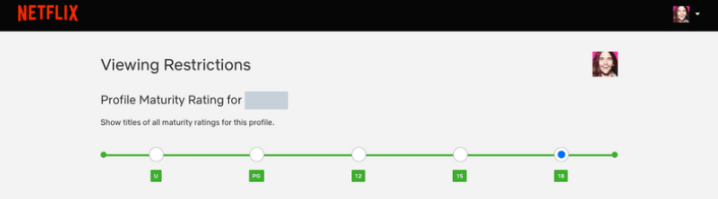
Alternatively, you can use the ‘Kids’ profile that comes with your account, where the rating limit is set to PG by default.

What other safety features are available?
Age ratings aside, there are several other ways you can make each family member’s Netflix user safer and more tailored to their needs and sensitivities.
Profile lock:
You might be thinking: what’s the point of restricting your child’s account when they can just click on yours instead? That’s where the profile lock function comes in handy.
From the same ‘Account’ section mentioned above, you can also protect each individual user with a four-digit PIN code so that only the intended person can access it. This can be a great help if you’re concerned about your child stumbling upon adult content or if you want to avoid family members overwriting each other’s progress on a TV show.
All you need to do is to select the user you want to PIN-protect, click ‘Profile Lock’ from the menu and type in your preferred code. Remember to click ‘Save’ before exiting!

Netflix - Profile lock.png
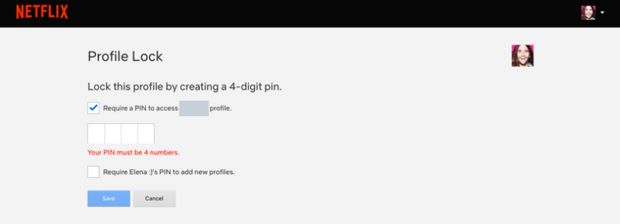
Title restrictions:
You can also prevent specific films and shows from appearing in your child’s feed – even if they’re within the allowed age rating bracket.
If there are certain titles that you believe your child might react strongly to or find upsetting, you can easily weed them out with Netflix’s ‘Title Restriction’ tool, which is available from the same ‘Accounts’ section as above. Simply type in the name of the film or show and click it from the drop-down menu to keep it from appearing on their feed. Don’t forget to hit ‘Save’.

Netflix - Title restrictions.png
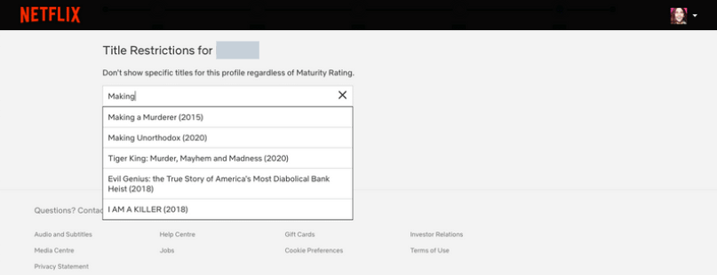

Is there anything else that parents need to know?
Netflix more or less invented the term ‘binge-watching’ – streaming many episodes in quick succession – and this was in large part due to its autoplay function.
Finish each episode and the next one will automatically be queued up; after a brief countdown, it will then kick into life without you needing to do anything. This can make it difficult to keep track of how long you’ve been in front of the screen. You can, however, turn off this feature from the ‘Account’ section if you choose.

Netflix: the Parent Zone verdict
As a video-on-demand service, Netflix can’t really be faulted. It offers a huge amount of quality films and TV shows, many of which aren’t available elsewhere, and is regularly updated with new content to keep you coming back for more.
It’s well-priced – particularly if you’re not bothered about 4K or using it on lots of devices – and flexible too, with the option to watch it on your phone and to download shows for offline viewing.
We’re similarly enamoured from a parents’ point of view. The ability not just to create different user profiles but also to customise them by age rating gives you complete flexibility to choose how little or how much access you give your child to the full Netflix catalogue.
At the same time, it’s simple enough that even young children can easily navigate around and choose their favourite shows, while little touches such as the ability to set child-friendly profile pics all add to the appeal.

