Improving Nutrition in Your School
How Good Nutrition Supports a Good Education
Young people’s brains use proportionately more energy than adults. By the time they arrive at school, our pupils may not have eaten a meal for 13-14 hours. A healthy breakfast and lunch are essential if young people’s brains are going to function, and will lead to better behaviour and better grades, improving:
- Cognitive function, particularly memory, attention, and executive function
- Academic performance and attendance
- On-task behaviour in the class
More than one in three year 6 children are overweight or obese in Tameside, leading to worse physical and mental health outcomes in early and adult life.

A Tameside study suggests that many families don’t have the money, time or knowledge to eat healthily. School meals may be one of the only opportunities for our pupils to eat a nutritious meal. And learning how to cook at school may also be the only opportunity our pupils get to try cooking.
Only 1% of packed lunches meet the national school food standards, and some catered menus don’t either. Governors are accountable for these standards being met.
Sugary snacks and drinks, which are often found in packed lunches, contribute to obesity, as well as tooth decay. Nearly half of 8 year olds (46%) have some form of tooth decay at a significant cost to them, and the NHS.
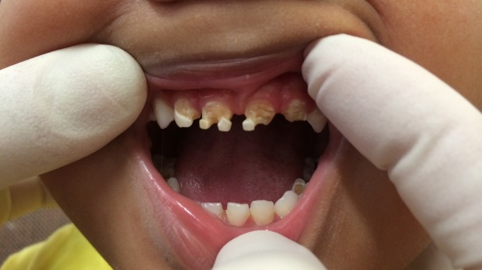

What you could do during the Covid-19 closures…
- Why not upload some nutrition lessons on to your school website for your learners. Foodafactoflife.org contains a number of teaching resources
suitable for remote learning, and recently developed a number
of specific online resources in response to Covid-19.
The workbooks for 5-7 year olds and 7-11 year olds both
contain food diaries, as well as content for older age groups.
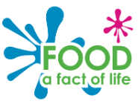
- Lessons could be supported by sharing a healthy recipe each week which learners could make independently, or with parents. This would support learners achieving cooking and nutrition curriculum outcomes. Some recipe ideas are listed here, or here.
- Plan for next year and how your school can take a whole school approach to nutrition. The Children’s Nutrition Team can help with this (see below) and in the meantime they are posting activities on their twitter feed https://twitter.com/NHSTamesideCNT.
What you can do in the new school year…
- Engage with the Children’s Nutrition Team (tga-tr.childrensnutrition@nhs.net) who can advise & support you in developing a whole school approach to healthy nutrition by:
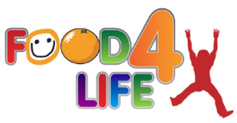
  - Training serving staff on nutrition and portion sizes
  - Reviewing canteen menus against the food standards
  - Providing templates for school nutrition policies
  - Supporting the school to get the Food4life accreditation
  - Offer interventions for specific groups of young people, as well as their parents.
- Develop your breakfast clubs so that more learners can access it and that healthy food is available. A range of grants are available from Magic Breakfast, Kelloggs and Greggs.
- Assign a lead teacher for healthy eating and nutrition in your school.
- Consistent messaging – learning about healthy food and eating and then being able to eat unhealthy food in canteens, tuck shops and class can send a confusing message.

Healthy learners will be better learners!

