**A Guide for Parents**

**Preparing Your Child for Nursery**

The period before your child starts nursery can be an anxious time for you as a parent. We have put together the following steps as a simple guide as to how you can best prepare your child for this exciting time in their lives!

**Early Mathematical Skills**

**Mathematical Development Counting Verbally & One to One**

Being able to count verbally to at least 10 will be of great benefit to a child starting nursery. Practise counting up to ten, and backwards too. One to one counting can also be done incidentally throughout the day, for example counting steps as your child climbs the stairs. You can count anything, for example: how many lamp posts are on the street? How many houses have a red door? How many pieces of fruit are in the bowl (and how many did we have yesterday)? To help your child understand what numbers mean, ask them to find the same amount of different items. For example, find 3 spoons, 3 hats, or 3 socks. You can also sing counting songs.

**Shape, Size & Quantity**

You could go on a shape hunt to see how many circles, squares, rectangles and triangles you can find. You could look for patterns too. Talk about the shape and size of objects, e.g. big car, little car, round ball, square table, rectangular book and ask your child questions such as ‘Can you pass me the biggest box?’, or ‘Which one is the smallest shoe?’. Play with blocks – encourage your child to think about size, colour and shape. Also play with containers – how many socks can you fit in the box? Which container holds the most, or the least, sand/water/beads etc.

**Number Recognition**

A number hunt is a fun way to look for numerals on doors, buses, cars, signs, at home, at the shops or on TV. You could also play ‘I spy’ but with numbers.

**Bedtime Routines**

Establish a good bedtime routine, as this will ensure that your child gets plenty of rest and is ready for nursery in the morning.



**Communication and Language**

Share a storybook with your child and talk about the pictures and the things that are happening; this will help them to practice sitting and listening for a short period of time.

Sing simple nursery rhymes with your child as this can help develop their language and communication skills. Introducing children to a variety of nursery rhymes can help them understand and learn about different sounds. This is an important part of developing those early literacy skills. Listening to different sounds in the environment as well as in nursery rhymes provides children with the foundations in helping them to read and

write.

**Promoting Independence**

Your child will really benefit from being as independent as possible when they start nursery. Your child will feel a real sense of achievement when they accomplish things by themselves! For example: being able to put on their own coat and shoes; being potty trained and able to go to the toilet independently; flushing the toilet and washing their hands.

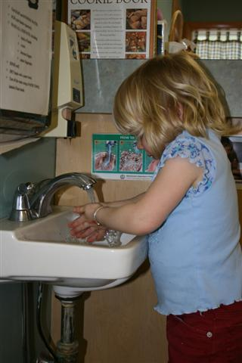 



**Social Skills**

Being able to interact appropriately with other children and adults and share resources is a key skill that will help your child when they start nursery. When playing with your child or when your child is playing with other children you can model useful phrases such as ‘my turn please’ or ‘let’s share’.

Let your child hear a lot of “please”, “thank you”, “you’re welcome” and “excuse me”, as you interact with people throughout the day. Let your child catch the flavour of polite talk.

