

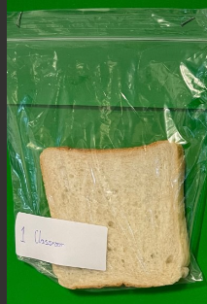

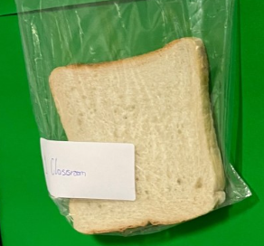

**Week 2**

**Week 1**

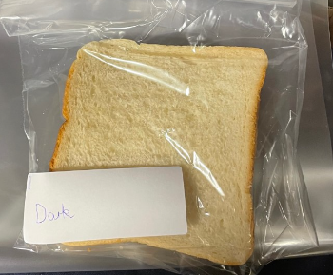

One has been placed in the dark

And another in the light

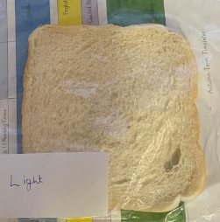

**Group 2**

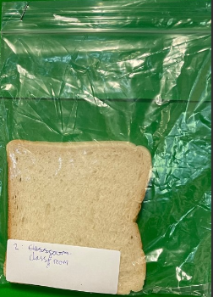

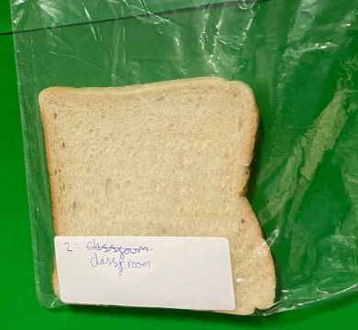

**Week 2**

**Week 1**

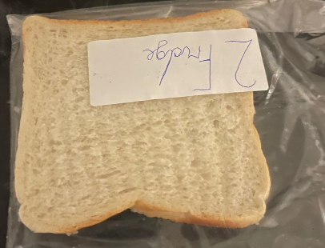

One has been placed in the fridge

And another by the radiator

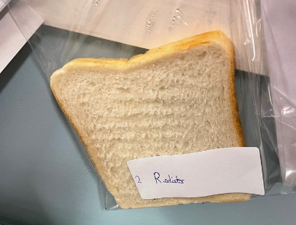

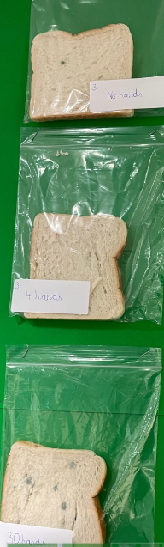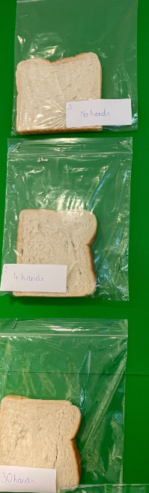

**Group 3**

**Week 2**

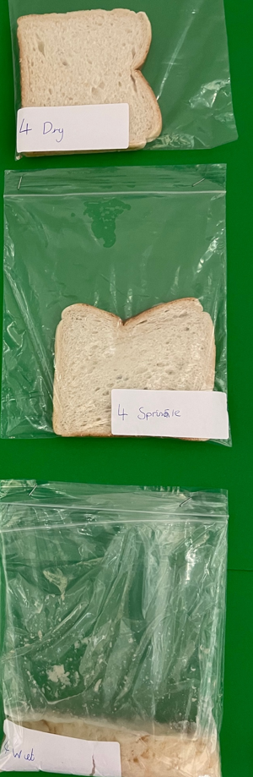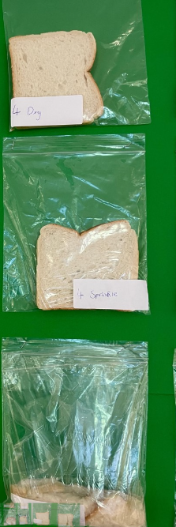

**Week 2**

**Group 4**

**Week 1**

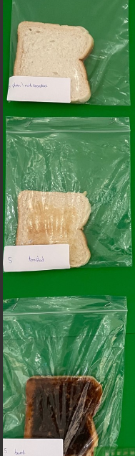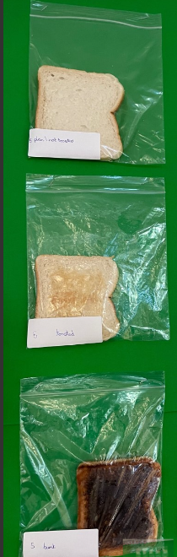

**Group 5**

**Week 2**

**Week 1**

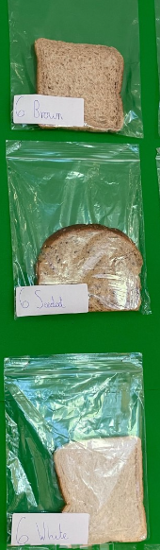****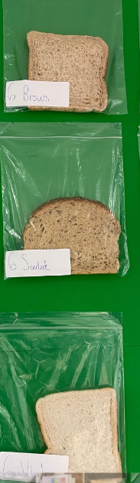

**Group 6**

**Week 1**

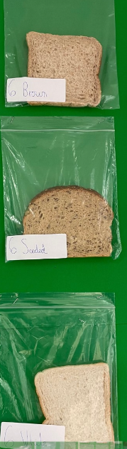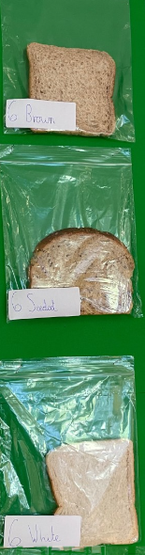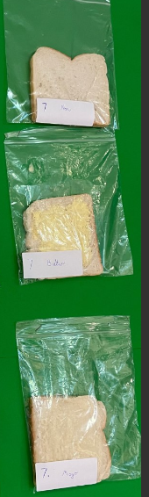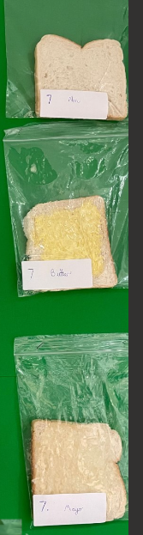

**Group 7**

**Week 2**

**Week 2**

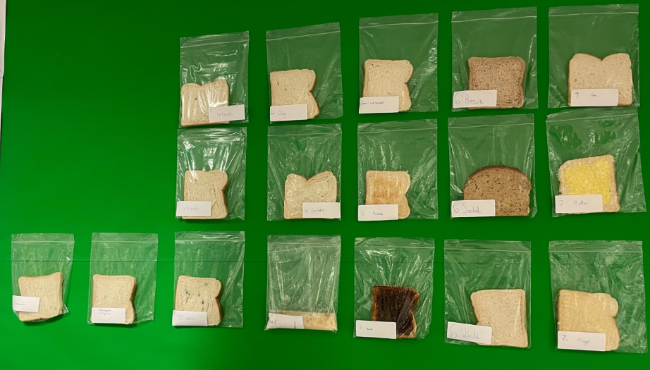

**Light**

**Dark**

**Radiator**

**Cold**

**Warm**

**Week 2 overall**

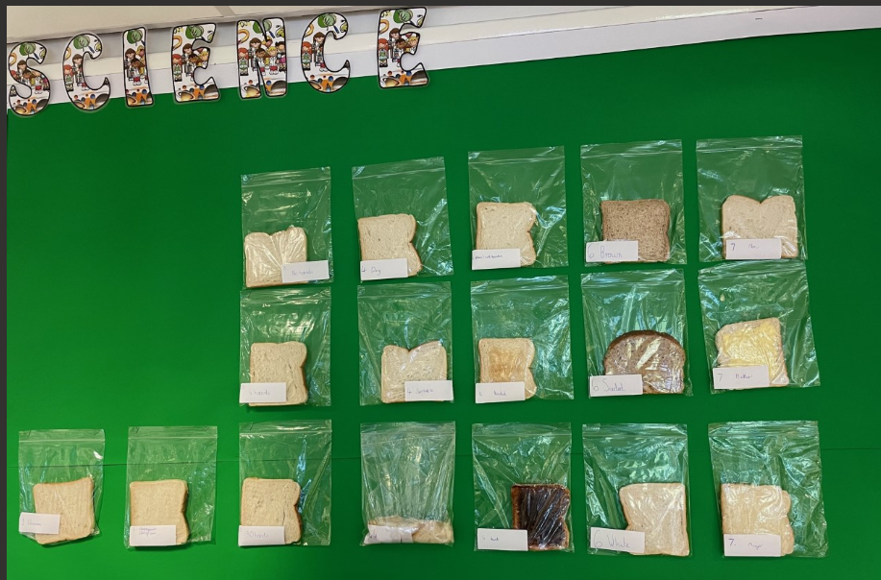

**Cold**

**Warm**

**Light**

**Dark**

**Radiator**

**Week 1 overall**