

Personal, Social and Emotional Development

* I can share and take turns
* I can show respect for other children and adults
* I understand that some behaviour is unacceptable and that this behaviour has consequences
* I can express simple emotions that I am feeling e.g. happy, sad, scared
* I can make my own needs known to an adult e.g. needing to use the bathroom, wanting to go outside, needing help with an activity.

**Preparing your child for Reception**

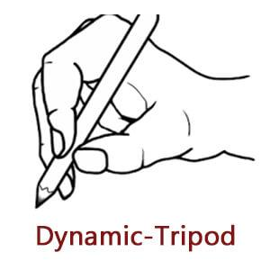

Maths

* I can count to 10
* I can recognise numbers to 10 and order them
* I can match a number and quantity to 10
* I can name and sort 2D shapes (square, circle, oblong, triangle)
* By just looking, I can identify which group has more or less.
* I can count things that cannot be seen e.g. claps, steps
* I can use positional language e.g. The book is *behind* the chair. The ball is *under* the bush.

English

* I can recognise my own name
* I can write my own name
* I can turn the pages in a book and handle books appropriately
* I have some favourite nursery rhymes and I can join in with traditional rhymes and songs
* I can talk about the marks I have made
* I can give meaning to the marks and signs I see in different places

Physical Development

* I can: run on my whole foot, squat and avoid obstacles
* I can hold a pencil correctly (tripod grip)
* When drawing, I can use appropriate shapes to represent images e.g. a circle for a head, and I can talk about what I have drawn.
* I am beginning to use scissors to snip and cut
* I can put on my own coat and shoes
* I can use the toilet and wash my hands independently.

Communication and Language

* I can sit and listen to a story
* I can respond to /follow simple instructions
* I will talk to other children and other well-known adults
* I can repeat a short sentence e.g. “The dog is running.”
* I can speak in simple 4 or 5 word sentences e.g. “I like to play outside.”
* Understands simple ordinal language e.g. first, next