Curriculum Overview Year Y&G Nursery 2024-2025
 | Term 1 |  |  | Term 2 |  |  | Term 3 |  | Term 4 |  | Term 5 |  | Term 6
Focus Themes | All About Me |  |  | Celebrations |  |  | Light and Dark |  | The wonderful world of animals |  | Once Upon a Tale |  | Growing and Changing
Story Focus | Nursery Rhymes  Goldilocks and the Three Bears  We’re Going on a Bear Hunt  Brown Bear, Brown Bear |  |  | The Enormous Turnip  We’re Going on a Leaf Hunt  The Nativity |  |  | The Three Little Pigs  Little Red Riding Hood  Mr Wolf’s Pancakes |  | Chicken Licken  Ugly Duckling  Farmer Duck |  | The Three Billy Goats Gruff  The Little Red Hen  Farmyard Hullabaloo |  | The Very Hungry Caterpillar  Cinderella  Train Ride
 | 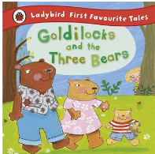  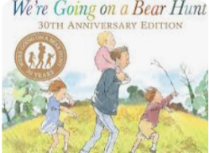  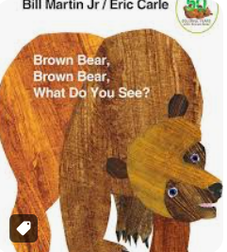 |  |  | 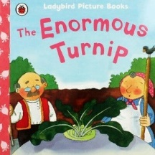  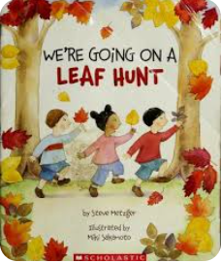  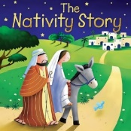 |  |  | 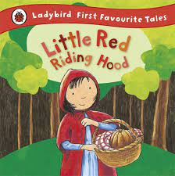  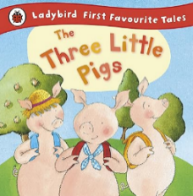  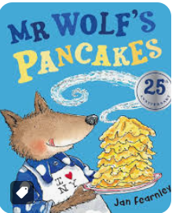 |  | 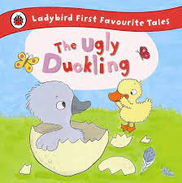  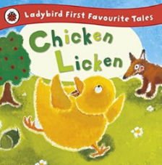  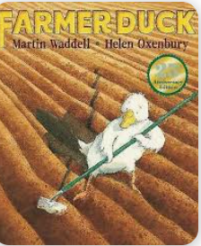 |  | 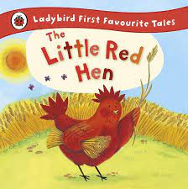  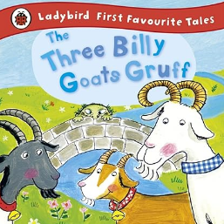  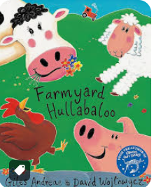 |  | 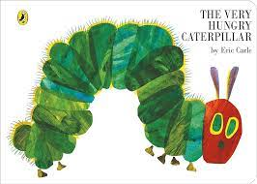  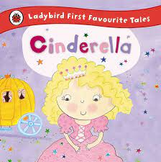  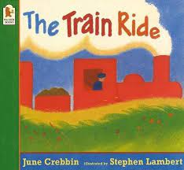
Nursery Rhyme Focus | Twinkle Twinkle  Jack and Jill |  |  | Baa Baa Black Sheep  Dingle Dangle Scarecrow |  |  | Incy Wincy Spider  Hot Cross Buns |  | Humpty Dumpty  Mary had a Little Lamb |  | I Hear Thunder  Hey Diddle, Diddle |  | Hickory Dickory Dock  Grand Old Duke of York
 | Twinkle Twinkle Little Star - CBeebies - BBC  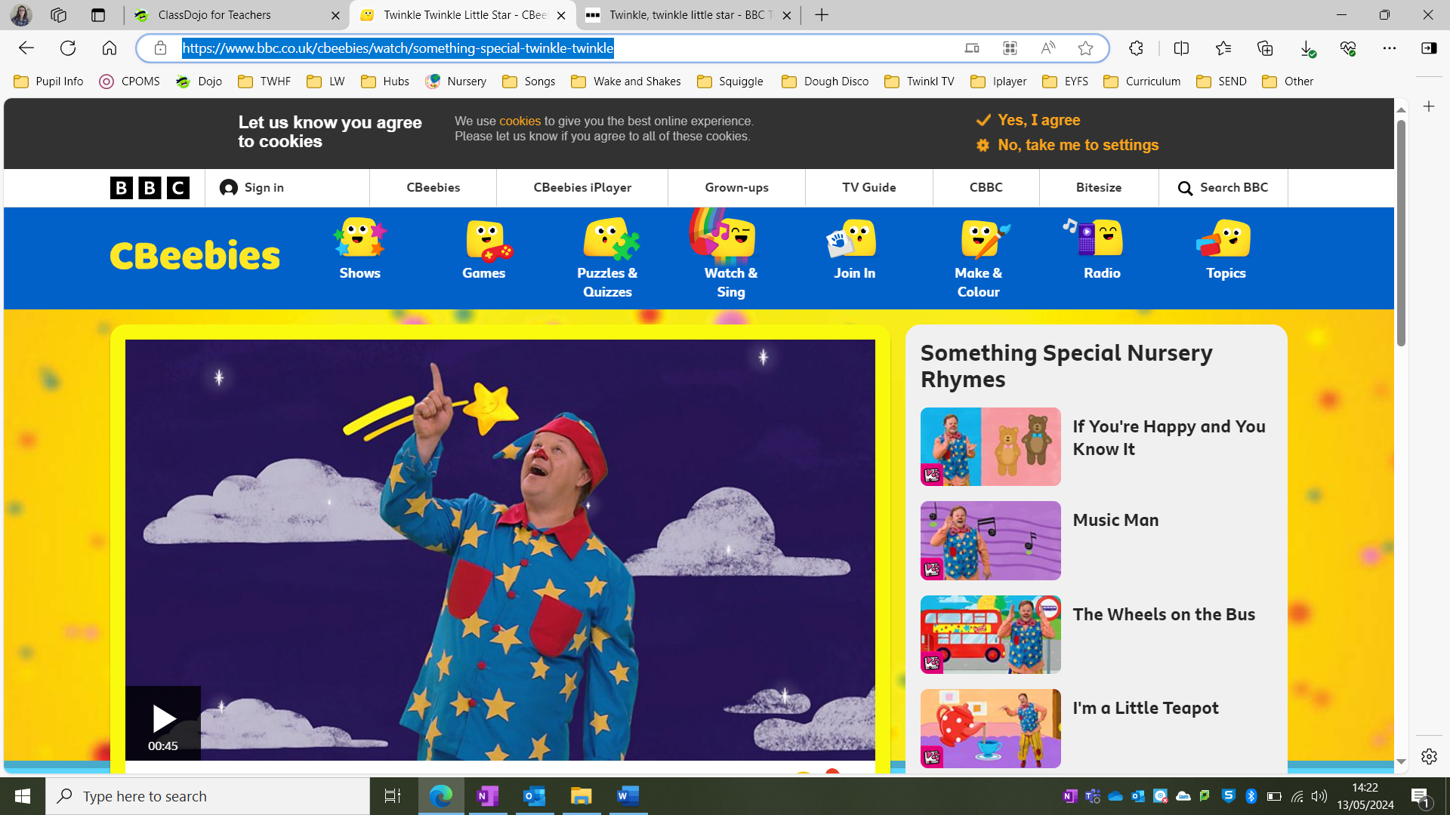 |  |  | Baa Baa Black Sheep: BSL Signed Nursery Rhymes | CBeebies (youtube.com)  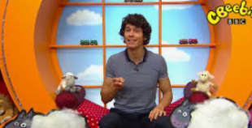 |  |  | Wind The Bobbin Up | The Baby Club (youtube.com)  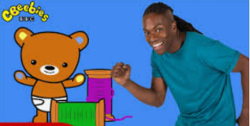 |  | Humpty Dumpty sat on a wall - BBC Teach  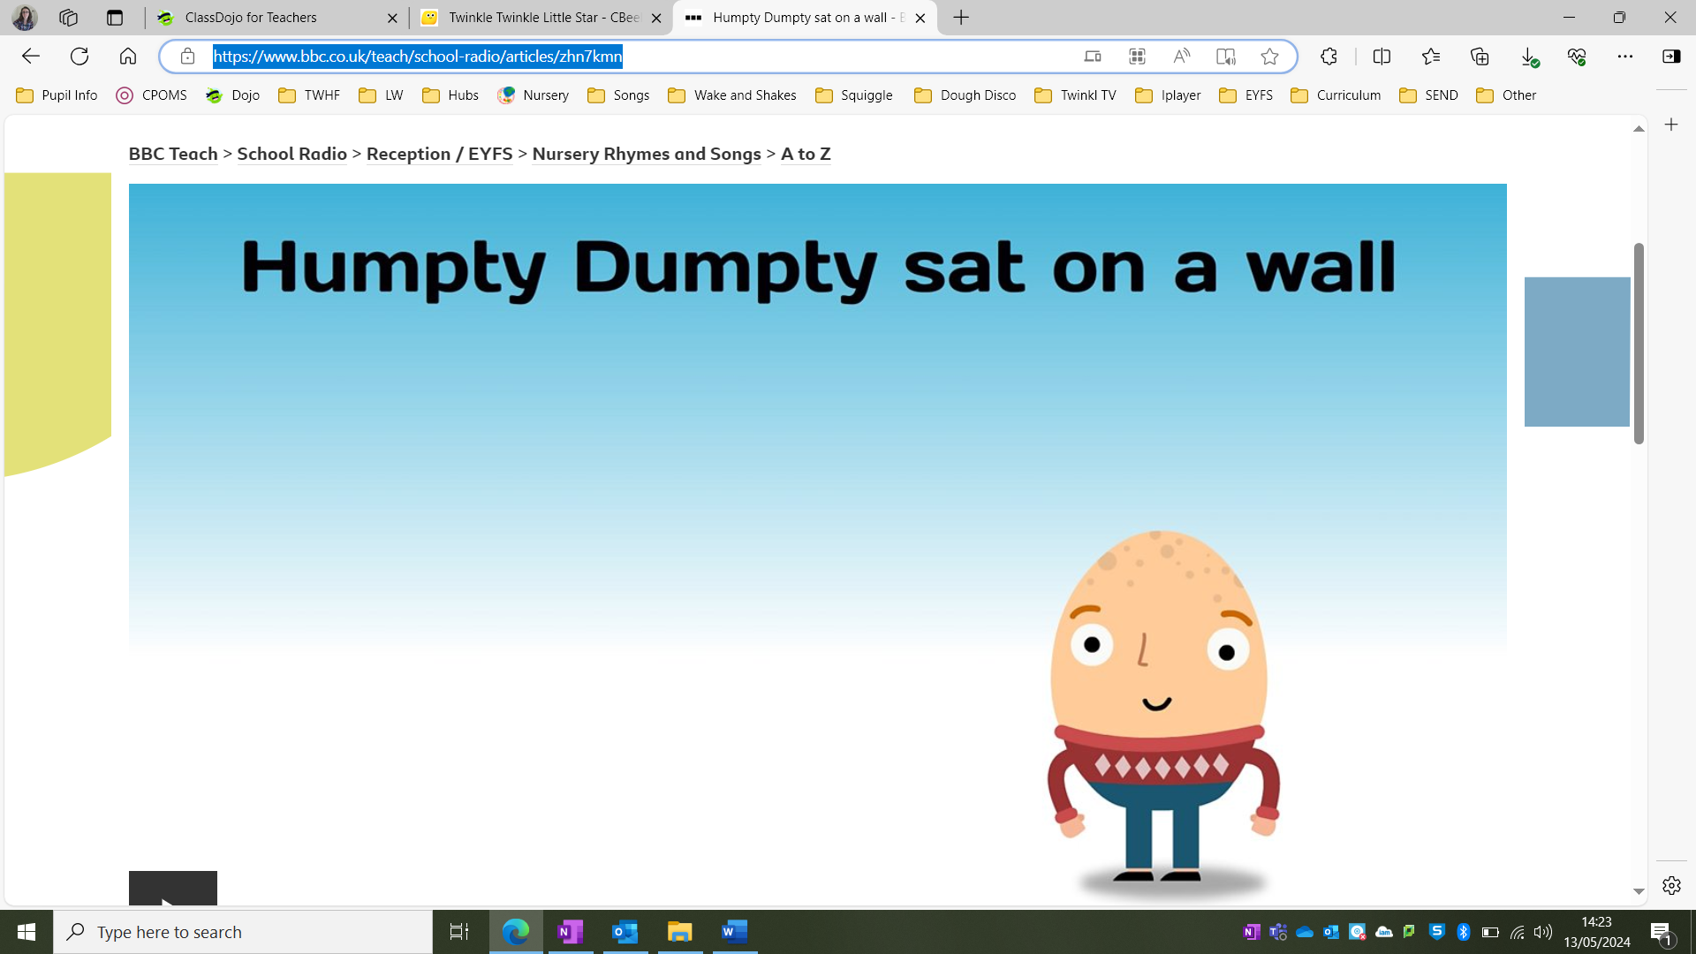 |  | CBeebies: Something Special - I Hear Thunder - Nursery Rhyme - YouTube  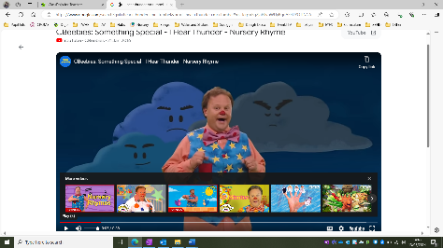 |  | 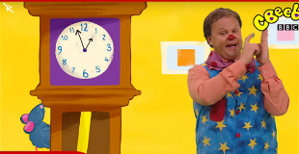  CBeebies: Something Special - Hickory Dickory Dock - Nursery Rhyme (youtube.com)
 | 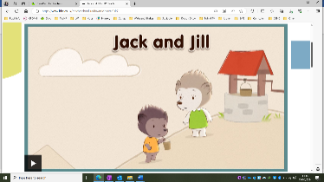  Jack and Jill - BBC Teach |  |  | 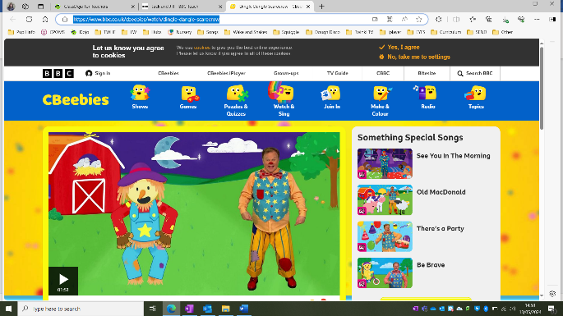  Dingle Dangle Scarecrow - CBeebies - BBC |  |  | 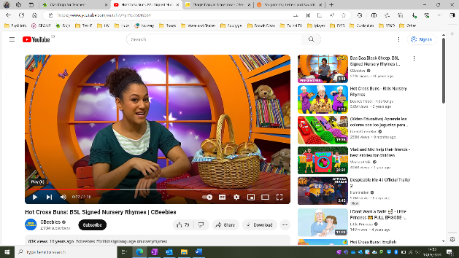  Hot Cross Buns: BSL Signed Nursery Rhymes | CBeebies (youtube.com) |  | 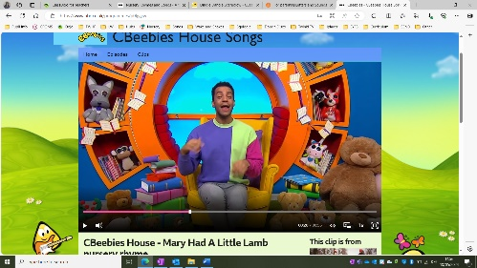  CBeebies - CBeebies House Songs, CBeebies House - Mary Had A Little Lamb nursery rhyme (bbc.co.uk) |  | Hey Diddle Diddle - CBeebies - BBC  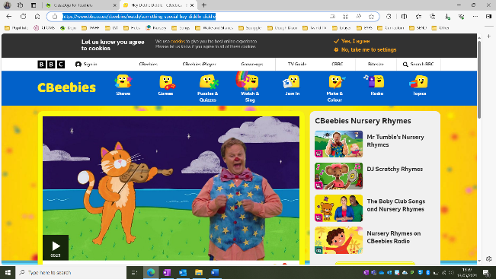 |  | The grand old Duke of York - BBC Teach  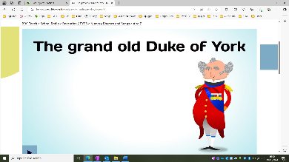
Wow moments | Sensory boxes  Nurse to Visit |  |  | Nativity performance  Festival story – read by a parent  Friday assembly person |  | Dark Den (create space).  School cook/chefs |  |  | Storyteller/puppet show.  Parent/grandparent come in to read a story.  Music centre |  | Visit to Aldi (buy fruits and veg).  Local vets |  | Garden centre visitors
Core vocabulary | Body parts -  Head, shoulders, knees, toes, leg, foot, eyes, mouth, lips, teeth, hands, fingers  Family names – mum dad, brother, sister, aunty, uncle, grandad, grandma, cousins |  |  | Christmas, Diwali, bonfire, fireworks, baubles, decorations, tree, mendi, lamps, colour, Hanukkah |  | Rockets, planets, stars, aliens, moon, sun |  |  | Animals, habitat, jungle, forest, zoo, farm |  | Once upon a time, Animals, fairies, tiara, princess, prince, crown, adventure, characters. |  | Growth, life cycle, minibeasts.  Caterpillar, cocoon, butterfly.  Tadpole, froglet, frog.  Baby, toddler, child, adult older person.  Days of the week.
Experiences – visitors | Male teacher to read story |  |  | Parent – Diwali |  |  |  |  | Librarian  -grandparents to read a story |  | A visit from a nurse |  | Jonathan`s Jungle Visit
Visits | Year 1 garden  Dental Nurse Visit |  |  | Visit to a church  Christmas performance  -Carol singers performance  - Book Fair |  | Visit Library |  |  | Visit to a shop (Aldi)  - Book Fair |  | Family picnic |  | Coat water park
Welly Walks |  |  |  |  |  | Welly walk (muddy puddles)
Parent partnership | Drove primary expectation meeting  Toilet Training Workshop |  |  | Diwali stay and play  Christmas stay and play  Nursery nativity |  | Reading session.  Early words together parent workshop. |  |  | Reading session world book day.  Grandparents story session  Easter Stay and Play |  | . |  | Graduation ceremony  Sports day
History/ events  Pictures of children when they were younger/babies |  |  |  | Diwali  Remembrance Day  Christmas & Christmas song performance  Guy Fawkes/bonfire night |  | Lunar New Year |  |  | Mother’s Day  Easter - egg hunt |  | Ramadan  Eid |  | Father’s Day  Summer party day  Planting sunflower/cress
Communication and language | Communication and language are not taught discretely; speaking, listening and understanding skill are entwined in all areas of learning
Whole EYFS Focus – C&L is developed throughout the year through high quality interactions, daily group discussions, sharing circles, PSHE times, stories, singing, speech and language interventions, Word Aware 2 , EYFS productions, assemblies and weekly interventions | LA – listens to others in small groups and is able to follow directions.  U – Identifies action words by following simple instructions.  -Understand who, what and where in simple questions.  S – Uses language to share feelings, emotions and thoughts. |  |  | LA – Listens to familiar stories with increasing attention and recall.  U – Beginning to understand more complex sentences, e.g. Put your toys away and then sit on the carpet.  S - Learns new words very rapidly and is able to use them in communicating. |  |  | LA – Joins in with repeated refrains and anticipates key events and phrases in rhymes and stories.  U – Understands who, what, where in simple questions (e.g. Who’s that? Who can? What’s that? Where is?).  S - Uses a variety of questions (e.g. what, where, who). |  | LA – Shows interest in play with sounds, songs and rhymes.  U – Developing understanding of simple concepts (e.g. fast/slow, good/bad).  S - Beginning to use word endings (e.g. going, cats. |  | LA – Focusing attention – can still listen or do, but can change their own focus of attention.  U – Understands use of objects (e.g. Which one do we cut with?).  S - Beginning to use more complex sentences to link thoughts (e.g. using and, because). |  | LA – Single channelled attention; can shift to a different task if attention fully obtained.  U – Shows understanding of prepositions such as under, on top, behind by carrying out an action or selecting correct picture.  S - Uses talk to explain what is happening and  anticipate what might happen next.
Personal, Social and Emotional Development | MR – Seeks companionship with adults and other children sharing experiences and play ideas.  SS – Knows their own name, preferences and interests and is becoming aware of their unique abilities.  UE – Express the self-aware emotions of pride and embarrassment as well as a wide range of other feelings. |  |  | MR- Shows empathy and concern for people who are special to them by partially matching others’ feelings with their own, e.g. may offer a child a toy they know they like.  SS - Is developing an understanding of and interest in differences of gender, ethnicity and ability.  UE - Is becoming able to think about their feelings as their brain starts to develop the connections that help them manage their emotions. |  |  | MR- Uses their experiences of adult behaviours to guide  their social relationships and interactions.  SS - Shows a sense of autonomy through asserting their ideas and preferences and making choices and decisions.  UE - Seeks comfort from familiar adults when needed and distracts themselves with a comfort object when upset. |  | MR- Enjoys playing alone, alongside and with others, inviting others to play and attempting to join  others’ play.  SS - Experiments with their own and other people’s views of who they are through their play, through trying out different behaviours, and the way they talk about themselves.  UE - Responds to the feelings of others, showing concern and offering comfort. |  | MR- Practices skills of assertion, negotiation and compromise and looks to a supportive adult for help in resolving conflict with peers.  SS - Is gradually learning that actions have  consequences but not always the consequences  the child hopes for.  UE - May recognise that some actions can hurt or  harm others and begins to stop themselves from  doing something they should not do, in favourable conditions. |  | MR- Develops particular friendships with other  children, which help them to understand different  points of view and to challenge their own and  others’ thinking.  SS - Is becoming more aware of the similarities and differences between themselves and others in  more detailed ways and identifies themselves in  relation to social groups and to their peers.  UE - Talks about how others might be feeling and responds according to their understanding of the  other person’s needs and wants.
Physical Development | MH – Begins to understand and choose different ways of moving.  -Holds mark-making tools with thumb and all fingers.  HSC – Develops some independence in self-care and shows awareness of routines.  -Able to help and increasingly independently to take off simple clothing. |  |  | MH - May be beginning to show preference for  dominant hand and/or leg/foot.  - Holds mark-making tools with thumb and all  Fingers.  HSC - Develops increasing understanding of and control of the bowel and bladder urges and starts to communicate their need for the preferred choice  of potty or toilet. |  |  | MH - Climbs up and down stairs by placing both feet on each step while holding a handrail for support.  HSC - Begins to recognise danger and seeks the support and comfort of significant adults. |  | MH - Moves in response to music, or rhythms played on instruments such as drums or shakers.  HSC - Can increasingly express their thoughts and emotions through words as well as continuing to use facial expressions. |  | MH - Uses wheeled toys with increasing skill such as pedalling, balancing, holding handlebars and sitting astride.  HSC - Can tell adults when hungry, full up or tired or when they want to rest, sleep or play. |  | MH - Shows increasing control in holding, using and manipulating a range of tools and objects such  as tambourines, jugs, hammers, and mark making tools.  HSC - Observes and can describe in words or actions the effects of physical activity on their bodies.
Literacy | R – Listens and joins in with stories and poems when reading one-to-one and in small groups.  W – Distinguishes between different marks they make. |  |  | R - Joins in with repeated refrains and anticipates key events and phrases in rhymes and stories.  W - Enjoys drawing and writing on paper, on screen and on different textures, such as in sand or playdough and through using touch-screen technology. |  |  | R - Begins to be aware of the way stories are  structured, and to tell own stories.  W - Makes up stories, play scenarios, and drawings in  response to experiences, such as outings. |  | R - Talks about events and principal characters in stories and suggests how the story might end.  W - Sometimes gives meaning to their drawings and paintings. |  | R - Stories and suggests how the story might end.  W - Begins to make letter-type shapes to represent the initial sound of their name and other familiar words. |  | R - Shows interest in illustrations and words in print and digital books and words in the environment.  W - Attempts to write their own name, or other names and words, using combinations of lines, circles and curves, or letter-type shapes.
Writing focus – MUST be used alongside Getting Ready to Write. This simply talks about types of marks. | - Random scribbling – Some meaning may be applied to this.  -Lines made to show writing will be different to their drawings.  - It will look like horizontal / vertical lines / circular marks. |  |  |  |  |  | - Scribble writing - Children will be ascribing meaning to their marks.  - Movement of writing will follow a left to right motion on the page.  - There will be a range of vertical, horizontal and circular lines and an attempt at using diagonal line. |  |  |  | - A wider variety of marks will be used to show writing.  - Bouncy patterns, zig zag, circular, horizontal  - Movement of writing will follow a left to right motion on the page.  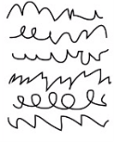 |  | - Name writing (or attempt to)  - Symbols produced to complete their name, these may or may not be correctly formed.  - A range of vertical, horizontal, circular and diagonal marks.  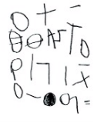
Mathematics | C – Beginning to count on their fingers.  SA – Moves their bodies and toys around objects and explores fitting into spaces. |  |  | C - Beginning to compare and recognise changes in  numbers of things, using words like more, lots or  ‘same’.  SA - Explores how things look from different  viewpoints including things that are near or far away. |  |  | C - Begins to say numbers in order, some of which are in the right order (ordinality).  S - Recognises that two objects have the same shape. |  | C - In everyday situations, takes or gives two or three objects from a group.  P - Joins in and anticipates repeated sound and action  Patterns. |  | C - Beginning to notice numerals (number symbols).  M - Explores differences in size, length, weight and capacity. |  | C - Compares two small groups of up to five objects, saying when there are the same number of objects in each group, e.g. You’ve got two, I’ve got two. Same!  M - Beginning to anticipate times of the day such as mealtimes or home time.
Understanding the World | PC – Has a sense of own immediate family relations and pets.  -Begin to have their own friends.  TW – Enjoys playing with small world reconstructions building on first hand experiences.  T – Plays with water to investigate `low technology` such as washing and cleaning. |  |  | PC – In pretend play, imitates everyday actions and events from own family and cultural background, e.g. making and drinking tea, going to the barbers,  being a cat, dog or bird.  TW - Can talk about some of the things they have observed such as plants, animals, natural and found objects.  T - Plays with a range of materials to learn cause and effect, for example, makes a string puppet using dowels and string to suspend the puppet. |  |  | PC – Learns that they have similarities and differences that connect them to, and distinguish them from, others.  TW - Comments and asks questions about aspects of their familiar world such as the place where they live or the natural world.  T - Shows skill in making toys work by pressing parts or lifting flaps to achieve effects such as sound, movements or new images. |  | PC – Enjoys joining in with family customs and routines.  TW - Developing an understanding of growth, decay and changes over time.  T - Knows how to operate simple equipment, e.g.  turns on CD player, uses a remote control, can  navigate touch-capable technology with support. |  | PC – Knows some of the things that make them unique, and can talk about some of the similarities and  differences in relation to friends or family.  TW - Shows care and concern for living things and the environment.  T - Plays with water to investigate “low technology” such as washing and cleaning. |  | PC – Recognises and describes special times or events for family or friends.  TW - Begin to understand the effect their behaviour can have on the environment.  T - Knows that information can be retrieved from digital devices and the internet.
UTW Science | Making playdough (changing tests) |  |  | Water balloons (hidden objects)  Pumpkin going mushy  Investigate wind (windmills, streamers, bubbles) |  |  | Pancakes (changing tests)  Categorizing materials (smooth, hard, soft, rough etc) |  | Melting chocolate -chocolate nests (changing states)  Forces (pushing, pulling etc) |  | Mouldy bread (bread over time)  Where do bugs live (underground, on leaves etc) |  | Jelly bath  Life cycle (butterflies)  Floating and sinking
Resources in provision:

Mirrors, natural objects: sticks, pine cones, bark, gravel, smooth stones, pebbles, wooden rings, sponge cylinders, shells, magnifying glasses, sand timers, oil timers, leaves, water play (funnels, pipes, sand play, different length tubes, magnetic shapes, my mirror book, texture books, life cycle books, weather station (daily routine), binoculars, magnifying sheet, bug viewers, animal skin pictures, people/animal jigsaws, animal/seasons/my body books, wind up torches, friction cars, bird feeders.

Expressive Arts and Design | CM – Joins in singing songs.  -enjoys and responds to playing with colour in a variety of ways such as combining colours.  BI – uses movement and sounds to express experiences, ideas and feelings. |  |  | CM - Creates sounds by rubbing, shaking, tapping, striking or blowing.  BI - Uses everyday materials to explore, understand  and represent their world – their ideas, interests and fascinations. |  |  | CM - Experiments with ways to enclose a space, create shapes and represent actions, sounds and objects.  BI - Begins to make believe by pretending using sounds,  movements, words, objects Beginning to describe sounds and music imaginatively, e.g. scary music. |  | CM - Develops an understanding of how to create and use sounds intentionally.  BI - Sings to self and makes up simple songs. |  | CM - Uses various construction materials, e.g. joining pieces, stacking vertically and horizontally, balancing, making enclosures and creating spaces.  BI - Notices what other children and adults do,  mirroring what is observed, adding variations and  then doing it spontaneously. |  | CM - Develops an understanding of using lines to enclose a space, and begins to use drawing  to represent actions and objects based on  imagination, observation and experience.  BI - Uses available resources to create props or creates imaginary ones to support play.
Texts that show cultural, social, technological and ecological diversity |  | Cultural diversity  Nursery - Families  -My Family, Your Family, Our Family  -Global babies  -We are all welcome  Reception  - The big book of families  - We are welcome | Nursery - The sand between my toes  -Bea by the sea  Reception – Lily and the Polar Bear |  | Nursery - A bear hug at bedtime  Reception |  |  | Nursery  Reception – Holi Festival of colours |  | Nursery  Reception – Proudest Blue  Moja Means One (Tanzania)  Amazing Africa |  | Nursery  Reception
 |  | Social Diversity  Nursery Families | Nursery – Clive and the babies |  | Nursery – Rosa loves dinosaurs |  |  | Nursery |  | Nursery |  | Nursery
 |  | Science Texts  Nursery | Nursery |  | Nursery |  |  | Nursery |  | Nursery |  | Nursery
 |  | Ecological diversity  Nursery | Nursery – Commotion in the ocean |  | Nursery |  |  | Nursery - Tiddler |  | Nursery |  | Nursery
 |  | Technological diversity  Nursery | Nursery – Robots, Robots Everywhere |  | Nursery |  |  | Nursery |  | Nursery |  | Nursery
Text for Past and Present |  | Nursery | Nursery |  | Nursery |  |  | Nursery |  | Nursery |  | Nursery
Text for people, culture and communities |  | Nursery | Nursery |  | Nursery |  |  | Nursery |  | Nursery |  | Nursery
Texts for the natural world |  | Nursery | Nursery |  | Nursery |  |  | Nursery |  | Nursery |  | Nursery

