What should I already know?

(Substantive Knowledge)

* Understand we can use a variety of brushes, holding them in a variety of ways to make watercolour marks.
* Understand watercolour is a media which uses water and pigment.
* Understand we may all have different responses in terms of our thoughts and the things we make. That we may share similarities. Understand all responses are valid.

Key Vocabulary:

|  |  |
| --- | --- |
| Sketchbook   | A book or pad of drawing paper for sketches. |
| Watercolour   | A dry paint that is mixed with water. |
|  | The materials used to make a work of art like clay, wood, paint, fabric, charcoal. |
| Colour | Made of different pigments that shows and describes different things. |
| Blending   | The process of putting two colors together so that the paint moves from one color to another, or combines to create a new color. |
| Composition   | The way something is put together in a piece of art or a photograph. |

What will I learn?

(Implicit Knowledge/Skills)

* Develop experience of primary and secondary colours.
* Practice observational drawing.
* Explore mark making.
* Explore watercolour in an intuitive way to build understanding of the properties of the medium.
* Paint without a fixed image of what you are painting in mind.
* Respond to your painting, and try to “imagine” an image within.
* Work back into your painting with paint, pen or coloured pencil to develop the imaginative imagery.

Focus Artists

Emma Burleigh

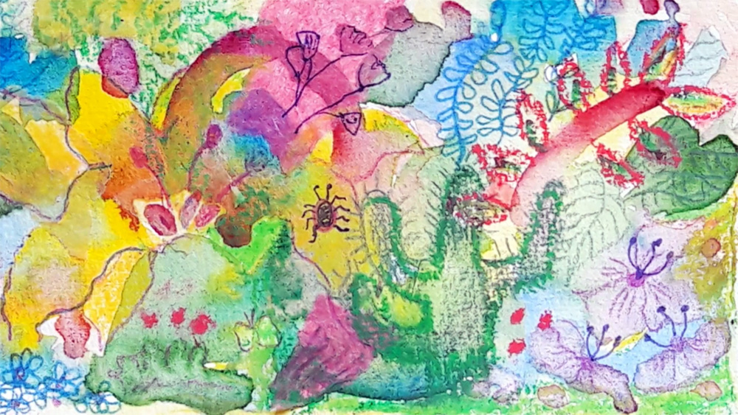

Blooms Taxonomy – Specific Verbs to Use in Lesson Aims

Knowledge: Describe, find, identify, list, locate, name, recognise, retrieve Comprehension: Classify, compare, explain, infer, interpret, paraphrase, summarise Application: Carry out, implement, use Analysis: Deconstruct, Organise, outline, structure Synthesis: Construct, design, devise, invent, make, plan, produce, Evaluation: Appraise, assess, choose,

Glue here.

My Learning Ladder

|  |  |  |  |
| --- | --- | --- | --- |
| Learning Objective | | Pupil Voice | Teacher Assessment |
| to discover what water is like as an art medium | |  |  |
| to discuss the work of Emma Burleigh | |  |  |
| to explore building imagery through watercolour | |  |  |
| to create a watercolour painting of *final piece | |  |  |
| to create a watercolour painting of *final piece | |  |
| to evaluate my watercolour painting | | See below. |  |
| Evaluation of my Final Piece | | | |
|  |  | | |
|  |  | | |
|  |  | | |