What should I already know?
(Substantive Knowledge)
- Understand that some painters use expressive, gestural marks in their work, often resulting in abstract, expressionist painting.

- Understand that the properties of the paint that you use, and how you use it, will affect your mark making.

- Understand that primary colours can be mixed together to make secondary colours of different hues.

- Understand the concept of still life.

- Understand artists take their inspiration from around them, collecting and transforming and that in art we can experiment and discover things for ourselves.
Key Vocabulary:

Colour  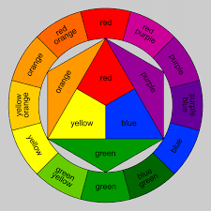 | Different pigments that help us to depict and describe the subject.
Gestures  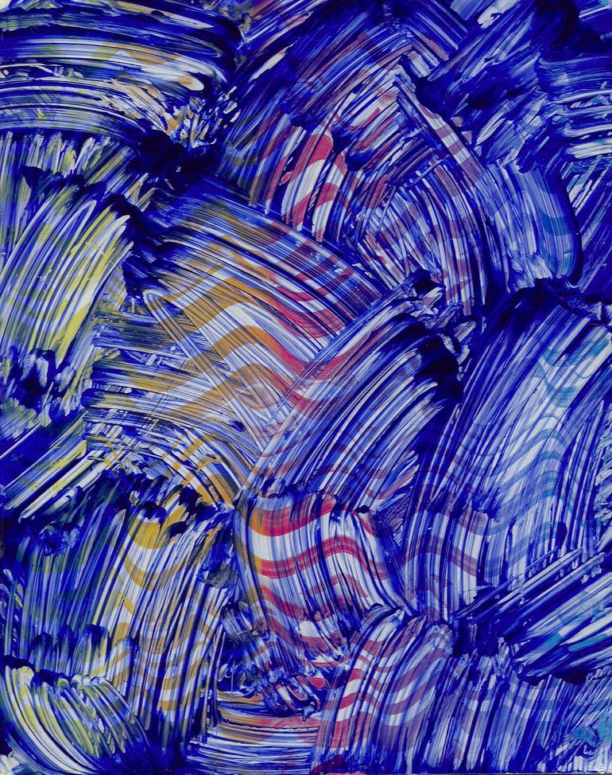 | The application of paint that is applied with free-flowing gestural strokes that result from the artists movement.
Paint  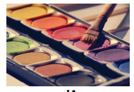 | A coloured substance which is spread over a surface and dries to leave a thin decorative or protective coating.
Texture  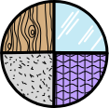 | The feel, appearance, or consistency of a surface or substance.
Form   | Something that is three-dimensional and encloses volume, having length, width, and height.
Expression   | Something about the 'self', the artist is trying to share. Like their feelings, own experiences and choices.

What will I learn?
(Implicit Knowledge/Skills)

- Explore colour and colour mixing.

- Explore colour mixing through gestural mark making, initially working without a subject matter to allow exploration of media. Experiment with using homemade tools.

- Create an arrangement of objects or elements. Use as the focus for an abstract still life painting using gestural marks using skills learnt above.

- Reflect upon the artists’ work, and share your response verbally (“I liked…”).

- Present your own artwork (journey and any final outcome), reflect and share verbally (“I enjoyed… This went well”).

- Talk about intention.

Focus Artists
Vincent Van Gogh

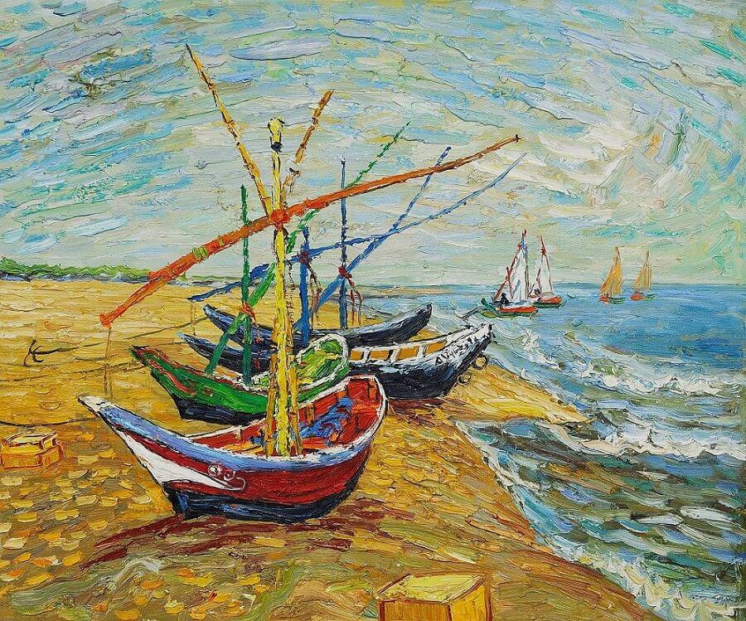

Blooms Taxonomy – Specific Verbs to Use in Lesson Aims
Knowledge: Describe, find, identify, list, locate, name, recognise, retrieve Comprehension: Classify, compare, explain, infer, interpret, paraphrase, summarise Application: Carry out, implement, use Analysis: Deconstruct, Organise, outline, structure Synthesis: Construct, design, devise, invent, make, plan, produce, Evaluation: Appraise, assess, choose,

Glue here.
My Learning Ladder

Learning Objective |  | Pupil Voice | Teacher Assessment
to discuss colour through the work of Marela Zacarias and Charlie French
to explore primary and secondary colours
to explore the work of Vincent Van Gogh
to use collage techniques to recreate Fishing Boats on the Beach
to use gestural marking techniques to recreate Fishing Boats on the Beach
to evaluate my Fishing Boats on the Beach recreation |  | See below.
Evaluation of my Final Piece


