What should I already know?
(Substantive Knowledge)
- Understand artists can work with pattern for different reasons: Understand Surface Pattern Designers work to briefs to create patterns for products: Artists work with pattern to create paintings or other works.

- Understand working with pattern uses lots of different concepts including repetition, sequencing, symmetry

- Understand that artists use sketchbooks for different purposes and that each artist will find their own ways of working in a sketchbook.
Key Vocabulary:

Layering   | Putting one thing on top of the other.
Repeating  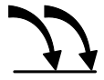 | To be affected, inspired or changed by someone or something.
Tessellated   | A piece of art made by sticking various different materials such as photographs and pieces of paper or fabric on to a backing.
Shape   | The external form, contours, or outline of someone or something.
Pattern  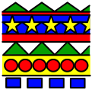 | A repeated decorative design.
Composition   | The way something is put together in a piece of art or a photograph.

What will I learn?
(Implicit Knowledge/Skills)

  - Use colour, composition, elements, line, shape to create pattern working with tessellations, repeat pattern or folding patterns.

- Practice drawing skills.

- Test and experiment with different materials.

- Make visual notes to record ideas and processes discovered through looking at other artists.

- Brainstorm pattern, colour, line and shape.

Focus Artists
Rachel Parker, Shaheen Ahmed,

Andy Glimore and Louise Despont

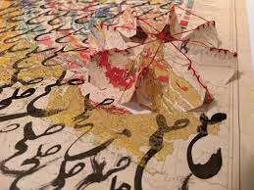
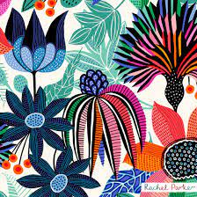

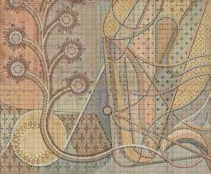
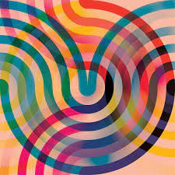

Blooms Taxonomy – Specific Verbs to Use in Lesson Aims
Knowledge: Describe, find, identify, list, locate, name, recognise, retrieve Comprehension: Classify, compare, explain, infer, interpret, paraphrase, summarise Application: Carry out, implement, use Analysis: Deconstruct, Organise, outline, structure Synthesis: Construct, design, devise, invent, make, plan, produce, Evaluation: Appraise, assess, choose,

Glue here.
My Learning Ladder

Learning Objective |  | Pupil Voice | Teacher Assessment
to explore the work of Shaheen Ahmed
to create my own rules and resolutions for my own drawings
to explore the work of a surface pattern designer (Andy Gilmore)
to create my own repeating pattern, exploring colour, shape and composition.

to add details to my own repeating pattern, exploring colour, shape and composition.
to evaluate my final piece |  | See below.
Evaluation of my Final Piece


