What should I already know?
(Substantive Knowledge)

- Understand that set designers can design/make sets for theatres or for animations.
- Understand that designers often create scaled models to test and share ideas with others.
- Understand that there is a tradition of artists working from land, sea or cityscapes. That artists use a variety of media to capture the energy of a place, and that artists often work outdoors to do this.
Key Vocabulary:

Scaled Models  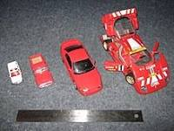 | An object smaller or its size relative to the size of the "real" version.
Cityscapes   | The visual appearance of a city or urban area; a city landscape.
Energy  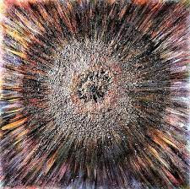 | To create inventive and expressive works of art that resonate with impact and feeling.
Hues and Tints  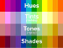 | Primary and Secondary colours are considered hues.  Tint refers to any hue or mixture of pure colours to which white is added.
Contrast  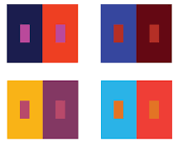 | Difference between art elements like color, value, size, texture, and so on can intensify the elements used.
Composition   | The way something is put together in a piece of art or a photograph.

What will I learn?
(Implicit Knowledge/Skills)

  - Explore mark making.
  - Use charcoal, graphite, pencil, pastel to create drawings of atmospheric “sets” to help inform (though not design) set design
  - Make visual notes to capture, consolidate and reflect upon the artists studied.
  - Experiment with different media and different marks to capture the energy of a landscape.
  - Explore colour, and colour mixing, working intuitively to mix hues and tints, but able to articulate the processes involved.
  - Explore how you can you paint (possibly combined with drawing) to capture your response to a place.
  - Explore how the media you choose, combined with the marks you make and how you use your body will affect the end result.
  - Think about colour, composition and mark making. Think about light and dark, movement and energy.

Focus Artists
Vanessa Gardiner, Shoreditch Sketcher,
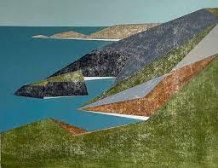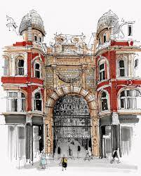

Kittie Jones
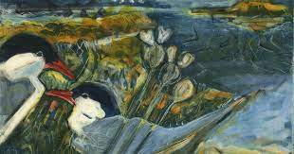

Blooms Taxonomy – Specific Verbs to Use in Lesson Aims
Knowledge: Describe, find, identify, list, locate, name, recognise, retrieve Comprehension: Classify, compare, explain, infer, interpret, paraphrase, summarise Application: Carry out, implement, use Analysis: Deconstruct, Organise, outline, structure Synthesis: Construct, design, devise, invent, make, plan, produce, Evaluation: Appraise, assess, choose,

Glue here.
My Learning Ladder

Learning Objective |  | Pupil Voice | Teacher Assessment
to explore the work of Vanessa Gardiner and Shoreditch Sketcher and compare them
to make spaces and places in my sketchbook
to explore the work of Kitty Jones using visual notes
to create a cityscape using mixed media

to add details to my cityscape

to evaluate my final piece |  | See below.
Evaluation of my Final Piece


