Technical Knowledge and skills:

- Understand that mechanisms are a collection of moving parts that work together in a machine.
- Explore and use mechanisms [wheels and axles], in their products.

What should I already know?
Use what they have learnt about materials,
thinking about uses and purposes
Think about and discuss what they want to make.
Discuss their work as it progresses with support.

DT Skills:
Discuss and evaluate the existing products to understand their purpose. Discus the given design brief and the design criteria.
Design their own product using labelled drawings. Be able to discuss what resources they require for their products.
Based on their individual designs, choose from a variety of materials and perform practical skills e.g cutting joining and finishing the product with some independence etc
Testing their products.
Evaluate their ideas and products against the design criteria provided using a sheet with sentence starters.

Key Vocabulary:

prototype  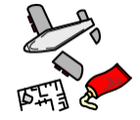 | the first version of something, such as a machine from which all later forms are developed
Wheel 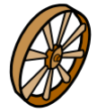 | a circular object that revolves on an axle
axle 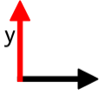 | a rod or spindle (either fixed or rotating) passing through the centre of a wheel
Vehicle  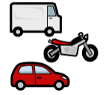 | a machine, usually with wheels and an engine, used for transporting people or goods
Chassis  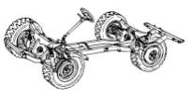 | the base frame of a car
assemble  | fit together the separate component parts.

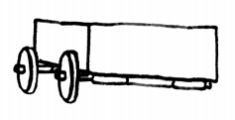

Focused designer/ company
Mini Production plant in Swindon

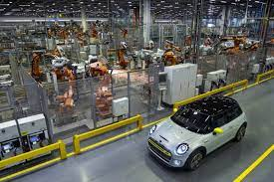

Blooms Taxonomy – Specific Verbs to Use in Lesson Aims
Knowledge: Describe, find, identify, list, locate, name, recognise, retrieve Comprehension: Classify, compare, explain, infer, interpret, paraphrase, summarise Application: Carry out, implement, use Analysis: Deconstruct, Organise, outline, structure Synthesis: Construct, design, devise, invent, make, plan, produce, Evaluation: Appraise, assess, choose,

Key Knowledge

Wheels and axles:
The wheels on the toy car move at the same time and speed because each pair of wheels is attached to a pole called an axle. Real vehicles, such as cars and vans, also have axles.

