Technical Knowledge and skills:

* Understand that mechanisms are a collection of moving parts that work together in a machine.
* Explore and use mechanisms [wheels and axles], in their products.

What should I already know?

Use what they have learnt about materials,

thinking about uses and purposes

Think about and discuss what they want to make.

Discuss their work as it progresses with support.

DT Skills:

Discuss and evaluate the existing products to understand their purpose. Discus the given design brief and the design criteria.

Design their own product using labelled drawings. Be able to discuss what resources they require for their products.

Based on their individual designs, choose from a variety of materials and perform practical skills e.g cutting joining and finishing the product with some independence etc

Testing their products.

Evaluate their ideas and products against the design criteria provided using a sheet with sentence starters.

Key Vocabulary:

|  |  |
| --- | --- |
| prototype | the first [version](https://dictionary.cambridge.org/dictionary/english/example) of something, such as a [machine](https://dictionary.cambridge.org/dictionary/english/machine) from which all [later](https://dictionary.cambridge.org/dictionary/english/later) [forms](https://dictionary.cambridge.org/dictionary/english/form) are [developed](https://dictionary.cambridge.org/dictionary/english/developed) |
| Wheel | a circular object that revolves on an axle |
| axle | a rod or spindle (either fixed or rotating) passing through the centre of a wheel |
| Vehicle | a machine, usually with wheels and an engine, used for transporting people or goods |
| Chassis | the base frame of a car |
| assemble | fit together the separate component parts. |

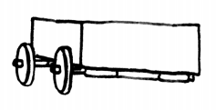

Focused designer/ company

Mini Production plant in Swindon

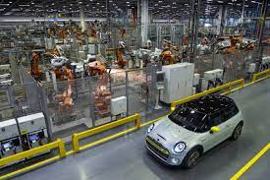

Blooms Taxonomy – Specific Verbs to Use in Lesson Aims

Knowledge: Describe, find, identify, list, locate, name, recognise, retrieve Comprehension: Classify, compare, explain, infer, interpret, paraphrase, summarise Application: Carry out, implement, use Analysis: Deconstruct, Organise, outline, structure Synthesis: Construct, design, devise, invent, make, plan, produce, Evaluation: Appraise, assess, choose,

Key Knowledge

Wheels and axles:

The wheels on the toy car move at the same time and speed because each pair of wheels is attached to a pole called an axle. Real vehicles, such as cars and vans, also have axles.

