Design and Technology Intent, Implementation & Impact Statement

At Drove Primary School we give children “The roots to grow and the wings to fly”. We want our children to use creativity and imagination, to design and make products that solve real and relevant problems within a variety of contexts, considering their own and others’ needs, wants and values. We intend for all children to acquire appropriate subject knowledge, skills and understanding as set out in the National Curriculum. It is our aim to create cross curricular links with other subjects, where possible, such as Mathematics, Science, Computing, and Art. We want Design and Technology to prepare our children, to give them the opportunities, responsibilities, and experiences they need to be successful in later life.

In order to achieve this, we have carefully designed a curriculum which is underpinned by 4 Golden Threads:
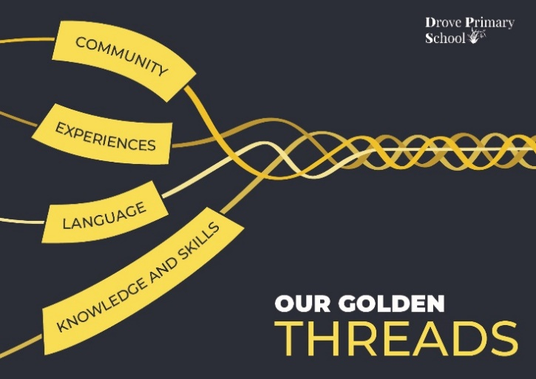

Our Intent:
At Drove Primary School, our 4 Golden Threads underpin our curriculum intent enabling our pupils to achieve the following in design and technology.

- Develop a line of enquiry, asking and answering questions.
- Have knowledge of a range of design and technology skills which they can practice and apply to create their own products.
- Develop an understanding of how design and technology impacts people and the world in which they live.
- To make links and extend learning across other areas of study and within other aspects of our curriculum.
- Develop their critical thinking skills.
- Build up resilience by exploring, designing, making and evaluating creative work.
- Combine their technical knowledge and skills through a hands-on approach using a range of tools, materials and real-life experiences.
- Develop their own sense of belonging as part of a community when learning about the work of designers and products that are significant to them

Our intent is to allow our pupils the experiences required in order to understand design concepts by looking at the works of designers, builders, carpenters and seamstresses and working to find out about the skills, methods and products designers have. Therefore, we encourage them to acquire knowledge and develop an understanding with subject rich vocabulary.

Implementation:
Design and Technology is a crucial part of school life and learning and it is for this reason that as a school we are dedicated to the teaching and delivery of a high-quality Design and Technology curriculum. This is implemented through:

- A well thought out, whole school, yearly overview of the DT curriculum which allows for progression across year groups in all areas of DT (textiles, mechanisms, structures, food and electrical systems)
• Well planned and resourced projects providing children with a hands-on and enriching experience.
• A range of skills being taught ensuring that children are aware of health and safety
issues related to the tasks undertaken.
• Teachers being given ownership and flexibility to plan for Design and Technology; often teaching DT as a block of lessons to allow the time needed for the children to be critical, inventive and reflective on their work.
• Each project from Year 1 to Year 6 addressing the principles of designing, making, and evaluating and incorporating relevant technical knowledge and understanding in
relevant contexts.
• Pupils being introduced to specific designers, chefs, nutritionists, etc. helping to
engender an appreciation of human creativity and achievement and increase the
cultural capital from which they can draw in the future.
• A range of skills taught ensuring that children are aware of health and safety issues related to the tasks undertaken
• Children's interests are captured through project design briefs, giving them purpose, motivation and meaning for their learning.
To support the implementation of our curriculum, we have developed a skills progression document that demonstrates a progression of the skills that need to be taught across each year group. Each skill area has clear progression planned for across each year group, developing on the previous year’s skills.

These are used to inform, plan and assess in design and technology:
- Food technology
- Mechanical systems
- Textiles
- Electrical systems
- Structures

The Knowledge organisers allow pupils to refer to the subject specific vocabulary, skills and knowledge throughout the term.

Wherever possible, teachers plan opportunities for learning design and technology within trips and our local area. It is important at Drove Primary School for pupils to be exposed to these experiences in order to develop their curiosity, deepen their understanding of design concepts and apply this in lessons and other contexts. Teachers are also encouraged to introduce the various replicas and high-quality models we have available in the school to encourage pupils to engage in an enquiry-based approach through levels of questioning:
- What do I already know? – What do you notice?
- What can I infer? – Based on previous knowledge.
- What do I want to know?
- How will I find out?
Pupils are encouraged to observe these sources and use them to evaluate, motivate and inspire their own product.

Early Years Foundation Stage

During the EYFS, pupils explore and use a variety of media and materials through a combination of child initiated and adult directed activities. They have the opportunities to learn to:
• Use different media and materials to express their own ideas
• Use what they have learnt about media and materials in original ways, thinking about form, function and purpose
• Make plans and construct with a purpose in mind using a variety of resources
• Develop skills to use simple tools and techniques appropriately, effectively and safely
• Select appropriate resources for a product and adapt their work where necessary
• Cook and prepare food adhering to good health and hygiene routines

Impact
Our impact is that by the time our pupils leave Drove Primary School, they have developed:
- A secure understanding of how products may have developed over time.
- How to follow the design, make, evaluate process to meet a goal
- Choosing from and using a growing range of tools and materials
- Using and understanding richer technical vocabulary associated with DT
- Critical thinking skills to develop their own technology enquires using a range of questions to develop their understanding of planning, products and designing.
- An ability to support and evaluate the work of others using a wide range of knowledge and evidence.
- A respect for aspects of design and technology and the range of social, cultural, religious and ethnic diversity, in Britain and the wider world, and how this has changed or influenced present day designs and technology.
- An interest in design and technology and an enthusiastic approach to learning, which develops their curiosity.
- Preparing a range of healthy, varied and nutritious dishes
- A wide range of knowledge about designers and design skills ranging from local to global products.
- They gain a firm foundation of knowledge and skills to see them equipped to take on further learning in Secondary School.
• Solving real life practical problems using innovation and creativity, both as an individual and as part of a group
Assessment
Pupil’s skills and knowledge are assessed on an ongoing basis by the class teacher throughout the lessons, using the learning ladders. This informs the Design and Technology coordinator of any further areas for curriculum development, pupil support and/or training requirements for the staff. Marking of children’s work is used alongside more informal questioning, pupil voices and photographic evidence. EYFS pupils' progress and attainment tells us whether each individual child is below expected, at expected or above expected attainment for their age.

