

Maths Policy

Key Document details:
Author: | Sana Ramzan | Approver: | Bryony Bardwell
Owner: | Sana Ramzan | Version No.:
Date: | November 2025 | Next review date: | August 2026
Ratified: | November 2025

Maths at Drove Primary School
At Drove Primary School we give children the roots to grow and the wings to fly through a combination of community, experiences, language, and finally, knowledge and skills.

In our mastery-based approach to Maths, community, experiences, language, and knowledge & skills are woven throughout learning. Mathematical understanding grows through collaborative problem-solving and shared reasoning within a supportive community, which includes our staff, pupils and families. Rich, real-life experiences provide meaningful contexts for applying concepts, making learning purposeful and engaging. Language is central—precise mathematical vocabulary, stem sentences and generalised statements together with oracy empower pupils to articulate thinking and deepen understanding. Finally, knowledge and skills are built systematically, ensuring fluency, reasoning, and problem-solving, enabling every child to achieve their full potential.
Context:
The National Curriculum for Maths aims to ensure that all pupils:
• Become fluent in the fundamentals of maths, including through varied and frequent practice with increasingly complex problems over time, so that pupils develop conceptual understanding and the ability to recall and apply knowledge rapidly and accurately
• Reason mathematically by following a line of enquiry, conjecturing relationships and generalisations, and developing an argument, justification or proof using mathematical language
• Can solve problems by applying their maths to a variety of routine and non-routine problems with increasing sophistication, including breaking down problems into a series of simpler steps and persevering in seeking solutions.’
The National Curriculum for Maths also states:
‘The expectation is that the majority of pupils will move through the programmes of study at broadly the same pace. However, decisions about when to progress should always be based on the security of pupils’ understanding and their readiness to progress to the next stage. Pupils who grasp concepts rapidly should be challenged through being offered rich and sophisticated problems before any acceleration through new content. Those who are not sufficiently fluent with earlier material should consolidate their understanding, this maybe through additional practice, before moving on.’ (National Curriculum, Pg. 3)
At Drove, we feel the best way to achieve the aims set out by the National Curriculum is through a Mastery Approach.
The Mastery Approach at Drove:
In essence, the Mastery Approach at Drove enables:
• pupils to have deep and secure understanding of mathematical concepts, so they do not need to be re-taught and pupils are ready for the next stage of their mathematical journey;
• the removal of gaps in learning so that pupils can make progress whilst also ‘keeping up with their peers, rather than catching up’.
The Mastery Approach at Drove is underpinned by a set of shared beliefs:
- Everyone can do maths, if they have the right attitude and teachers support and challenge them appropriately;
- Teachers are expert mathematicians, who model a positive attitude towards maths;
- We only learn our year group’s content and we make progress by going deeper and securing understanding of that content;
- Everybody has the same opportunities to be successful in Maths;
- We learn Maths together;
- Nobody is ‘just good at Maths’, success comes through effective teaching and hard work;
- We seek out challenge;
- Maths is enjoyable and is an opportunity to be creative;
- Maths is real; we play with it, we feel it, we draw it and talk about it so that we can understand it and use it in our own lives.
Our Aim for all Pupils:
When pupils leave Drove, they will be able to:
- recall facts rapidly, whilst also understanding how to use and apply them in different contexts;
- explain their understanding of mathematical concepts to others in a coherent way;
- use their deep and secure understanding of concepts to solve real life problems.
Whilst learning Maths at Drove, you will see pupils:
- enjoying maths
- embracing challenge
- supported by adults and/or resources where appropriate
- at different depths of understanding about the same concept (differentiation)
- describing mathematical concepts and explaining their understanding
- representing mathematical concepts in a variety of ways (e.g. using concrete materials, pictures and symbols)
- recognising connections between the current learning and other concepts;
- recognising previous learning that can support them in their current situation.

Our approach involves:
- Teaching all pupils in class, together, about an age related concept;
- Reasoning about concepts in every part of every lesson;
- Immediate, verbal feedback and highlighting of correct concepts within lessons;
- Ongoing Assessment for Learning (AfL) during lessons;
- Spending longer on one concept, which is taught through well sequenced manageable steps;
- Adults being deployed flexibly, according to the needs of the children in the current lesson;
- Providing support for pupils who need it over shorter, more intense timescales (ideally within 24 hours) to prevent gaps in learning occurring;
- Regular, low stake assessments which inform future teaching.
What Maths Lessons Look Like at Drove
Math lessons are sequenced into manageable steps of learning with concepts being taught at a measured pace. This will ensure that no child is left behind, as well as providing deeper and richer experiences for pupils who are grasping concepts quickly. To ensure coverage and progression across year groups, we use the units and manageable steps from the Trust’s NRICH curriculum. Within the curriculum, CanDo Maths stays as the foundational source of planning and resources.
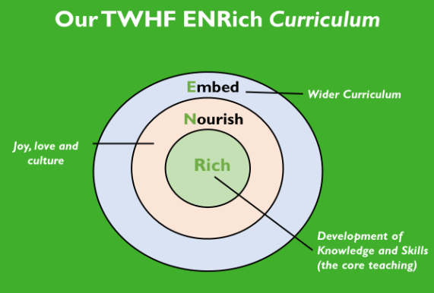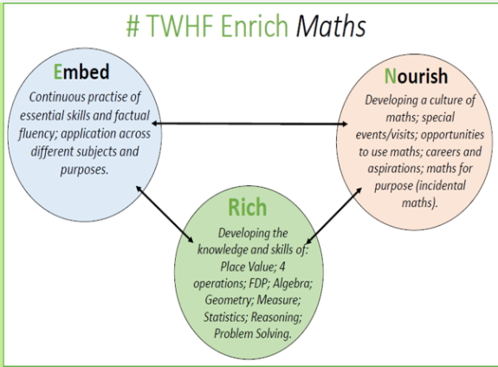
General Structure of Maths Timetable
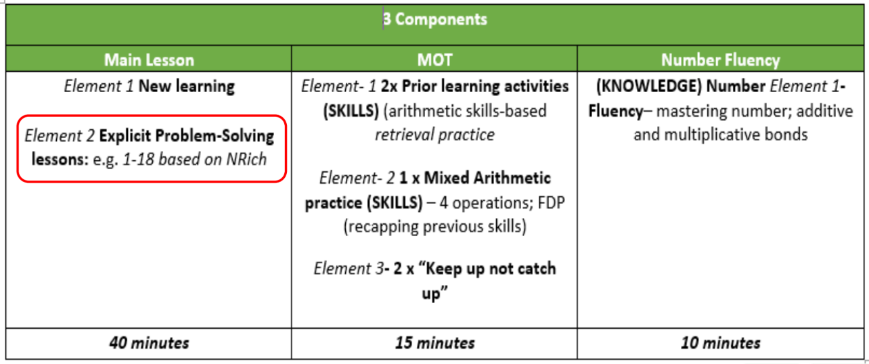

The Main Lesson (New learning)
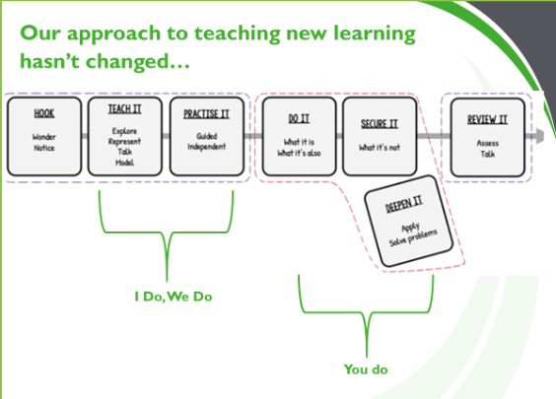
Pupils’ progress through the parts of the lesson, depends on their depth of understanding. Pupils who complete the ‘Do it’ and ‘Secure it’ parts of the lessons successfully and independently, will meet the aim of the lesson because they are fluent and can demonstrate their understanding of the mathematical concept. Pupils who have completed all parts of the lesson successfully and independently (Do it, Secure it and Deepen it) will have mastered that concept at greater depth.
Throughout lessons, teachers will recognise pupils’ misconceptions as they arise and address them immediately to enable those pupils to progress through the lesson independently. Pupils are taught through whole-class interactive teaching, enabling all to master the concepts necessary for the next
part of the curriculum sequence. All children are involved.
In a typical lesson, the teacher leads back and forth interaction, including questioning, short tasks, explanation, demonstration, and discussion, enabling pupils to think, reason and apply their knowledge to solve problems. I do, We do, You do
Use of precise mathematical language enables all pupils to communicate their reasoning and thinking effectively. Sentence stems, generalised statements and vocabulary. If a pupil fails to grasp a concept or procedure, this is identified quickly, and gaps in understanding are addressed systematically to prevent them falling behind. Keep up not catch up. Maths on Track (MoT) Sessions allow those pupils who did not have a secure understanding of the concept in the lessons, a further opportunity to keep up with their peers by recapping the learning from the lesson.
When introducing new or more challenging concepts (particularly in EYFS and KS1), pupils can have opportunities to develop the mathematical foundations that the concept relies upon and embed this learning into their long-term memories. Pupils will achieve this by having whole lessons (which do not follow the structure above), that follow the Concrete-Pictorial-Abstract (CPA) approach:
Concrete – pupils have the opportunity to use concrete objects and manipulatives to help them understand what they are doing.
Pictorial – pupils should then build on this concrete approach by using pictorial representations. These representations can then be used to reason and solve problems.
Abstract – with the foundations firmly laid, students should be able to move to an abstract approach using numbers and key concepts with confidence.
Significant time is spent developing deep understanding of the key ideas that are needed to
underpin future learning. Key number facts are learnt to automaticity, and other key mathematical facts are learned deeply and practised regularly, to avoid cognitive overload in working memory and enable pupils to focus on new learning. Number fluency, Mastering Number etc.

PROBLEM SOLVING
The research indicates that while children are developing their problem-solving skills, the level of maths challenge should be at an "accessible level".
The new ENRich Curriculum includes explicit problem-solving sessions across each term for every year group (Y1-Y6).
- These sessions are scheduled once every 2 weeks (roughly 3 x a term).
- The main aim of the problem-solving sessions is to develop children's understanding of strategies they can use to solve maths problems.
- To support children's understanding, initially we have aligned a strategy to a problem type.
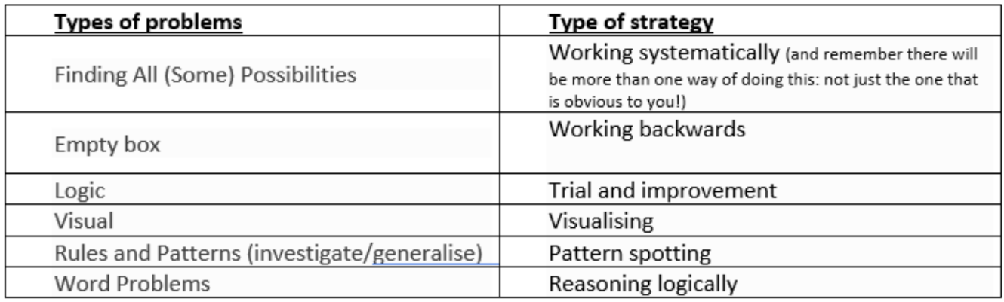
Similar to the daily New Learning Sessions, we feel it is important that each Problem-Solving lessons follows a similar "flow".
Lesson flow
Stage 1: Getting started
Stage 2: Working on the problem
Stage 3: Digging deeper
Stage 4: Reflecting
For each problem-solving lesson, the structure of each question is the same but with different surface features. To scaffold learning, the questions across each lesson progresses through an I do, We do and You do process. In the Initial I Do step only one element changes each time. This is to support children's understanding of how to solve the problem (variation theory)
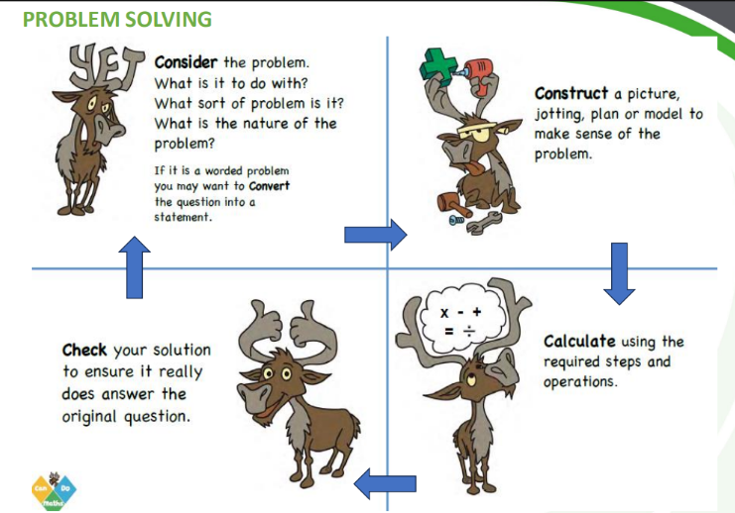

MoT Sessions
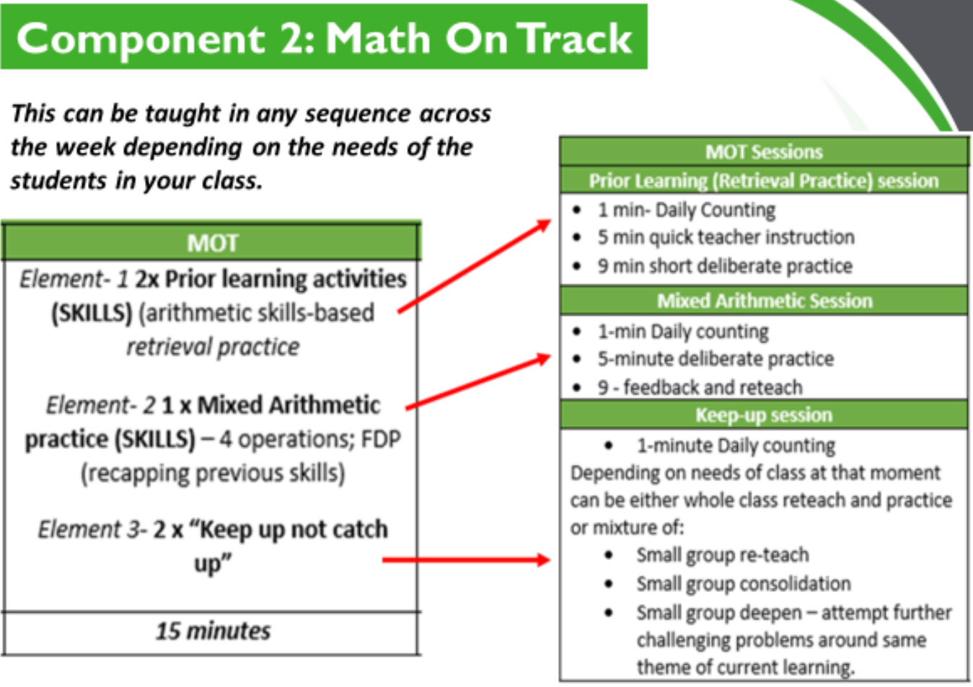
The second component of daily Maths is the MoT session. This is separate from the main Maths lesson and is 15 minutes long. Across the week 2 sessions will be based on “prior learning”, 1 on mixed “arithmetic” and 2 on “keep up not catch up” which depends on the need of the pupils.
Prior learning sessions will be based on the retrieval and practice of previously learnt concepts; these concepts can be from the previous term or previous year groups.
The mixed arithmetic sessions will have a variety of calculations from the four basic operations ( addition, subtraction, multiplication and division ) and Fractions/decimals/percentages.
The “keep up not catch up” sessions can be used to:
- Review and reteach new learning with a small groups/ individuals
- Provide opportunities to children to consolidate their learning by focusing on specific concepts.
- Attempt further challenge and deepen the understanding of concepts around the same theme of current learning.

Number Fluency Sessions:
During the ten minute daily number fluency sessions, pupils will have the opportunity to return to a number fluency skill regularly. This will support them in remembering these facts more readily when it comes to completing new learning tasks.
In KS1 the focus of number fluency is on additive bonds. This will be taught through “Mastering Number” programme.
In KS2, the focus of number fluency sessions is on multiplicative bonds. This will ne taught via a TWHF designed programme.
The aim of the Number Fluency component of TWHF ENRICH Maths Curriculum is to give pupils daily opportunities to revisit Number Fluency Facts which will enhance their ability to complete new learning tasks efficiently.
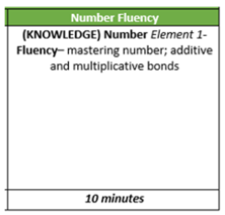

The Rapid Grasping Pupils
Although we encourage challenge for all pupils through the mastery approach, we ensure that Rapid Grasping Pupils are given the opportunity to master concepts at a greater depth within each lesson. We believe that if a child is developing mastery with greater depth the child can:
• solve problems of greater complexity (i.e. where the approach is not immediately obvious), demonstrating creativity and imagination;
• independently explore and investigate mathematical contexts and structures, communicate results clearly and systematically explain and generalise the Maths.
These pupils are given the opportunity to show mastery with greater depth through daily, challenging ‘Deepen it ’ activities.
Pupils with Special Educational Needs (SEN):
Normally, all pupils are taught Maths as part of a whole class of mixed ability pupils. This is because we believe that pupils benefit from exposure to mathematical discussion, demonstration and explanation of methods through quality first teaching, and learning alongside their peers. All pupils with SEN are encouraged and supported to participate in daily maths lessons by accessing the same concept as their peers as much as reasonably possible. However, it is recognised that where applicable, pupils will have individual targets which are based on the child’s level of development and these are matched appropriately to the National Curriculum Programme of Study for Maths.
On the very rare occasion that pupils with severe SEN are unable to access the content of main Maths lessons, they are supported by additional support staff who work in collaboration with the class teachers. Pupils with severe and complex learning needs may be supported through an individualised programme of support in the main part of a lesson, so that the content of lessons is matched to their level of ability. This may mean that these pupils are being taught knowledge, skills and understanding in ways that suit their individual needs. This could be presented as teaching them knowledge, skills and understanding from previous Year Groups or Key Stages so that they can make progress at a pace which is appropriate for them. Wherever reasonably possible, this learning takes place within the classroom, alongside peers and at the same time as the main Maths lesson.
Early Years Foundation Stage (EYFS):
At Drove, we follow our TWHF ENRich EYFS maths curriculum, ensuring children have a strong foundational knowledge of maths. This is delivered through taught sessions and a number-rich learning environment where children can grow and develop their mathematical understanding.
We believe that a strong foundation in number is essential for mathematical success. Children are provided with a variety of opportunities to confidently count and develop a deep understanding of numbers to 10, their relationships, and patterns. Through frequent, varied opportunities—such as using manipulatives like pebbles and ten frames—pupils build secure knowledge and vocabulary for mathematical mastery. The EYFS curriculum also provides rich experiences in spatial reasoning across shape, space, and measures. This approach fosters positive attitudes, encourages pattern recognition, problem-solving, and discussion, and promotes resilience by viewing mistakes as learning opportunities.
In EYFS, the EY practitioners model vocabulary in an appropriate playful context so that when formal learning takes place in the National Curriculum years, children are able to build upon the foundations that the EY practitioners helped foster in those first few years of their life.
Teachers and practitioners support pupils in developing their understanding of Maths in a broad range of contexts in which they can explore, enjoy, learn, practise and talk about their developing understanding. This area of development includes seeking patterns, making connections, recognising relationships, working with numbers, shapes and measures, and counting, sorting and matching. Pupils use their knowledge and skills in these areas to solve problems, generate new questions and make connections across other areas of learning and development.
Pupils in the EYFS learn by playing and exploring, being active, and through creative and critical thinking which takes place both indoors and outside. We recognise that pupils learn through routine, continuous provision and incidental learning opportunities, as well as planned sessions and activities. Mathematical understanding can be developed through stories, songs, games, routine, questioning, imaginative play, child-initiated learning and structured teaching.
In Nursery, group activities are timetabled and planned in to sessions throughout the week. Reception, daily time is dedicated to Maths. Overall, these lessons include a balance between whole-class work, group teaching and individual practice. In the Autumn term, these sessions are similar to those in Foundation Stage 1. However, throughout the year there is a gradual shift where adult-directed sessions are extended in preparation for Year 1.

