

Maths Calculation Policy

Key Document details:
Author: | Sana Ramzan | Approver: | Bryony Bardwell
Owner: | Sana Ramzan | Version No.: | 2
Date: | November 2025 | Next review date: | August 2026

Maths Calculation Policy

We aim for all children to be:
- able to recall quickly and accurately basic number facts (e.g. number bonds, multiplication and division facts)
- fluent in applying quick, efficient mental and written methods of calculation.
Teachers are confident and skilled to teach mental and written calculation methods. The progression of methods mean that the pupils have a secure understanding of mental and written methods of calculation suitable for their stage of learning. This enables the pupils to choose appropriate calculation methods depending on the numbers. Pupil feel confident to recall, understand and make connections by using facts suitable for their stage of learning.

Appendix 1 - Age Related Expectations

Mental and Written Methods (Addition and Subtraction)
Mental and Written Methods (Multiplication and Division)
Mental and Written Methods (Number Facts)
Year
1 | 2 | 3 | 4 | 5 | 6
Read, write and interpret mathematical statements involving addition (+), subtraction (–) and equals (=) signs  Solve one-step problems that involve addition and subtraction, using concrete objects and pictorial representations, and missing number problems such as 7 = ☐ – 9 | Add and subtract two two-digit numbers using concrete objects, pictorial representations progressing to formal written methods  Add and subtract numbers using concrete objects, pictorial representations, and mentally, including:  - a two-digit number and ones  - a two-digit number and tens  - two two-digit numbers  adding three one-digit numbers | Add and subtract numbers with up to three digits, using formal written methods of columnar addition and subtraction  Add and subtract numbers mentally, including:  - a three-digit number and ones  - a three-digit number and tens  a three-digit number and hundreds | Add and subtract numbers with up to 4 digits using the formal written methods of columnar addition where appropriate  signs  Solve addition and subtraction two-step problems in contexts, deciding which operations and methods to use and why | Add and subtract whole numbers with more than 4 digits, including using formal written methods (columnar addition and subtraction)  Add and subtract numbers mentally with increasingly large numbers | Solve addition and subtraction multi-step problems in contexts, deciding which operations and methods to use and why  Perform mental calculations, including with mixed operations and large numbers
Year
1 | 2 | 3 | 4 | 5 | 6
Represent & use number bonds and related subtraction facts within 20  Add and subtract one-digit and two-digit numbers to 20, including zero | Recall and use addition and subtraction facts to 20 fluently, and derive and use related facts up to 100  Recall and use x and ÷ facts for the 2, 5 and 10 x tables, including recognising odd and even numbers. | Recall and use x and ÷ facts for the 3, 4 and 8 times tables. | Recall x and ÷ facts for x tables up to 12 x 12. | Recall prime numbers up to 19  Know and use the vocabulary of prime numbers, prime factors and composite (non-prime) numbers  Recognise and use square numbers and cube numbers, and the notation for squared (²) and cubed (³) | Recall x and ÷ facts for x tables up to 12 x 12 and use to find other related facts

Year
1 | 2 | 3 | 4 | 5 | 6
Solve one-step problems involving multiplication and division, by calculating the answer using concrete objects, pictorial representations and arrays with the support of the teacher | Calculate mathematical statements for multiplication and division within the multiplication tables and write them using the multiplication (×), division (÷) and equals (=) signs  Show that multiplication of two numbers can be done in any order (commutative) and division of one number by another cannot  Solve problems involving multiplication and division, using materials, arrays, repeated addition, mental methods, and multiplication and division facts, including problems in contexts | Write and calculate mathematical statements for ÷ using the x tables they know progressing to formal written methods.  Write and calculate mathematical statements for multiplication and division using the multiplication tables that they know, including for two-digit numbers times one-digit numbers, using mental methods  Use place value, known and derived facts to multiply and divide mentally, including: multiplying by 0 and 1; dividing by 1; multiplying together three numbers  Recognise and use factor pairs and commutativity in mental calculations | Multiply two-digit and three-digit numbers by a one-digit number using formal written layout | Multiply numbers up to 4 digits by a one- or two-digit number using a formal written method, including long multiplication for two-digit numbers  Divide numbers up to 4 digits by a one-digit number using the formal written method of short division and interpret remainders appropriately for the context  Multiply and divide numbers mentally drawing upon known facts  Multiply and divide whole numbers and those involving decimals by 10, 100 and 1000 | Multiply multi-digit numbers up to 4 digits by a two-digit whole number using the formal written method of long multiplication  Divide numbers up to 4-digits by a two-digit whole number using the formal written method of short division where appropriate for the context  Divide numbers up to 4 digits by a two-digit whole number using the formal written method of long division, and interpret remainders as whole number remainders, fractions, or by rounding, as appropriate for the context  Perform mental calculations, including with mixed operations and large numbers

Appendix 2 – Mental Methods and Jottings
Year 1
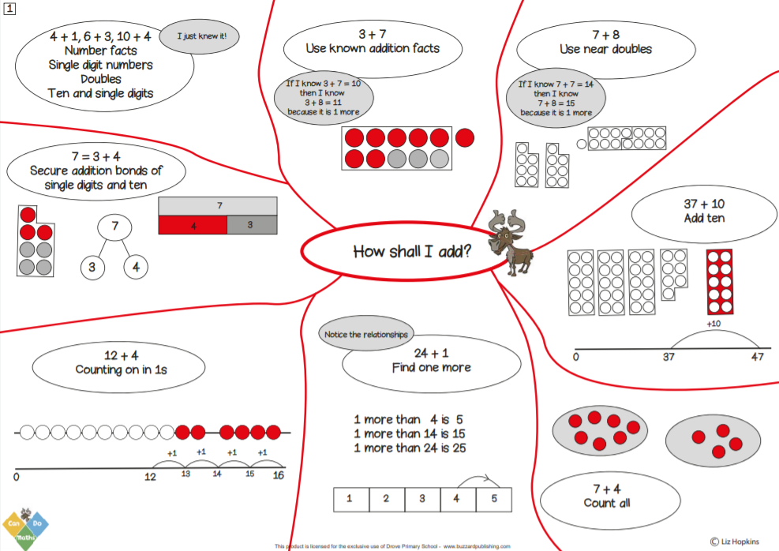 | 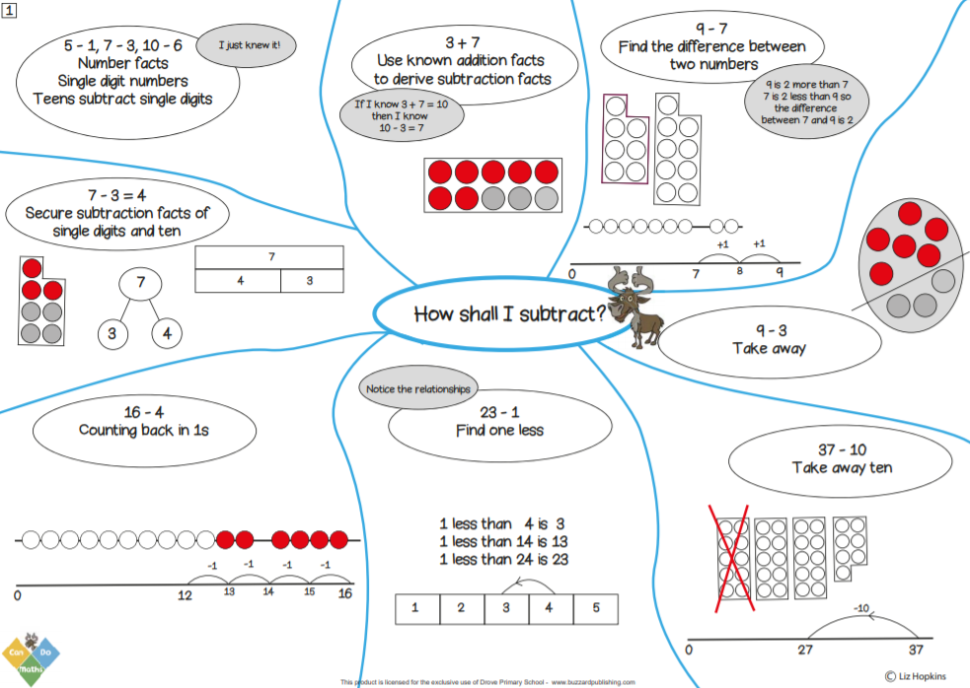
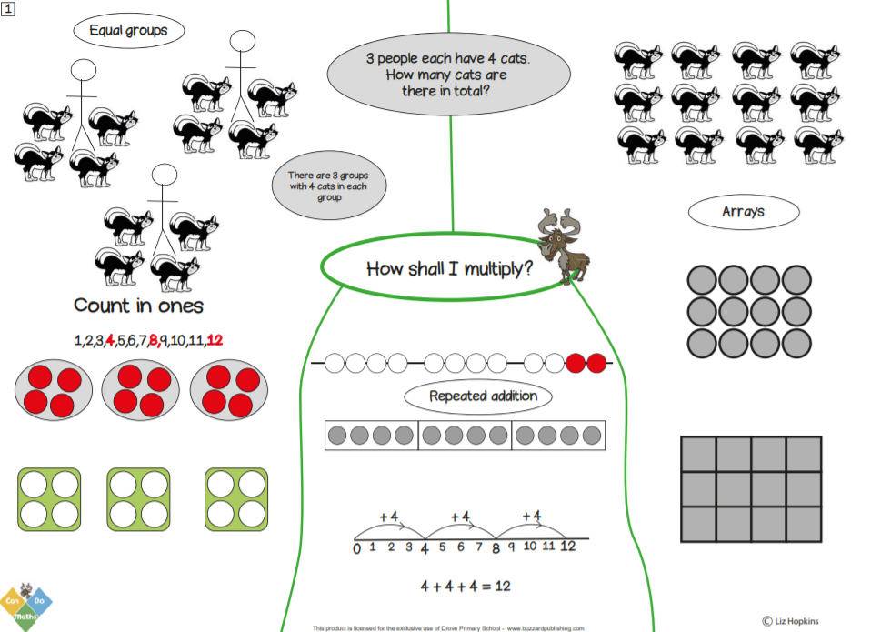 | 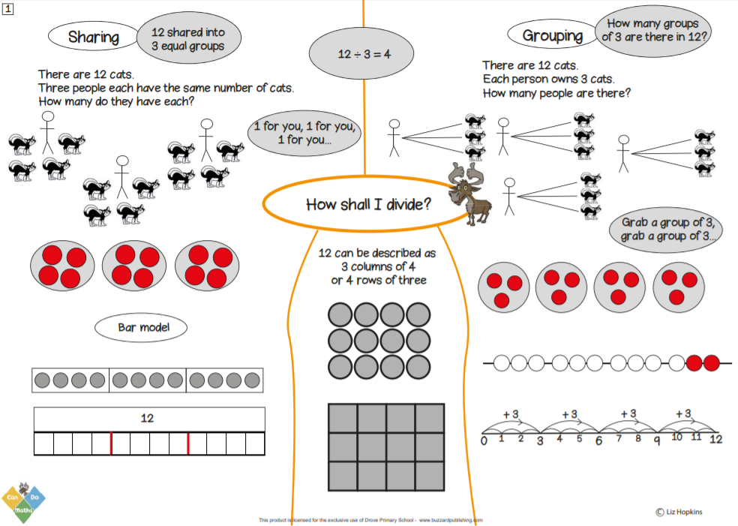

Year 2
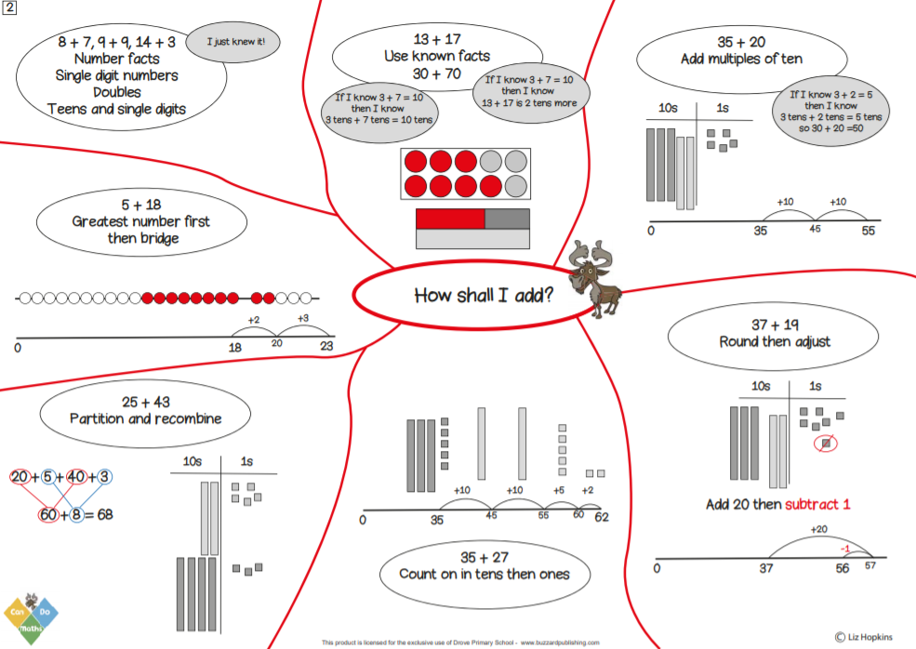 | 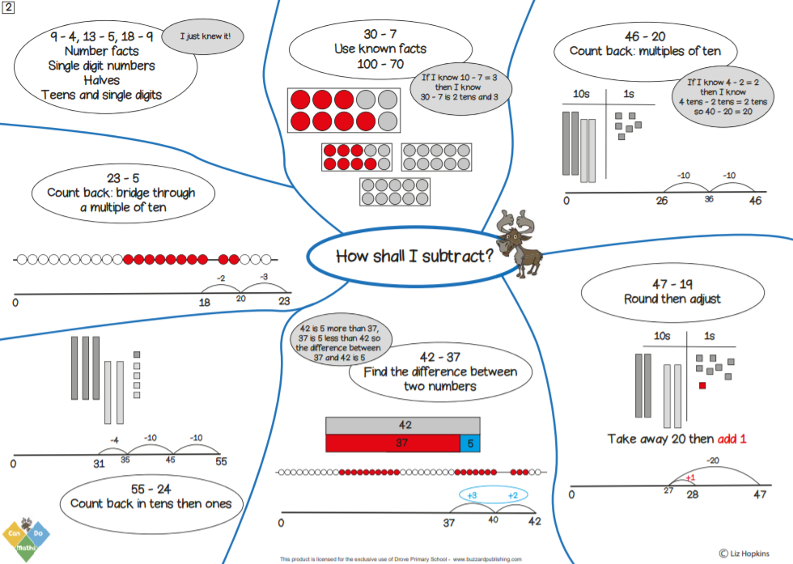
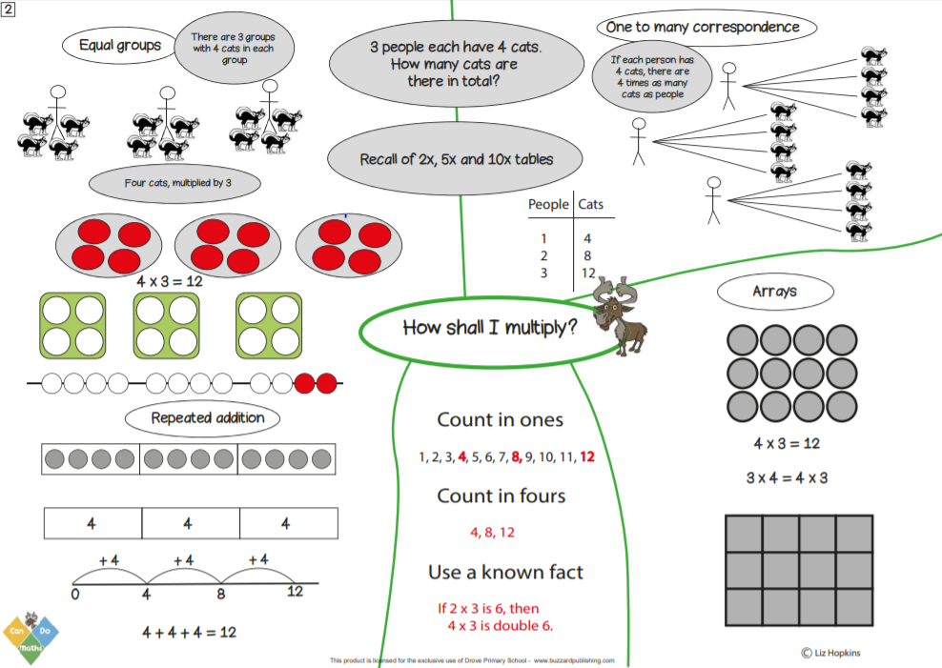 | 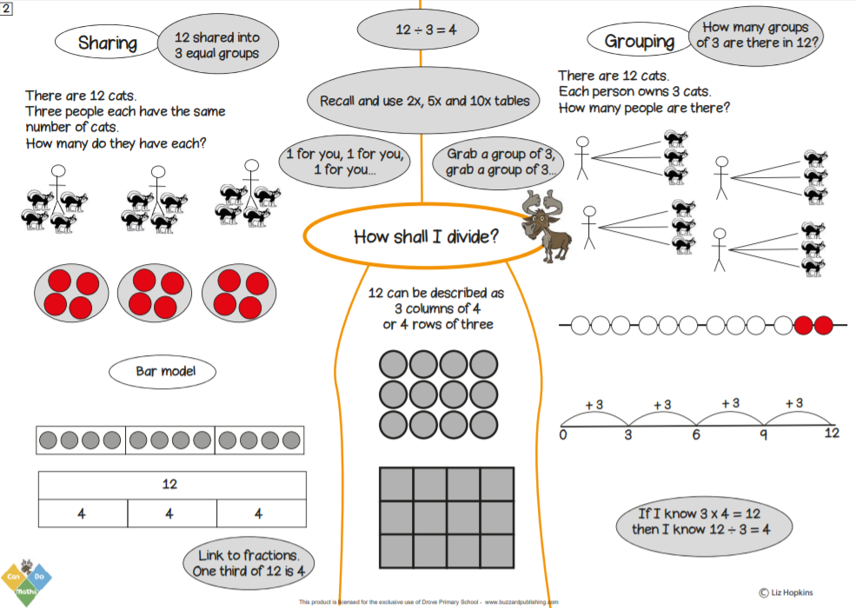
Year 3
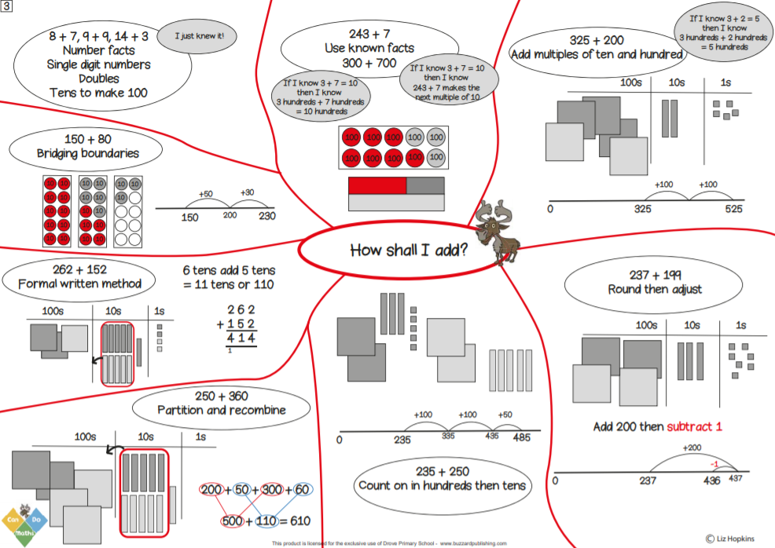 | 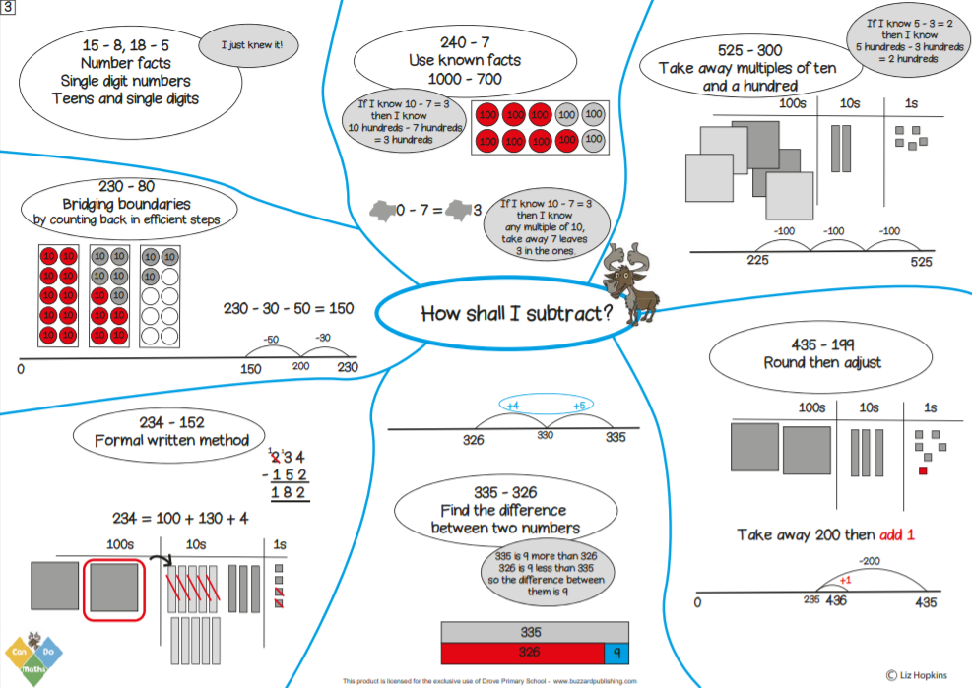
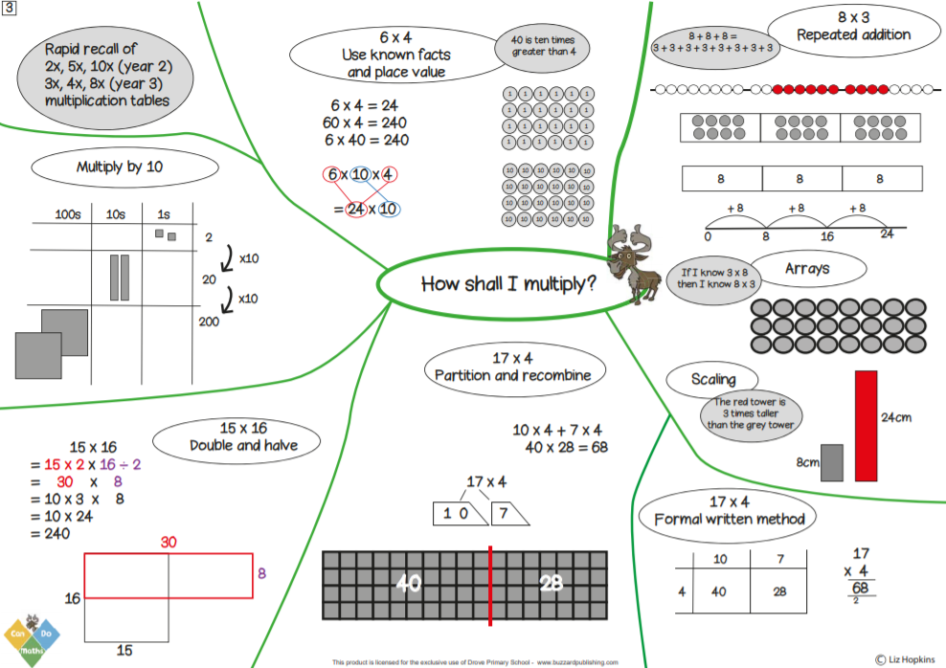 | 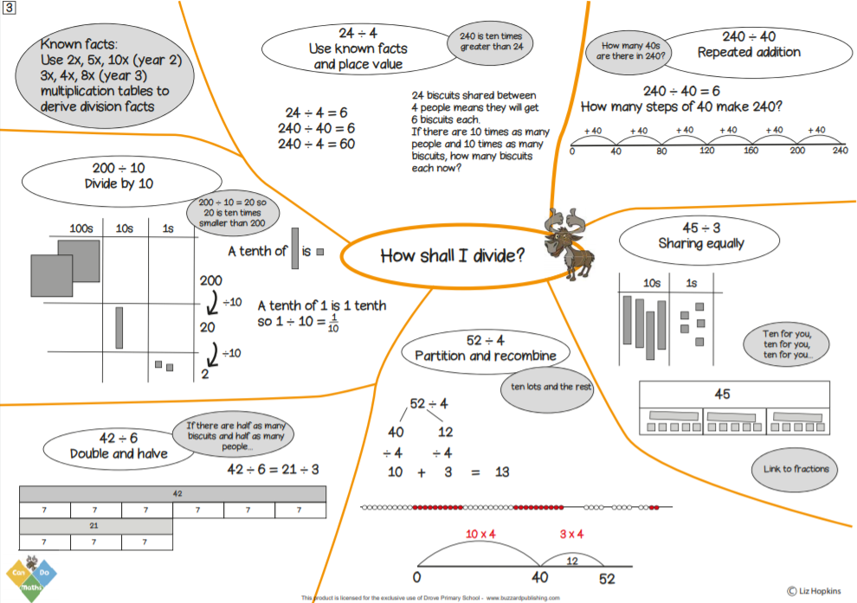
Year 4
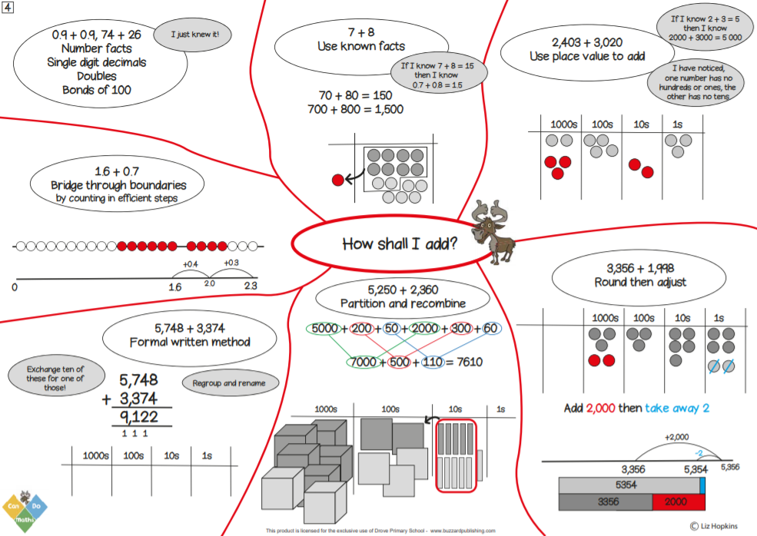 | 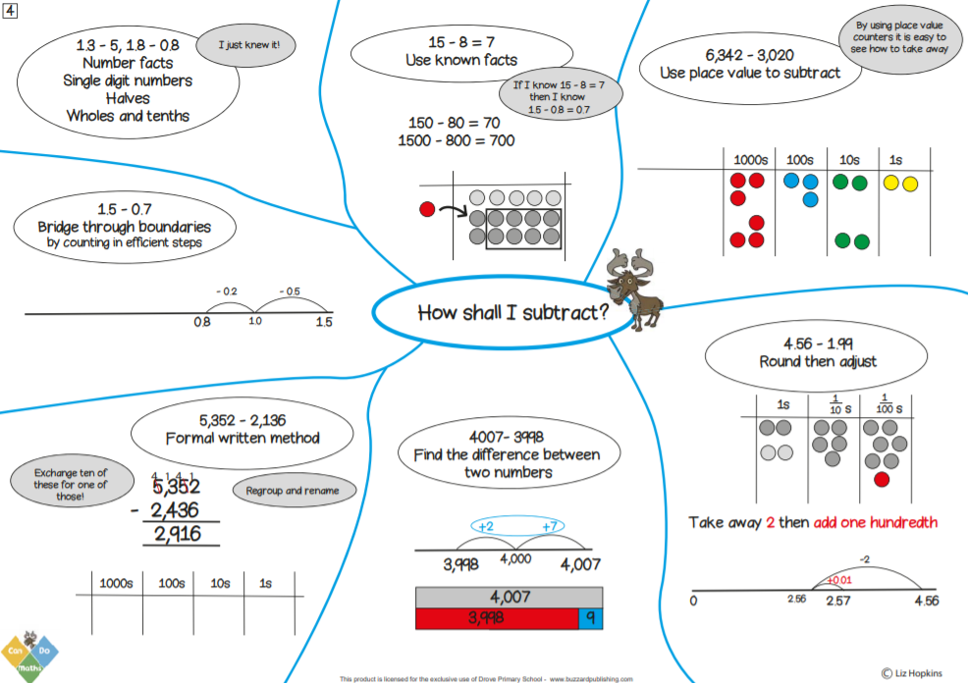
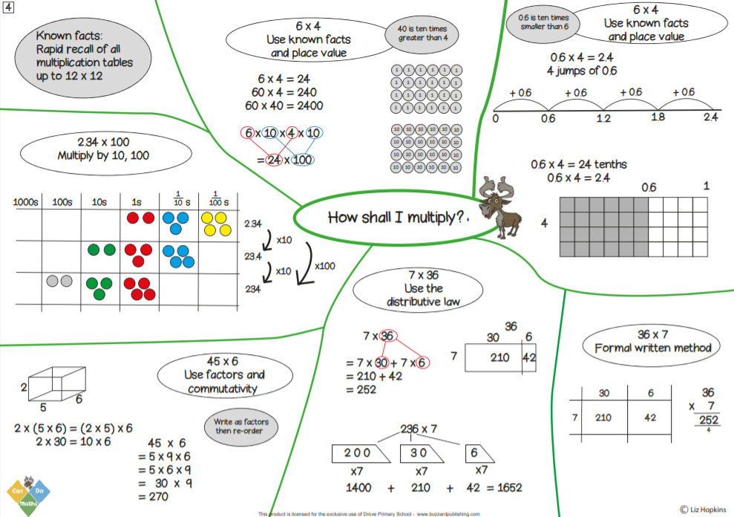 | 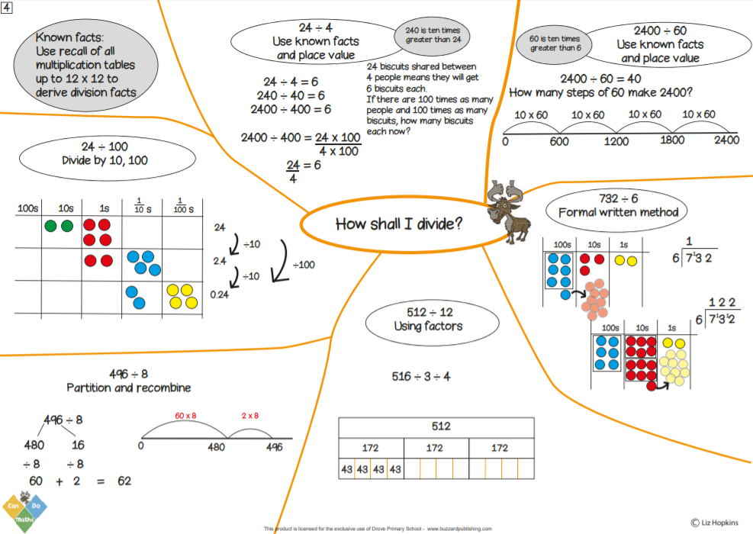
Year 5
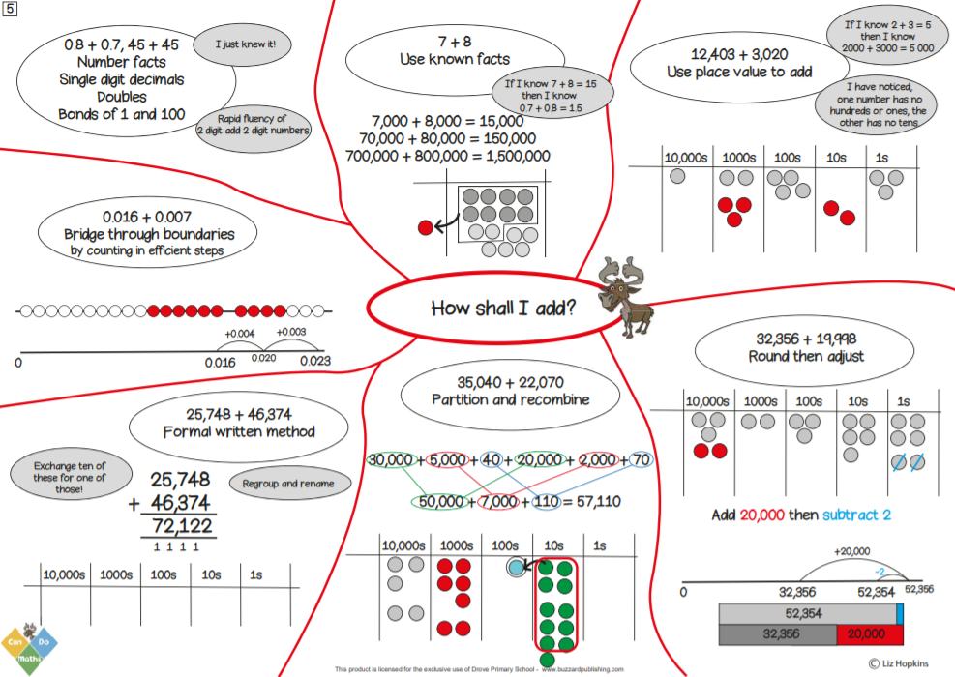 | 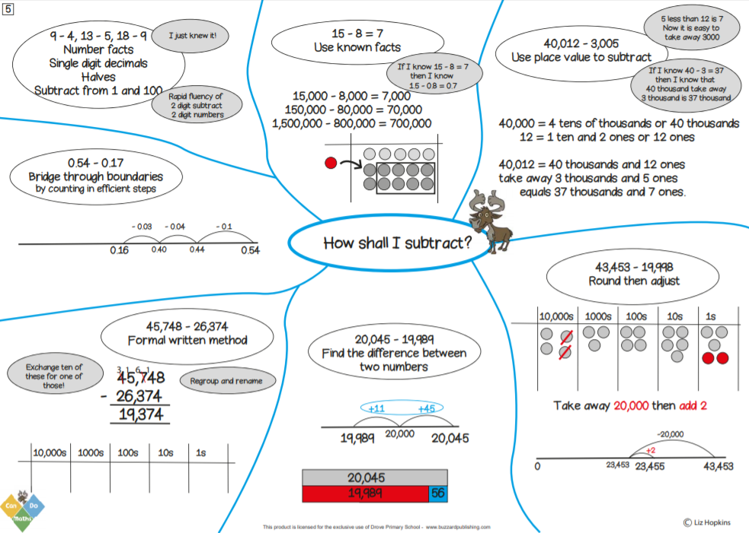
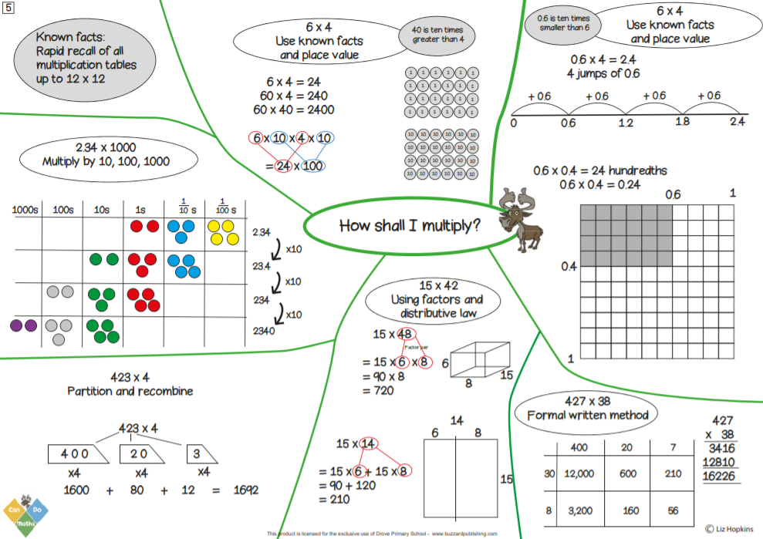 | 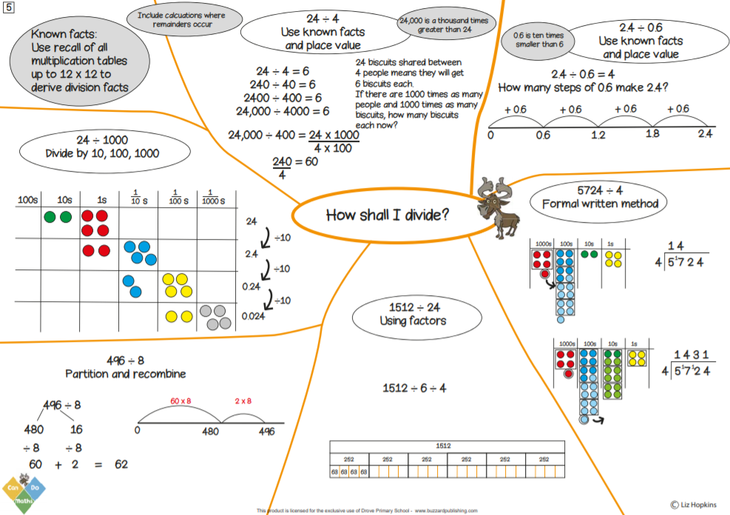
Year 6
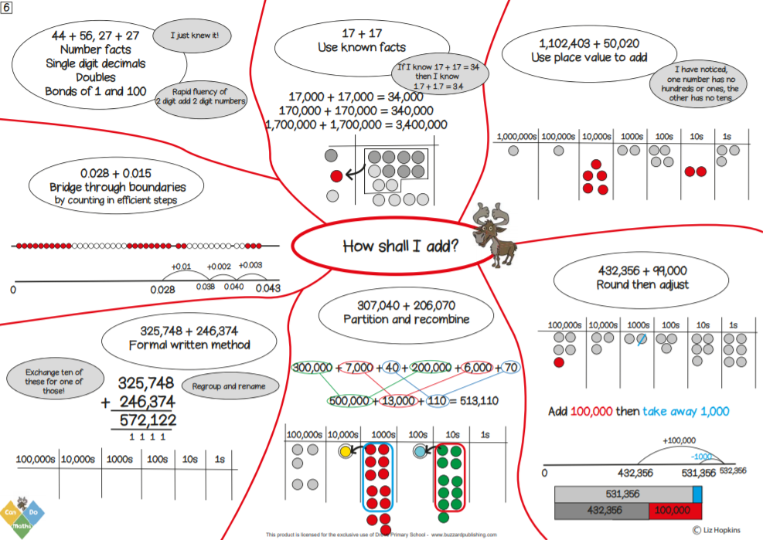 | 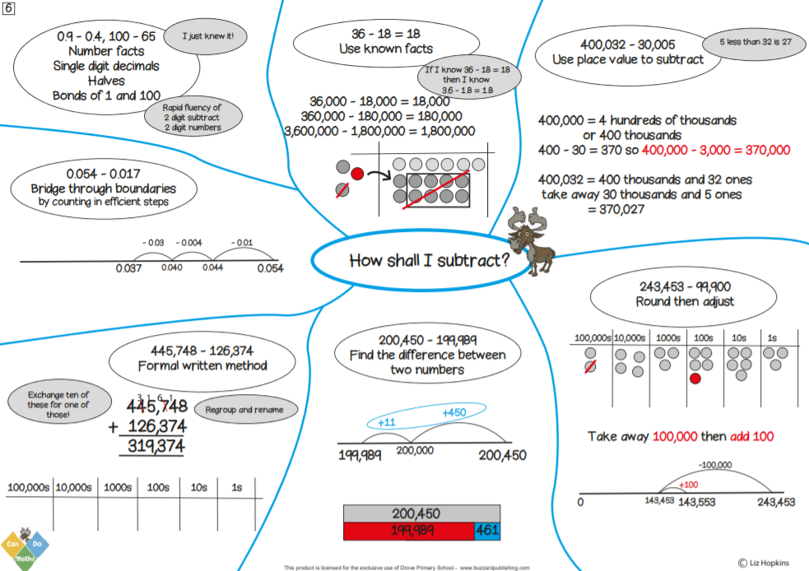
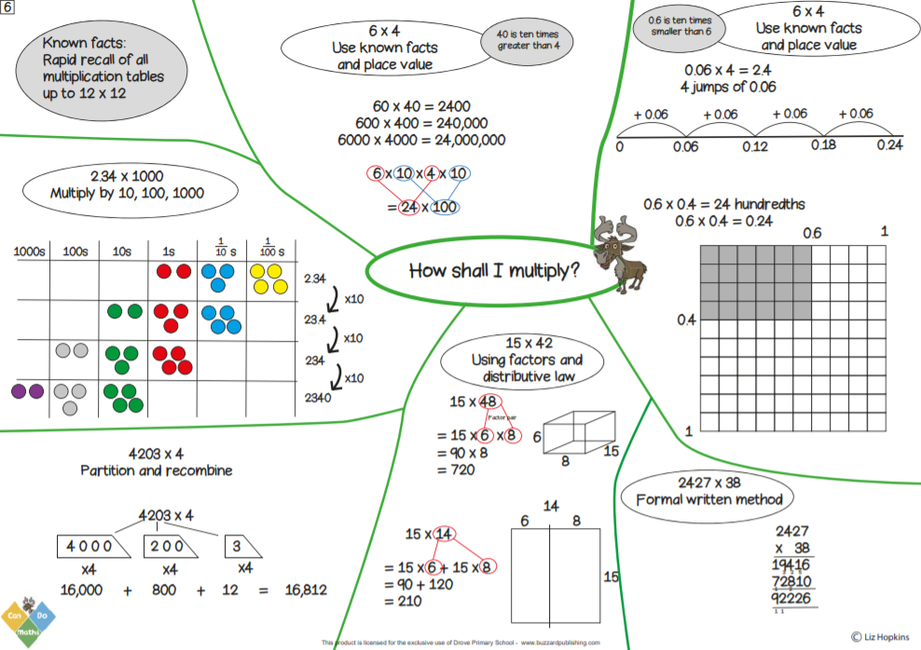 | 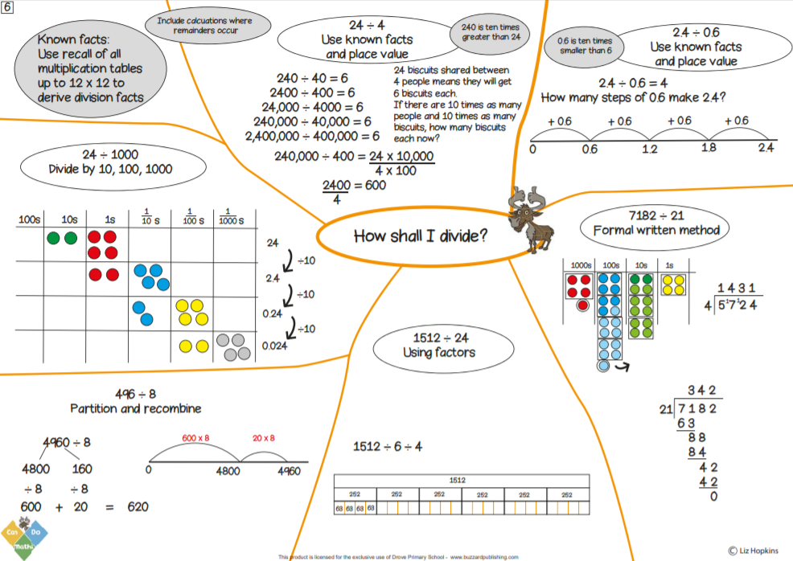

Appendix 3 – Written Methods
