English Policy

Rachel Liddiard & Craig Richardson

LGB

Bryony Bardwell

Drove Primary School

1

1-9-2021
n/a

1-9-2025

Drove Primary School

English Policy

Reading Intent
For every child to develop a lifetime of enjoyment in reading by providing access to high-quality, engaging texts; explicit teaching of a wider range higher-level vocabulary and the understanding of the knowledge and skills to confidently analyse fiction and non-fiction texts.
Writing Intent
To deliver a language-rich, engaging curriculum through high quality texts, visual stimuli and real-life experiences. This will enable children to be completely immersed in their learning, to develop a wider vocabulary and stimulate their imagination. Allowing children to create high quality and creative written and oral outcomes.
How Reading & Writing is taught at Drove
Reading and writing are integrally linked at Drove Primary School. Each unit of work is based around a high-quality text chosen by the teacher/s from ‘Drove’s high-quality-text reading list’ which is a list compiled by Drove, drawing from a variety of well-established lists (such as the 5 Plagues of Reading, Power of Reading, Integra Schools’ Recommended Text List and Pie Corbett’s Reading Spine). Additionally, video or image stimuli may also be used alongside a high-quality text. Any other text chosen that does not appear on ‘Drove’s High-Quality Text’ reading list, must be read by the teacher prior to teaching, a ‘mapping text potential’ form filled in and checked by English lead/s.
Teachers must ensure that they cover a variety of text types (see the 5 Plagues of Reading) as well as a variety of cultures throughout the year.
Books should be chosen by each year group in July for the following year. They must show progression from term 1-6 within a year group and across years. This is to be approved by English lead/s before the start of the new teaching year.
At Drove, our learning journey within a term has 3 phases (within reading and writing). Please see the model below.
Reading | Writing
Phase 1 Reading
This is the pre-writing phase.
This phase gives the opportunity to teach and research the context needed for children to access the high-quality text for the term.
Non-fiction texts will be used to research background information and examples of the phase 3 writing genre will be used to prepare the children for their fiction writing sequence.
Phase 2 Reading  Domain focussed questions based on the term’s chosen high-quality text following our 3-part lesson sequence – Modelled, Paired, Independent.  Aims taken from Drove’s Year Group Reading Coverage Tracker Tick-sheets -  Modelled = 1/2 question  Paired = 1/2 question  Independent = 5 questions | Phase 1 Writing  Recap 1 previously taught skill, teaching of 1 new skill from current year group integra sheet (to be included in the final assessment marker) and 2 previously taught genres (Year group dependent). Time given for the teaching of editing and revising.
Phase 3 Reading  Domain focussed questions based on the term’s chosen high-quality text following our 3-part lesson sequence – Modelled, Paired, Independent.  Aims taken from Drove’s Year Group Reading Coverage Tracker Tick-sheets.  Modelled = 1/2 question  Paired = 1/2 question  Independent = 5 questions | Phase 2 Writing  Recap 1 previously taught skill, teaching of 1 new skill from current year group integra sheet and applying them into 2 written outcomes. Time given for the teaching of editing and revising.
Phase 1 Reading  This phase gives the opportunity to read a variety of non-fiction texts related to the final non-fiction writing sequence. | Phase 3 Writing  Independent work – Fiction Assessment Marker  Plan, orally rehearse, write, edit and revise an assessment marker.
Phase 2 Reading  Domain focussed questions based on the term’s chosen high-quality text following our 3-part lesson sequence – Modelled, Paired, Independent.  Aims taken from Drove’s Year Group Reading Coverage Tracker Tick-sheets -  Modelled = 1/2 question  Paired = 1/2 question  Independent = 5 questions | Phase 1 Writing  Recap 1 previously taught skill, teaching of 1 new skill from current year group integra sheet (to be included in the final assessment marker) and 2 previously taught genres (Year group dependent). Time given for the teaching of editing and revising.
Phase 3 Reading  Domain focussed questions based on the term’s chosen high-quality text following our 3-part lesson sequence – Modelled, Paired, Independent.  Aims taken from Drove’s Year Group Reading Coverage Tracker Tick-sheets.  Modelled = 1/2 question  Paired = 1/2 question  Independent = 5 questions | Phase 2 Writing  Recap 1 previously taught skill, teaching of 1 new skill from current year group integra sheet and applying them into 2 written outcomes. Time given for the teaching of editing and revising.
Phase 1 Reading  This is the pre-writing phase for the next chosen high-quality text.  This phase gives the opportunity to teach and research the context needed for children to access the high-quality text for the term.  Non-fiction texts will be used to research background information and examples of the phase 3 writing genre will be used to prepare the children for their fiction writing sequence. | Phase 3 Writing  Independent work – Non-Fiction Assessment Marker  Plan, orally rehearse, write, edit and revise an assessment marker.

Writing
Each year group have a Writing LTP Overview which covers all the required writing skills to be taught in each year group (based on the 2014 NC). A variety of text purposes should be taught across the year (see Text Purpose Matrix as an example). Teachers are required to match skills to text purposes and show progression throughout the year building on prior learning. This is completed through the MTP.
The main focus in the teaching and the learning of writing is skills based. There will be evidence in books of the explicit of skills as well as tasks which allow the children to apply new skills independently. Children will also be given plenty of opportunities to apply their new skills to a range of text types and also subjects. Through assessment markers which have been completed independently by the children, teachers will be able to make judgements as to whether the child is currently meeting age-related expectations.
In each term, there must be one fiction and one non-fiction written outcome which are written in phase 3 as the assessment markers. In phase 1 & 2, there must be 4 written outcomes. Within phase 1 & 2, two previously taught skills and two new skills must be taught. Skills taught must be taken from year group ‘Integra list skills list’. All skills and written outcomes in each phase must support the children’s journey to their final written outcome in phase 3. Before planning, a teacher model of the final written outcome must be created to inform planning for reading and writing (phase 1 reading and skills taught in phase 1&2 of writing).
Each week, in writing lessons, one word from ‘Drove’s Adventurous Vocabulary List’ must be taught as a word of the week using the activity template. The list comprises of 36 words for each year group. https://thewhitehorsefederation.sharepoint.com/:w:/s/DRO-StaffDrive/EbVy1lJNR-hCkgmFb38-TC0BPLQbny4fmpYn3_IZV7WO6w?e=BBt3TH
Additional text-specific vocabulary is to be taught during reading sessions. The high-quality-text chosen must be read in full within the term.
Nursery and Reception use ‘Word aware’ to teach children new vocabulary during Literacy lessons.
‘Assessment Markers’
To help demonstrate progress over a unit of work, children are asked to produce two independent pieces of writing per term based on the ‘high quality text’ – one non-fiction and one fiction. These tasks are called Assessment Markers and should take place at the end of phase 3 in the writing journey. The task set should enable the children to demonstrate the ranges of skills covered in that term. Weaker areas identified in the first of the phase 3 assessments, should then be addressed in phase 2 of the 3-phase cycle of the term. Over the course of the year, these Assessment Markers should show clear progress towards the Age-related Expectations for each year group.

Spelling
Pupils are encouraged to develop as independent and accurate spellers who are confident to use an evolving and adventurous vocabulary in their own writing. They should have a range of spelling strategies that they can use to attempt unknown words and a sound knowledge of irregular high frequency words for use in their daily work. Children are made aware of the differences between spoken dialect and written English in terms of spelling. From FS1 to Y2 phonics is taught through the ‘Rising Stars Rocket Phonics’ programme. Year 3 phonics interventions are used to support low attaining children. In KS2, children are taught spellings following the ‘Rising Stars’ spelling scheme. Spelling lessons are taught weekly for up to 30 minutes. Each classroom will clearly display the spelling rule being taught that week with examples.

We aim for pupils to be able to:

- Attempt words for themselves using a range of strategies
- Write an increasingly wide range of words from memory (Appendix list 1 and 2 in the NC document)
- Use a variety of resources to help with spelling e.g. dictionaries, word banks, word mats, classroom environment etc.
- Develop an understanding of spelling patterns and rules through investigations and identifying the exceptions to those rules as "interesting” or “tricky”

Handwriting

It is important for pupils to be able to write clearly and develop a fluent and legible handwriting style. Presentation should be neat and later joined when children are secure within the Rocket Phonics programme. From Reception to Year 1, children are taught and encouraged to use print handwriting which leads into cursive during year 2. Letter join is use across the school to support handwriting practice and homework.

We aim for pupils to be able to:
• Form letters correctly
• Use upper- and lower-case letters appropriately
• Begin to use a joined style during Year 2
• Use a correct and comfortable pencil/pen grip
• Foundation Stage to use appropriate tools for their writing according to their developmental stage
• Key Stage 1 to use a pencil
• From Year 2 to use a blue ballpoint pen/pencil for editing
• In KS2, when a child is ready, they may use a black handwriting pen for writing and a blue handwriting pen for editing

Working walls
At Drove we have a consistent approach to our working walls. The wall should be divided into three sections and headed with Phase 1, 2, & 3. Each of the phases should reflect key learning from the week’s work and build up to the final outcome in phase 3 this is also reflected around the headings. Each display must indicate what skills are to be explicitly taught during the phases.
Another integral part of the working walls, is child involvement. Children must be able to talk confidentially about what is on the display and how this supports their learning.
In regards to monitoring the coverage of skills, the only expectation is that teachers complete the school MTP with skills taught. MTP to be displayed on working wall.
Reading
At Drove, pupils are encouraged to become confident, enthusiastic, critical and independent readers. They are given opportunities to experience print produced in a variety of forms and for a variety of purposes. We believe children should read for information, interest and enjoyment.
The Teaching of Reading at Drove
During reading phase 2 & 3, children are explicitly taught how to use a range of strategies during daily half hour reading sessions. Each strategy is mapped against the new KS1 and KS2 Reading Domains (see below).
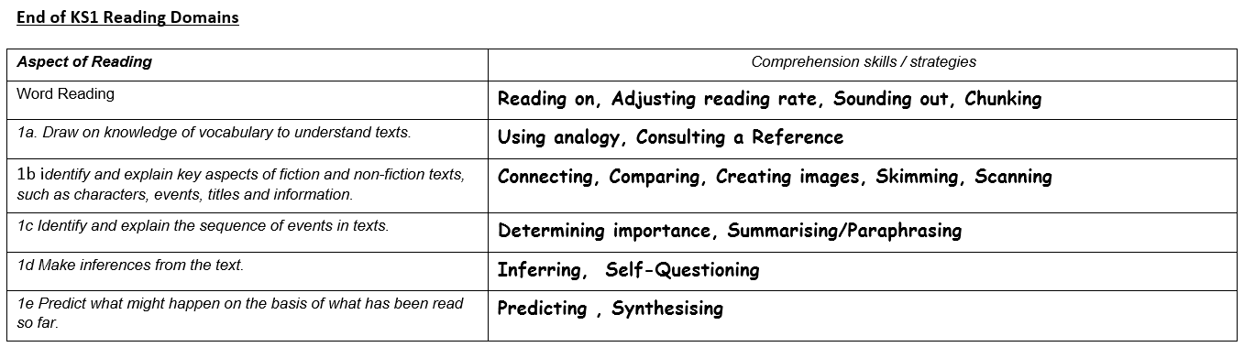
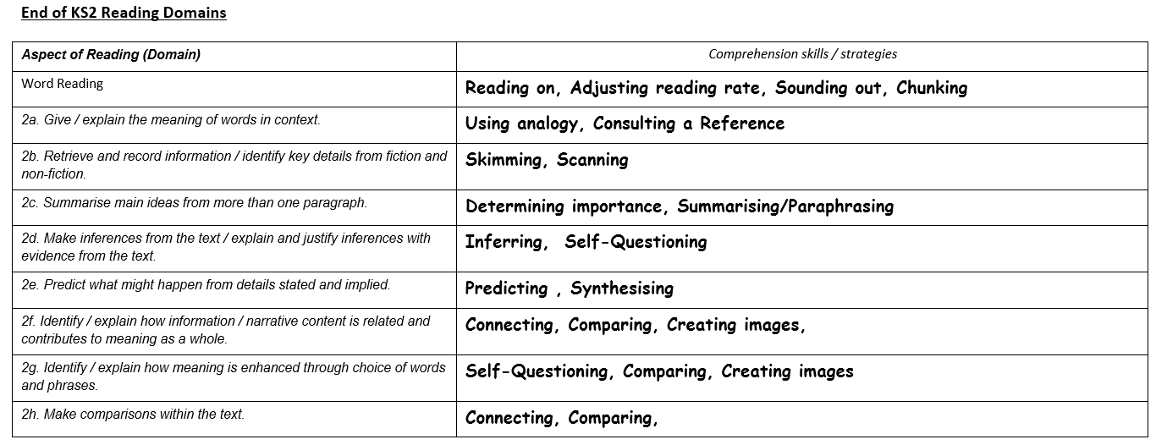
These strategies are taught across the school in through whole class reading – where teachers and children engage in a text and answer a range of comprehensions questions. To help focus teaching and learning. Teachers will have major focuses each term which are based around individual domains. By doing this the teacher can model explicitly the skills needed to answer these types of comprehension questions.

The school’s approach to the teaching of reading is based on the Gradual Release of Responsibility Approach (See below)
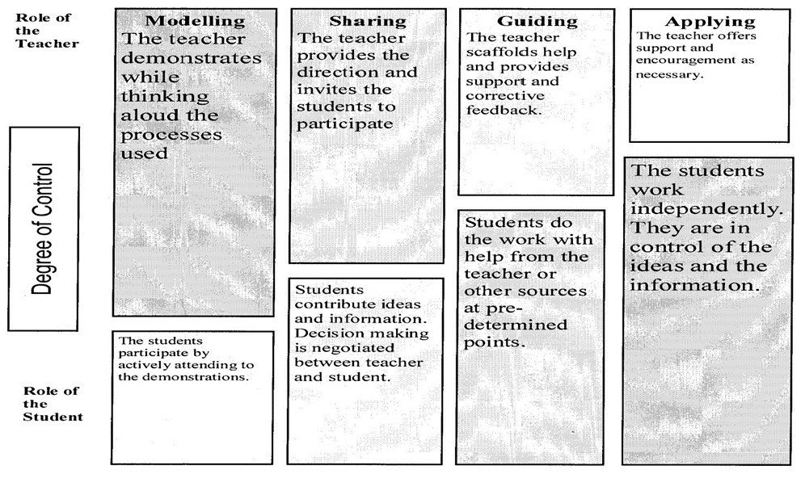
Modelled reading
We believe modelled reading is the most significant step when teaching any reading strategy. Through short regular sessions, the teacher will demonstrate the use of the strategy as an effective reader. As with modelled writing, the teacher will verbalise any thought process that takes place giving the children a good example of how the strategy is used effectively and also why it is being applied. For these sessions to be effective they need to be planned and thought out.
Shared reading
Once sufficient modelling sessions have taken place, sharing sessions can be planned to help develop the use of the strategy. In these sessions the teacher continues to demonstrate the use of the strategy however, the students are now invited to contribute. During this time, strategy charts can be drawn up and developed and refined.
Guided reading
Guided reading sessions, to be implemented when working with a group, provide the opportunity for pupils to practise the strategies in meaningful reading contexts when using a variety of texts. The teacher switches to providing scaffolds as pupils practise the strategy. It is important that the teacher provides on-going feedback and support as pupils begin to independently use the strategy.
Independent Application
Pupils need opportunities to work independently to apply the newly taught strategy. Encourage pupils to use this strategy when working in other curriculum areas.

Reading for pleasure
We feel that the children at Drove should enjoy reading and have opportunities to read for pleasure. Book displays in corridors and classrooms promote reading for pleasure in class. Every day, 30 minutes are devoted to reading for pleasure. Children may choose to read their own books or books or magazines displayed. Teachers will aim to read 3 additional books (additional to the high-quality-texts chosen for study in reading and writing per term) for pleasure with their class. Teachers are responsible for ensuring that their reading corners are inviting and display a variety of age-appropriate texts.
We also offer our children a range of opportunities to develop their interest in reading for example; school visits to the library, author visits to the school and visits from book fairs.
Since September 2021, children in KS1 and KS2 have access to the online reading scheme through Rising Stars. The scheme offers the children access to a range of fiction and non – fiction books and comprehension activities.
Phonics
‘Rising Stars Rocket Phonics’ is delivered in FS1, FS2 and KS1 for up to 30 minutes daily. It is differentiated according to the ability of the children. The scheme of work is used and adapted to support the planning of each phase.
Class Teachers and Teaching Assistants deliver the planning to small groups following the revisit and review/teach/practise/apply format.
For children who do not pass the phonics screener test after Year 2, small targeted interventions are conducted to stop children falling further behind in Year 3.
When teaching phonics staff are expected to follow the same procedures when teaching letter formation.
All graphemes with more than 1 letter MUST be joined so that the children become familiar with them and it starts their handwriting journey. A range of fonts must be used during delivery so that children can recognise sounds across a range of reading and writing materials.
Sound buttons must be used consistently during the lessons. Sound buttons must be used in the following ways
- Single sounds need to be represented with a _ (short line) underneath.
- Graphemes with more than 1 letter need to be represented with a __ (longer line) underneath.
- Split digraphs need to be linked with a curved line.
Speaking and Listening
At Drove we believe it is important to provide planned opportunities for a range of speaking and listening tasks. This encourages children to develop as fluent, confident and competent speakers who are also able to listen with interest and understanding for sustained periods. Speaking encourages pupils to work co-operatively with others and to listen to the views of others. Working collaboratively and sharing ideas is a valuable and supportive exercise that is planned and developed within each classroom.

We aim for pupils to be able to:
• Use speech appropriately for different purposes
• Adopt appropriate vocabulary, tone, pace and style for a variety of audiences and in a variety of situations
• Understand the effect of speech on the listener
• Use talk to develop and express ideas
• Communicate meaning effectively
• Listen attentively and derive meaning from what others say and respond with confidence
• Develop the skills of turn-taking, negotiation and reaching consensus.

Drama within English
At Drove we recognise the enormous value of drama and role play. Pupils are given planned opportunities to use a range of dramatic forms to express feelings and ideas both verbally and non-verbally. Children are encouraged to appreciate drama, both as participants and observers through theatre visits, visiting drama groups and annual plays performed to parents from each year group over the course of the year.
In addition, visits from well-known individual characters will be planned in throughout the year. We believe the use of ‘real’ characters in costume will create an immensely powerful learning experience.

We aim for:
- Opportunities to be given for the development of drama in a variety of contexts, including time in the role play corner of every classroom in EYFS and KS1.
- Pupils to be encouraged to use drama to link ideas through role-play, hot seating, tableaux, mime and freeze-frame techniques
- Pupils to explore a range of endings to stories through role-play and use these as a pre-writing stimulus

Learning Resources
There are a number of resources in each classroom used daily and are appropriate to the children’s age and level of need, these include flashcards, word cards, alphabet strips, dictionaries and thesauruses. Resources are available for children to access easily and independently.
Homework
Children are encouraged to read as often as possible at home.
In EYFS & KS1, for homework each child should be given, one decodable book, chosen by the teacher, which is related to their current phonics’ phase (using Rising Stars ‘Reading Planet) and one book chosen by the child for reading for pleasure.
In KS2, ‘Rising Stars Reading Planet’ is used to set age appropriate reading comprehension, weekly. Age appropriate spelling patterns, from ‘Rising Stars’ spelling scheme are also set each week. Homework is given on a Friday and returned completed to the school by the following Wednesday. Children are encouraged to take a reading book from the book corners for their for pleasure or their own books at home.. A recommended reads book list is included in their reading homework planner.
Inclusion
In English teaching at Drove, staff are aware of children’s individual needs and how to best differentiate teaching and learning, to enable access for all. This is done through teaching to suit a variety of learning styles, often using a multisensory approach. Teachers consider classroom organisation and management strategies to ensure optimal access for all learners, including those with physical and learning needs. Teachers have access to specialist support for advice on target setting and assessment. All disabled pupils are identified on Drove’ Vulnerable Learner Database, and their progress is systematically recorded and monitored.
As Drove is already a Dyslexia Friendly School, all teachers are aware of the Dyslexia Friendly Schools guidelines. As a result, all teachers strive to meet these standards in teaching and learning and are implementing ideas which have been shared in training.

Writing Marking Policy
Marking Key | Teachers annotations  Green/ orange pen = marking.  Blue pen = children’s editing
ER Teacher who has marked my work  ✔ My work is correct.  - I need to look at this again.  I was given help at this point.  G I was supported by an adult today.  I I worked all by myself today.  The Here is where you have met the aim  The Edit this mistake  ☺ What I’ve done well  What I need to change in my work  9 bd My teacher has corrected my  letter/number formation | Initials only need to be recorded by anyone who is not the class teacher e.g. supply teachers or teaching assistants  Tick the aim if they have achieved it.  Dot the aim if they have not achieved it.  Use this symbol to indicate the teacher has intervened at a particular point or given particular feedback to a child for them to work on as a next step.  Use this symbol to indicate that this work has been completed as a guided activity.  Use this symbol next to the aim to indicate the student has worked independently, or specific answers if the majority of the work has been guided.  Specifically identify where children have met the aim with green highlighter. Age related or targeted skills that have been met for an individual are listed.  Specifically identify and area for improvement. Where orange has been used, the expectation is that children edit these aspects of the writing.  Use this symbol to list the skills that have successfully been used in the piece of work.  Write what they need to action to improve the piece of work. This action statement should be related to the aim. If the aim has been met, the ‘action statement’ is not always required.  Ensure that correct letter or number formations are modelled

