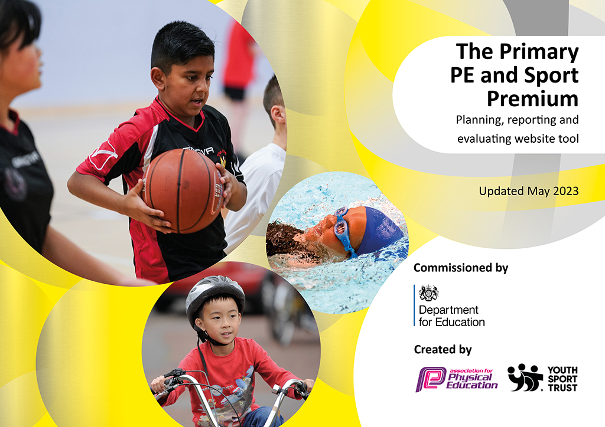
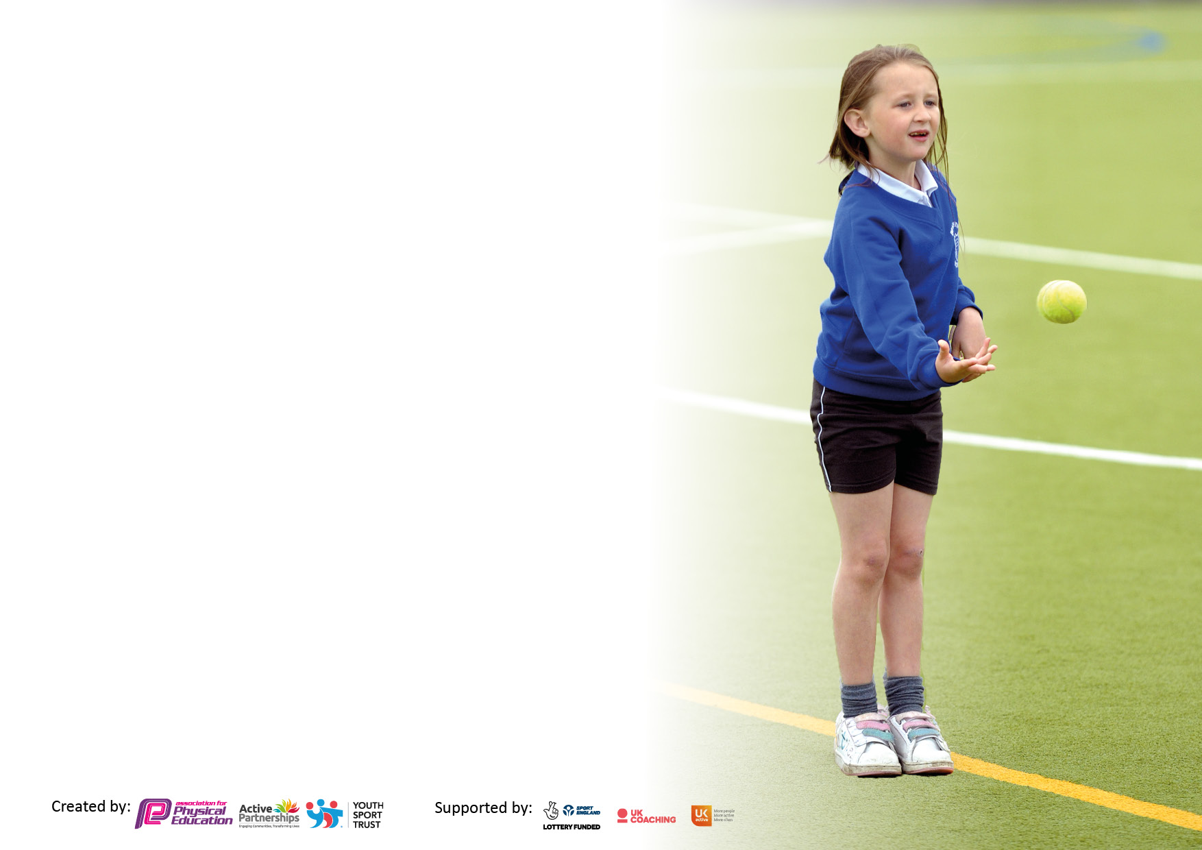

It is important that your grant is used effectively and based on school need. The Education Inspection Framework makes clear there will be a focus on ‘whether leaders and those responsible for governors all understand their respective roles and perform these in a way that enhances the effectiveness of the school’.

Under the Quality of Education Ofsted inspectors consider:
Intent - Curriculum design, coverage and appropriateness
Implementation - Curriculum delivery, Teaching (pedagogy) and Assessment
Impact - Attainment and progress

To assist schools with common transferable language this template has been developed to utilise the same three headings which should make your plans easily transferable between working documents.

Schools must use the funding to make additional and sustainable improvements to the quality of Physical Education, School Sport and Physical Activity (PESSPA) they offer. This means that you should use the Primary PE and sport premium to:

- Develop or add to the PESSPA activities that your school already offer
- Build capacity and capability within the school to ensure that improvements made now will benefit pupils joining the school in future years
- The Primary PE and sport premium should not be used to fund capital spend projects; the school’s budget should fund these.

Pleasevisitgov.ukfortherevisedDfEguidanceincludingthe5keyindicatorsacrosswhichschoolsshoulddemonstrate animprovement.Thisdocumentwillhelpyoutoreviewyourprovisionandtoreportyourspend.DfEencouragesschools to use this template as an effective way of meeting the reporting requirements of the Primary PE and Sport Premium.

We recommend you start by reflecting on the impact of current provision and reviewing the previous spend.

Schools are required to publish details of how they spend this funding, including any under-spend from 2021/2022, as well as on the impact it has on pupils’ PE and sport participation and attainment. All funding must be spent by 31st July 2023.

We recommend regularly updating the table and publishing it on your website throughout the year. This evidences your ongoing self-evaluation of how you are using the funding to secure maximum, sustainable impact. Final copy must be posted on your website by the end of the academic year and no later than the 31st July 2023. To see an example of how to complete the table please click HERE.

Details with regard to funding
Please complete the table below.

Total amount carried over from 2021/22 | £0
Total amount allocated for 2021/22 | £
How much (if any) do you intend to carry over from this total fund into 2022/23? | £0
Total amount allocated for 2022/23 | £21,300,00
Total amount of funding for 2023/23. To be spent and reported on by 31st July 2023. | £ 21,300.00
Swimming Data
Please report on your Swimming Data below.

Meeting national curriculum requirements for swimming and water safety.

N.B. Complete this section to your best ability. For example you might have practised safe self-rescue techniques on dry land which you can then transfer to the pool when school swimming restarts.
Due to exceptional circumstances priority should be given to ensuring that pupils can perform safe self rescue even if they do not fully meet the first two requirements of the NC programme of study
What percentage of your current Year 6 cohort swim competently, confidently and proficiently over a distance of at least 25 metres?  N.B. Even though your pupils may swim in another year please report on their attainment on leaving primary school at the end of the summer term 2022.  Please see note above | 26%
What percentage of your current Year 6 cohort use a range of strokes effectively [for example, front crawl, backstroke and breaststroke]?  Please see note above | 20%
What percentage of your current Year 6 cohort perform safe self-rescue in different water-based situations? | 20%
Schools can choose to use the Primary PE and sport premium to provide additional provision for swimming but this must be for activity over and above the national curriculum requirements. Have you used it in this way? | Yes

Action Plan and Budget Tracking
Capture your intended annual spend against the 5 key indicators. Clarify the success criteria and evidence of impact that you intend to measure to evaluate for pupils today and for the future.

Academic Year: 2022/23 | Total fund allocated: | Date Updated:
Key indicator 1: The engagement of all pupils in regular physical activity – Chief Medical Officers guidelines recommend that primary school pupils undertake at least 30 minutes of physical activity a day in school |  |  |  | Percentage of total allocation:
 |  |  |  | 97.42%
Intent | Implementation |  | Impact
Your school focus should be clear what you want the pupils to know and be able to do and about  what they need to learn and to  consolidate through practice: | Make sure your actions to achieve are linked to your intentions: | Funding allocated: | Evidence of impact: what do pupils now know and what can they now do? What has changed?: | Sustainability and suggested next steps:
Children and parents will have a greater awareness of how to lead a healthy lifestyle. Encourage a lifelong interest and understanding of the benefits of physical activity and healthy eating.  Offer a wider variety of sport/activity to all pupils.  Children will spend more time being physically active.  Increase engagement of girl’s participation in sporting activities and competitive sport.  Increase swimming lessons, giving access to lessons for children in years 2, 3 and 4. More teachers and smaller groups.  To continue to develop children’s confidence and ability in order to reach national curriculum targets.  1-1 and small group SPARKS intervention aimed at targeted children to improve gross motor skills. Additional  Reception cycling  To improve the physical development in Reception and Nursery- assessments after covid showed that children’s physical development was behind expectations post lockdown. | - Access to born to move for children in all year groups 4 days a week before school.  - Health and well-being meetings with targeted parents and children to support in increasing activity levels and suitable diet.  - Additional targeted club after school once a week and 1 additional session during the week.  - Fizz Free February  - 1-1 cycling sessions for targeted children  - Fencing to be during school day, targeted at children not accessing clubs.  - Wide range of after school clubs a week offering variety for all ages throughout the school year.  - Tracking of children attending all clubs  - Resources to ensure there is sufficient equipment for all children attending clubs, including bikes, helmets and PE equipment.  - Girls only clubs including football and active club.  - Affiliation to the girls football league and cup competitions.  - Engagement with Swindon Town football Foundation girls only sessions.  - Ensuring girls are selected to be involved in school competitions.  - Hire more pool time and continue with use of own swimming teachers.  - Track children achieving the NC standard so that specific children can be targeted in Year 6.  - Targeted children attended regular SPARKS sessions throughout the year, improving balance, coordination and gross motor control. Assessments carried out 3 times during the year.  - CPD for staff  - Resources for SPARKS  - All children in reception have termly blocks of balance ability with targeted children receiving further support in our after-school clubs.  - Resources to provide all children with  more opportunity to develop their gross motor skills including balance, agility, coordination and upper body strength. | 2 staff £17 x 5 days a week x 30 weeks a year - £5100  £180- health meetings (5 weeks x £36  1 x staff x £17 x 2 hours a week x 30 weeks- £1020  1 x staff x £17 x 1 day a week x 30 weeks - £510  £0  3 x staff x £17 x 4 days a week x 30 weeks- £6120  £2824.50  Included in club budget  £700 additional use of Ridgeway pool increased by 24 hours over terms 5 and 6.  1 x £17 x 4 hours a week x 30 weeks - £2040  1.5 hours x £17  X 30 weeks - £756  £1500 | - More children are attending sports clubs before school, improved ability, confidence and fitness levels.  - Advice and guidance given on exercise and diet and children given option of sports clubs to attend as well as sign posting parents to alternative sports clubs outside school.  - Children were able to join in a range of sporting activities.  - Children took part in Fizz free February and celebrated in school and surveys sent home to discuss with parents.  - Targeted at children in need of mobility, balance and confidence support. Children have gained confidence and ability in cycling and improved physical strength, mobility and wellbeing.  - Children regularly attended fencing sessions during term 6 and some continued to attend during the school holidays.  - More children have accessed clubs and taken part in a wide variety of activities, including a SEN club, girls only and reception.  - Tracking to ensure more children get the opportunity to attend regular clubs and monitor attendance.  - Children have been able to access quality sessions aimed at all ages and abilities, improving confidence and social skills as well as overall wellbeing.  - More girls have attended clubs throughout the year, in girls only and mixed clubs. Girls have attended competitions and taken part in the girls football cup as well as girls playing in the mixed  teams.  - Girls have signed up and are attending out of school sports club through Swindon Town Foundation after taster sessions ran in school.  - More children attended regular SPARKS sessions throughout the year improving balance, coordination and gross motor control. Assessments carried out 3 times during the year.  - Staff went on Training days organised through occupational therapy.  - All children in reception had termly blocks of balance ability with targeted children receiving further support in our after-school clubs. More Reception children are riding bikes without support. Children were also able to access an afterschool club using the school bikes.  - Childrens gross motor skills and physical strength have improved with all children having the opportunity to develop confidence in themselves. | Born to Move to continue next year.  Health meetings will continue, and new children targeted for the coming year. Working alongside the family support advisor.  Continue to work with and develop the of SNAPS project to enable a whole school approach.  Continue to support children to develop their balance, co-ordination and cycling ability.  Continue to offer a wide range of clubs throughout the school year.  Continue to track and monitor attendance after school clubs.  Resources will continue to be used in the coming school years.  Continue to encourage girls to be active and join in clubs and competition. Affiliation in girls football cup an joining a mixed Netball league.  Swimming in years 2,3 and 4 confirmed for next school year. Current year 2s will have 2 more blocks of swimming to see more children achieve the NC targets. 10 additional weeks.  Continue to work with the SENCO to identify children who require additional gross motor support, continue with  Regular sessions and assessments.  Staff will continue to deliver quality SPARKS sessions.  To be continued next year.  Resources to be continued to be used for the coming years.
Key indicator 2: The profile of PESSPA being raised across the school as a tool for whole school improvement |  |  |  | Percentage of total allocation:
 |  |  |  | 1.2%
Intent | Implementation |  | Impact
Your school focus should be clear what you want the pupils to know and be able to do and about  what they need to learn and to  consolidate through practice: | Make sure your actions to achieve are linked to your intentions: | Funding allocated: | Evidence of impact: what do pupils now know and what can they now do? What has changed?: | Sustainability and suggested next steps:
Healthy lifestyle and sport displays around the school.  PE and healthy eating to continue to be visible and have a higher profile within school.  Introduce playleaders from year 6 | - Boards allocated for PE and healthy lifestyle.  - Clubs and events to be advertised / celebrated.  - Year 6 children to be given the opportunity to support key stage 1 with physical activity. | £17 x 15 hours - £255 | - A higher profile of PE in the school and children are more aware of the opportunities available to them in school to participate in PE and Sport.  - All year 6 children given the opportunity to support during key stage 1 PE for athletics and a selection were chosen to support on sports day. | PE staff to continue promoting all clubs, events and healthy lifestyles across the school.  Continue to give year 6 the opportunity to support keystage 1 During terms 5 and 6.

Key indicator 3: Increased confidence, knowledge and skills of all staff in teaching PE and sport |  |  |  | Percentage of total allocation:
 |  |  |  | 5.5%
Intent | Implementation |  | Impact
Your school focus should be clear | Make sure your actions to | Funding | Evidence of impact: what do | Sustainability and suggested
what you want the pupils to know | achieve are linked to your | allocated: | pupils now know and what | next steps:
and be able to do and about | intentions: |  | can they now do? What has
what they need to learn and to |  |  | changed?:
consolidate through practice:
Staff skills, knowledge and confidence to deliver PE is developed through targeted CPD to enable improved delivery of PE sessions.  Lesson drop ins | - CPD for all staff provided through Fortius on delivery of PE.  - Staff to be trained in assessment of PE.  - Staff survey to find areas of strength and weakness.  - Team teach to support staff in delivery of PE where a need is identified  - Sports coaches to drop in and observe PE lessons, support and feedback given if needed. | £250- part of fortius package  £17 x 2 x 20 = £680 | - All staff attended CPD session on delivery of PE and a staff meeting allocated to PE assessment.  - Staff feedback is used to support staff where needed.  - New teachers were supported in delivery of PE with sports coaches team teaching.  - Drops ins were scheduled throughout the year with feedback and support given if required. | - CPD to continue yearly.  - Staff surveys to be completed yearly to find areas for improvement.  - Continue to support the development of ECTs.  - Session drops to continue.
Key indicator 4: Broader experience of a range of sports and activities offered to all pupils |  |  |  | Percentage of total allocation:
 |  |  |  | 1.9%
Intent | Implementation |  | Impact
Your school focus should be clear | Make sure your actions to | Funding | Evidence of impact: what do | Sustainability and suggested
what you want the pupils to know | achieve are linked to your | allocated: | pupils now know and what | next steps:
and be able to do and about | intentions: |  | can they now do? What has
what they need to learn and to |  |  | changed?:
consolidate through practice:
Whole school to take part in sponsored events raising funds for charities.  Whole school sports day.  Year 6 residential trip, engaging in a variety of outdoor pursuits. | - Organise a whole school sponsored event to raise funds for Children in need.  - Whole school sponsored mile to raise funds for Swindon Hydrotherapy Pool.  - Whole school to take part in sports day.  - Year 6 children to be given the opportunity to attend an outdoor activity center for a residential trip. | £17 x 1 x 3 =£51  £0  £17 x 3x 5=£255  Plus £100 track hire | Children all took part in sponsored events, raising awareness of charities and healthy lifestyles.  Group of year 6 children attended Braeside in Devizes where they took part in a range of outdoor activities, including rock climbing, high ropes, orienteering and team building physical games. | Continue to support local charities through sponsored activity.  Whole school to be involved in sports day.

Key indicator 5: Increased participation in competitive sport |  |  |  | Percentage of total allocation:
 |  |  |  | 0.5%
Intent | Implementation |  | Impact
Your school focus should be clear | Make sure your actions to | Funding | Evidence of impact: what do | Sustainability and suggested
what you want the pupils to know | achieve are linked to your | allocated: | pupils now know and what | next steps:
and be able to do and about | intentions: |  | can they now do? What has
what they need to learn and to |  |  | changed?:
consolidate through practice:
Enter mixed football competitions for more year groups.  Enter more girls teams into football competitions.  Take part in School games events.  Enter mixed teams into Cricket tournament. | - Entered a 5/6 mixed team into all football competitions and a 3/4 team into the indoor 5 a side events.  - Enter into the girls cup and 5 a side indoor cup.  - Join Fortius membership and take part in school games events. Use afterschool clubs to practice for new events.  - Entered 2 mixed teams into the Dynamo cricket. | £50 league fees  Coaching included in club budget  Part of Fortius package  1 X £17 x 4= £68 | Boys and girls took part in more mixed competitive football matches and events.  More girls took part in competitive football.  Children took part in a range of sporting events, including Dodgeball. Qualified for the Dodgeball regional finals and won.  2 teams took part in the cricket festival with 1 team winning and qualifying for the finals. Came 2nd overall in the county cricket. | Continue to take part in the mixed football league and cup.  Continue to take part in the girls football events.  Continue with Fortius membership and attend school sports games events.  Enter into the county cricket festival.

Signed off by
Head Teacher:
Date:
Subject Leader:
Date:
Governor:
Date:

