Music development plan summary:
Drove Primary School

Overview
Detail | Information
Academic year that this summary covers | 2024-2025
Date this summary was published | September 2024
Date this summary will be reviewed | August 2025
Name of the school music lead | Bryony Bardwell
Name of school leadership team member with responsibility for music (if different) | Bryony Bardwell
Name of local music hub | Swindon Music Service
Name of other music education organisation(s) (if partnership in place)

This is a summary of how our school delivers music education to all our pupils across three areas – curriculum music, co-curricular provision and musical experiences – and what changes we are planning in future years. This information is to help pupils and parents or carers understand what our school offers and who we work with to support our pupils’ music education.

Part A: Curriculum music
This is about what we teach in lesson time, how much time is spent teaching music and any music qualifications or awards that pupils can achieve.
At Drove Primary School we give children “The roots to grow and the wings to fly”.
In order to achieve this, we have carefully designed a curriculum which is underpinned by 4 Golden Threads:

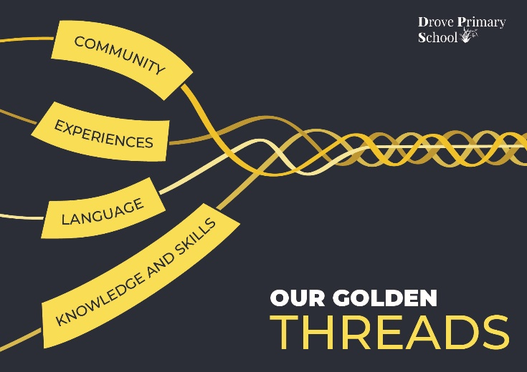

Our Intent for our Music Curriculum:
At Drove Primary School, our 4 Golden Threads underpin our curriculum intent enabling our pupils to achieve the following in Music:
- To be curious about different music genres.
- To have the knowledge of how music is composed and have the skills to perform.
- To have the experience of playing the recorder and the glockenspiel.
- To learn and develop music specific language.
​
At Drove Primary School, we intend to deliver an exciting, culturally diverse musical education which provides an enjoyable and stimulating learning experience. By encouraging a balance of singing, playing, listening, composing, and performing, we aim to develop children's ability to respond to a range of music and increase their confidence to express themselves through music.

Our music curriculum is an excellent way of celebrating our diverse school community. We aspire to offer a range of opportunities to sing a variety of multicultural songs, listen to inspirational composers, and compose pieces of music that reflect the mastery of music that all children have developed through accessing a planned and structured curriculum.

We are committed to ensuring that children understand the value and importance of music and can transfer their musical skills knowledge and experiences into their wider community. As a school we intend to develop every child’s self-confidence and social development that will support them in their future, and as such we believe that Music offers all children an opportunity to express their creativity and inspire self-confidence through practical experiences leading to various musical performances and activities.

Implementation:
The National Curriculum is the starting point of our curriculum design. It has been used to drive our curriculum design, to ensure the aims of the National Curriculum are met, and it has been used to inform the choices we have made about the content that we teach at Drove Primary School.

The implementation of the Music Curriculum at Drove Primary School is through the Charanga scheme of work delivered by the teacher. It offers a range of differentiated activities to allow every child an opportunity to access the music curriculum and celebrate the diversity of our school community. We are committed to providing a range of musical experiences such as the Christmas Nativity, The Year 6 leavers performance, a Choir, and the opportunity to be involved in a local community performance. Each experience offering awe and wonder for the children, celebrating the different cultures and heritage within our school and the wider community.

We present a variety of learning stimuli to ensure the curriculum is accessible to all. At Drove Primary School, musical vocabulary is built upon from Nursery through to Year 6 through movement, pictorial representations and written / oral language of musical terminology and notations. This helps to develop the skills to be able to read and understand how to perform a basic musical composition. During our Music lessons children are exposed to a range of music giving them the opportunity to sing in unison and harmony, they are taught to consider the elements of music required for performances such as tone, tempo, pitch, along with enhancing their ability to listen, respect and cooperate with each other.

Impact
Our intended impact is that by the time our pupils leave Drove Primary School, they will have developed:
- Their own opinions of different music genres and how they are composed and performed by listening and analysing different music types.
- To have challenged themselves to create and perform different genres of music.
- Develop skills in order to acquire, apply and transfer their knowledge ​across different musical instruments and genres.
- An appreciation for music and how it makes us feel and how it represents different cultures and other parts of the world.

Part B: Co-curricular music
This is about opportunities for pupils to sing and play music, outside of lesson time, including choirs, ensembles and bands, and how pupils can make progress in music beyond the core curriculum.
Our school works in partnership with the Swindon Music Service to provide pupils with opportunities to take part in community events such as the Christmas Voice Festival and the Infant/Junior Voice festivals.
We offer both Piano lessons in school and these are facilitated by an external Piano teacher.
Assembly time is also set aside on a weekly basis for singing. Children are introduced to new songs and enjoying practising, rehearsing and performing together.
We have incorporated the use of Drumba throughout PE lessons this year. The Drumba programme supports the music curriculum, teaching children the basics in drumming, rhythm and beats.

Part C: Musical experiences
This is about all the other musical events and opportunities that we organise, such as singing in assembly, concerts and shows, and trips to professional concerts.
- Assembly time for singing
- Christmas Performances for EYFS, KS1 and KS2
- End of year Performances for KS2
- Singing Festivals ay the Wyvern Theatre in Swindon run by Swindon Music Service
- Community Events within the local area.
- Visits to the Local retirement home to sing for the residents

In the future
This is about what the school is planning for subsequent years.
It is the intention of the leadership team to:
- Plan additional opportunities for children to engage in musical events
- Further develop our music lesson offer available to children throughout the school
- Continue to embed the music curriculum and further support teachers in their knowledge and understanding of the curriculum.

Further information (optional)
Swindon Music Service:
The Platform Faringdon Road Swindon Wiltshire SN1 5BJ
Peter Clark
pclark@smscio.co.uk (Chief Executive Officer)

