Music development plan summary:
Drove Primary School

Overview
Detail | Information
Academic year that this summary covers | 2026 – 2027
Date this summary was published | September 2026
Date this summary will be reviewed | December 2026
Name of the school music lead | Linda Matthews
Name of school leadership team member with responsibility for music (if different) | Bryony Bardwell
Name of local music hub | Swindon Music Service
Name of other music education organisation(s) (if partnership in place)

This is a summary of how our school delivers music education to all our pupils across three areas – curriculum music, co-curricular provision and musical experiences – and what changes we are planning in future years. This information is to help pupils and parents or carers understand what our school offers and who we work with to support our pupils’ music education.

Part A: Curriculum music
This is about what we teach in lesson time, how much time is spent teaching music and any music qualifications or awards which pupils can achieve.
At Drove Primary School we give children “The roots to grow and the wings to fly”.
In order to achieve this, we have carefully designed a curriculum which is underpinned by Four Golden Threads:

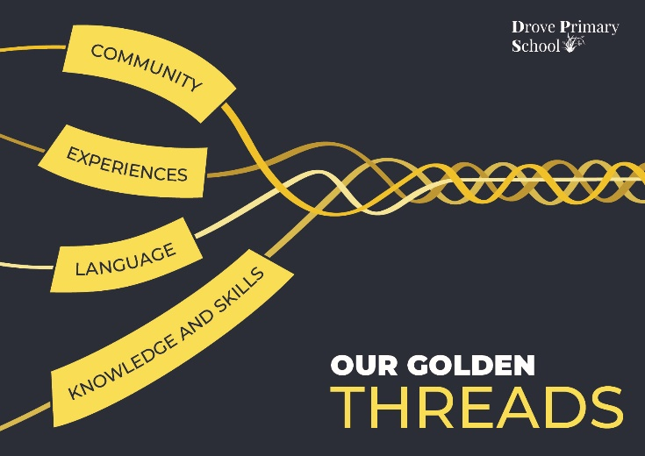

Our Intent for our Music Curriculum:
At Drove Primary School, our Four Golden Threads underpin our curriculum intent enabling our pupils to:

- Be curious about different music genres.
- Have the knowledge of how music is composed and have the skills to perform.
- Gain experience of playing the recorder and the glockenspiel.
- Learn and develop music specific language.
​
At Drove Primary School, we intend to deliver an exciting and culturally diverse music education which provides an enjoyable and stimulating learning experiences. By providing a balance of singing, playing, listening, composing, and performing, we aim to develop children's ability to respond to a wide range of music and increase their confidence to express themselves musically.

Our music curriculum provides an excellent opportunity to celebrate our diverse school community. We aim to offer pupils a range of opportunities to sing multicultural songs, listen to inspirational composers an create their own pieces of music. Through a carefully planned a structured curriculum, all children will progressively develop their musical knowledge, skills and understanding.

We are committed to ensuring that children understand the value and importance of music and can apply their musical skills, knowledge and experiences within school and the wider community. We intend to develop every child’s self-confidence, creativity and social skills, supporting them both now and in the future. Through practical musical experiences, performances and activities, all children are given opportunities to express themselves creatively and grow in confidence.

Implementation:
The National Curriculum provides the starting point for our curriculum design. Its aims and requirements inform the content we teach at Drove Primary School and ensure that pupils develop the knowledge and skills expected at each stage of their education.

Our music curriculum is primarily delivered through the Charanga scheme of work. Lessons are carefully sequenced and taught by class teachers, enabling pupils to build upon their prior learning and develop their musical knowledge and skills progressively. A range of inclusive and adaptable activities ensures that every child can access the curriculum and experience success.

We are committed to providing pupils with a wide range of musical experiences, including the Christmas Nativity, the Year 6 leavers’ performance, school choirs and opportunities to participate in performances within the local community. These experiences inspire a sense of awe and wonder, build pupils’ confidence and celebrate the diverse cultures and heritage represented within our school and wider community.

A variety of teaching approaches and learning resources is used to ensure that the curriculum is accessible to all pupils. Musical vocabulary is developed progressively from Nursery to Year 6 through movement, visual representations, discussion, written language and musical notation. This enables pupils to understand, perform and create increasingly complex musical compositions.

During music lessons, children listen and respond to music from a wide range of genres, cultures and traditions. They are given regular opportunities to sing in unison and, where appropriate, in harmony. Pupils learn to recognise and use the elements of music, including rhythm, pitch, tempo, dynamics, timbre and structure. Through collaborative practical activities, they also develop important skills such as listening, cooperation, respect and self-expression.

Impact
Our intended impact is that, by the time pupils leave Drove Primary School, they will have developed:
- The confidence to form and express their own opinions about a range of musical genres through careful listening and analysis.
- The confidence and resilience to challenge themselves when composing and performing different styles of music.
- A secure foundation of musical knowledge and skills that they can apply and transfer across different instruments, compositions and genres.
- An appreciation of music, the emotions it can evoke and the ways in which it reflects different cultures, traditions and communities around the world.
Pupils will leave Drove Primary School with positive musical experiences, increased confidence and the knowledge and skills required for the next stage of their musical education.

Part B: Co-curricular music
This is about opportunities for pupils to sing and play music, outside of lesson time, including choirs, ensembles and bands, and how pupils can make progress in music beyond the core curriculum.
Co-curricular music provides pupils with opportunities to sing, play and perform beyond their classroom lessons, while continuing to develop their musical knowledge, skills and enjoyment.
Our school works in partnership with Swindon Music Service to provide pupils with opportunities to participate in community events, including the Christmas Voice Festival and the Infant and Junior Voice Festivals.
Piano tuition is available within school and is delivered by an external specialist teacher, allowing pupils to develop their individual instrumental skills.
Dedicated assembly time is provided each week for collective singing. Children are introduced to a variety of songs and learn to practise, rehearse and perform together, developing their confidence and sense of belonging.
Drumba is also incorporated into PE lessons. The programme complements our music curriculum by developing pupils’ understanding of pulse, rhythm and beat while supporting coordination, teamwork and physical fitness.

Part C: Musical experiences
This is about all the other musical events and opportunities that we organise, such as singing in assembly, concerts and shows, and trips to professional concerts.
Pupils are provided with a range of opportunities to experience, perform and celebrate music beyond their classroom lessons. These include:
- Weekly singing assemblies.
- Christmas performances involving EYFS, KS1 and KS2.
- End-of-year performances across KS2.
- Singing festivals at the Wyvern Theatre in Swindon, organised by Swindon Music Service.
- Opportunities to perform at events within the local community.
These experiences allow pupils to perform for different audiences, develop their confidence and celebrate music as part of the wider school community.

In the future
This is about what the school is planning for subsequent years.
The leadership team intends to:
- Provide additional opportunities for pupils to participate in musical events and performances.
- Further develop the range of instrumental tuition available to pupils throughout the school.
- Continue to embed the music curriculum consistently across all year groups.
- Provide further support and professional development to strengthen teachers’ musical subject knowledge and confidence

Further information (optional)
Swindon Music Service:
The Platform Faringdon Road Swindon Wiltshire SN1 5BJ
Peter Clark
pclark@smscio.co.uk (Chief Executive Officer)

