

Phonics and Early Reading Intent, Implementation & Impact Statement

At Drove Primary School we give children “The roots to grow and the wings to fly”.

In order to achieve this, we have carefully designed a curriculum which is underpinned by 4 Golden Threads:
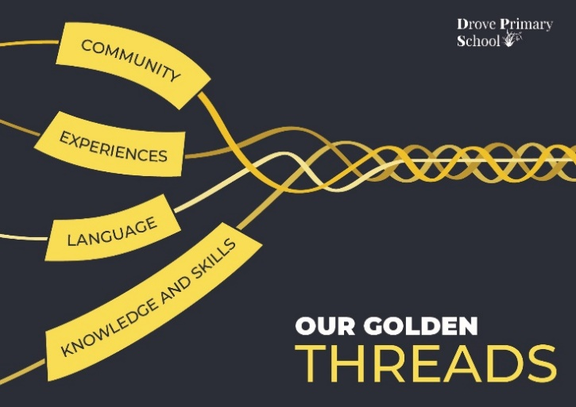

We have carefully chosen our Golden Threads because they are unique to our school context and setting:
- Experience: Our intent is for every child to be provided with a breadth of experiences that enriches their learning and enables them to transfer their skills across all areas of the curriculum.
- Knowledge and Skills: Our pupils will develop mastery across the curriculum as a result of a carefully planned and sequenced curriculum which builds progressively on knowledge and skills.
- Language: Over 86 % of our pupils have English as an additional language, including 51 different languages, so it is our intent that our pupils will acquire knowledge, develop their vocabulary and have the tools to communicate their ideas effectively, both orally and in writing.
- Community: Our intent is for all children to embrace and develop our shared set of values so that they become good citizens within our community and are prepared for a life in an ever-changing and modern world.
Intent for our Phonics and Early Reading Curriculum:
Our intent, underpinned by our 4 Golden Threads, is to provide children with;
- explicitly taught letters and sounds correspondents (graphemes and phonemes,) to be able to successfully blend and segment individual sounds together to read and spell
- the knowledge and skills needed to become fluent readers and writers
- language rich experiences to develop a love of reading for both pleasure and information
- to build and apply their phonemic skills through early reading into Key Stage 2 so that they are reading at age-related expectations and beyond
- to support our families with resources and phonics knowledge to help their children secure a solid early reading foundation.

Implementation:
At Drove Primary we have adopted Rocket Phonics as our systematic synthetic phonics programme to teach phonics in Reception and Year 1. Rocket Phonics is a fully resourced, systematic synthetic phonics programme that provides us with everything we need to teach children to read and write. Rocket Phonics lessons follow a Review, Teach, Practice and Apply whole class mastery style structure. Our phonics lessons are taught daily for 30 minutes. Teaching uses a combination of digital and printed resources, along with a fully matched series of decodable reading books. At the heart of the programme, are the ‘Big Books’, which consist of language-rich stories to teach all the target letter-sounds in context. Through detailed termly assessments we track pupils with rigour to identify and respond to their individual learning needs. The Phonics Screening Check is administered in June of Year 1 with a re-check in Year 2, if required.

From year 1 specific Reading skills are taught each week implemented through a structured and progressive 3 phase approach, which immerses pupils into a text/section of text, whilst they develop reading skills:
- Pre-phase equips the children with the information and understanding they will need to access the high-quality text for the term. This is before the book is shared with the children as we believe, this gives our children an equal starting point within their learning. In a Non-fiction pre-phase, subject knowledge, language and genre features needed for the sequence and end of phase write will be discussed and explored.
- Phase 1 allows time to teach reading skills using our integra-based aims. This will be based around the core text and any supplementary texts. Children will engage in active reading lessons during this phase, where our sequences are planned to offer real life and hands on experiences, creating a range of opportunities for all children to be immersed in and engaging with language.
- During Phase 2, children are explicitly taught how to use a range of strategies effectively when answering comprehension questions. These are taught across the school through whole class reading – where teachers and children engage in a text and answer a range of comprehension questions. Additionally, children are able to practise developing fluency and prosody by reading the same section of text for two days. Our teachers use the ‘I do, we do’ model to support the teaching of reading. Teachers model explicitly the skills needed to answer different types of comprehension questions.

Impact:
At Drove we measure the impact of Phonics and Early Reading through the themes of our Golden Threads.
- Experience Phonics and Early Reading learning enables our children to transfer their skills across all areas of the curriculum at a steady pace and progression of two letter-sounds per week (rather than the usual four) so that knowledge and skills are embedded from the start. Texts are chosen to widen thee children’s understanding of the world as well as secure their understanding of phonics.
- Knowledge and Skills Phonics and Early Reading’s whole-class mastery style teaching ensures no child is left behind and consistent daily practice of reading and writing builds children’s confidence. Children become fluent readers able to segment and blend unfamiliar words ready to succeed at KS2.
- Language Phonics and Early Reading enables an early love of reading through illustrated stories, and immersion of whole class texts. Children increase their knowledge of blending, segmenting and understanding unfamiliar words to support their comprehension.
- Community Our pupils gain a secure foundation of early reading skills to build upon as they venture into KS2 backed with support from their families at home.

